ARBITING MATTERS

Number 1 Autumn 1993

The Newsletter of the Chess Arbiters' Association

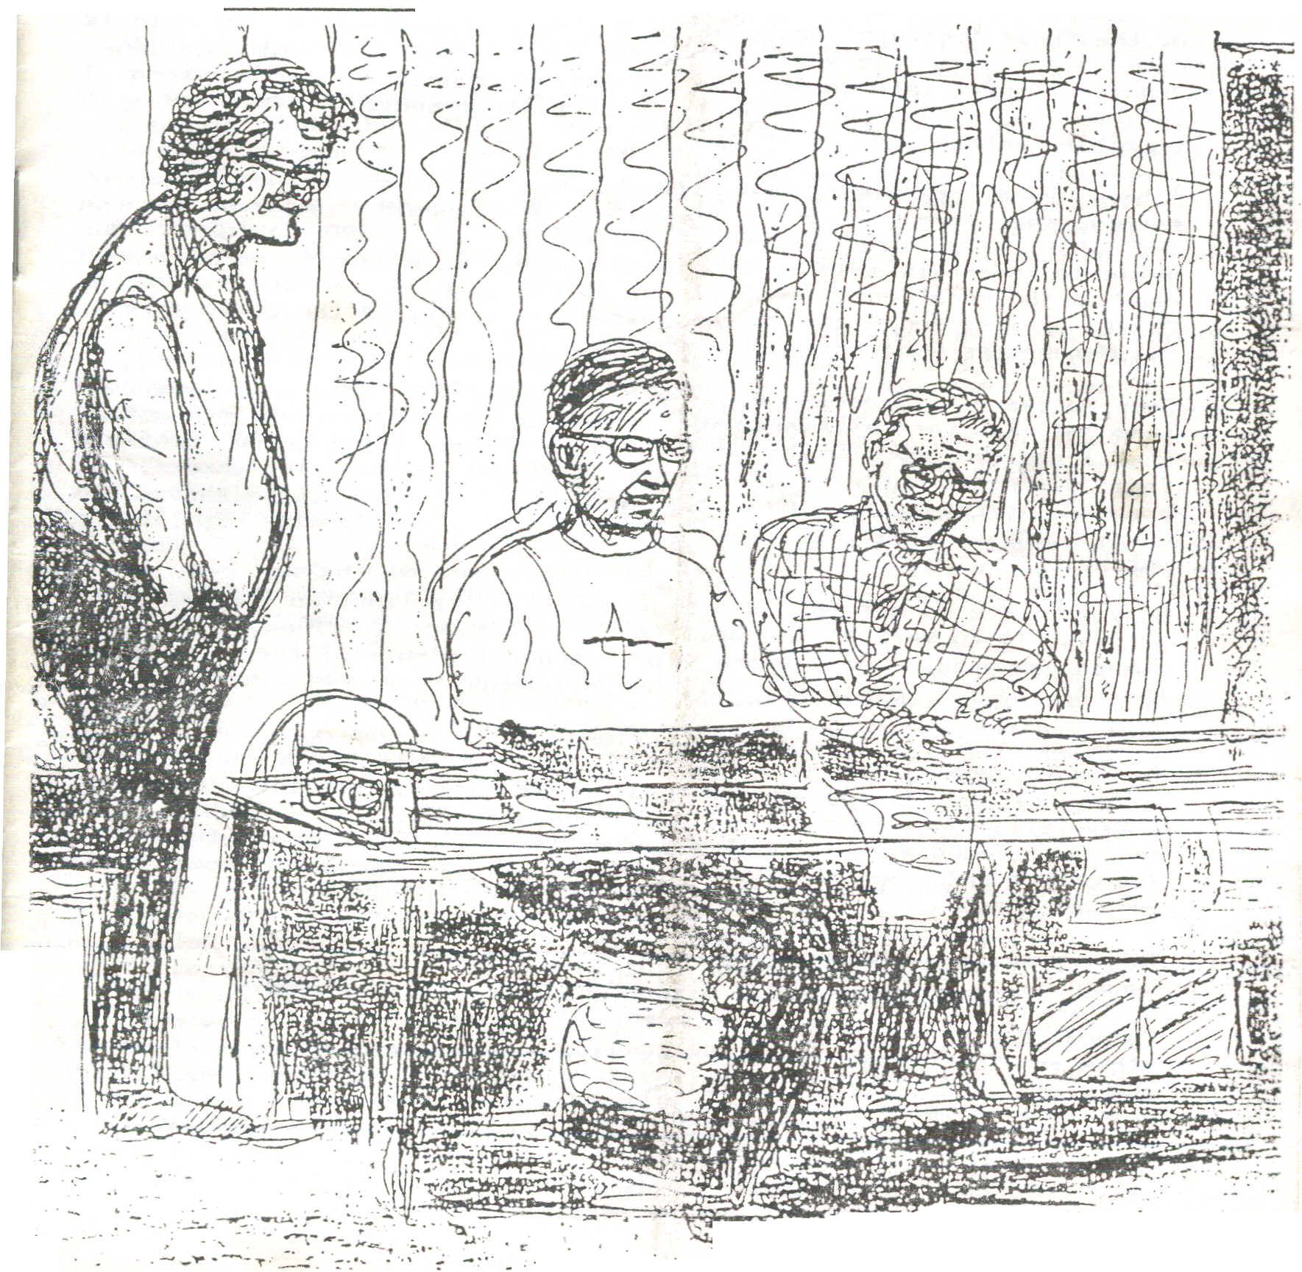

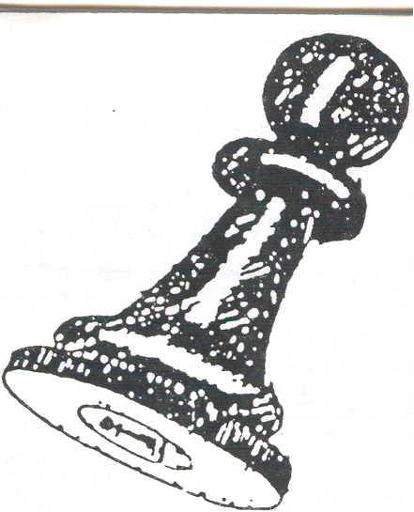
CHESS ARBITERS'
ASSOCIATION
I suppose lots of people start a new job with good intentions. I am no exception, so what is my aim as volunteer editor of the Newsletter of the Chess' Arbiters' Association? Many organisations, and this is not only true in the world of chess, suffer from poor communications. News and useful information are not passed around. This is where I believe the CAA. has a duty to keep its members informed and, if possible, entertained as well.

I have been organising tournaments and congresses for close on twenty five years. I don't claim this as a record. Many of you can top this. I have worked as an arbiter for nearly as long. Due acknowledgement is made here to Harry Lamb, from whom I learnt a good deal in the great chess boom of the1970s, when combined – he as Chief Arbiter and I as Congress Director during the great days of the Manchester Congresses at Owens Park.

Despite years of experience, it was not until 1988 when I joined the team of arbiters at. Blackpool for the British Championships Congress that I had the opportunity to work with other experienced arbiters from different parts of the country and from north of the border. I probably learnt more in my first three years at the British than I had done in the previous ten years of doing my own thing on my own little patch.

Many arbiters do not have the opportunity or inclination (perhaps they ‘re wise!) to work at The British. If through this Newsletter I find others can pass on advice and tips, and get plenty of feedback, then the CAA and its Newsletter will be performing a valuable service.

I would like to distribute at least three issues of the Newsletter during the coming twelve months. I have a number of ideas for items to include, but I will welcome your ideas and your contributions also. I have already commissioned some features (all contributor" will receive remuneration equal to mine!) but, if you have not yet been approached and have something to offer, please contact as soon as the muse hits you.

This inaugural issue concentrates mainly on the new BCF Rules for seeded Swiss Pairings which you should have received either at Dundee or through the post; at the beginning of October and on the new Cadogan Master Point System. Not surprisingly I have a few personal views on "That Match". There is also an article by Peter Purland and
there is the "Practical Pairings" section where I thank David Welch for checking the logic of my explanations. Thanks are extended to all my contributors and to Roger Edwards for taking care of the photocopying. Unattributed articles are mine, Finally, remember this is your Newsletter. Please let me have your ideas and contributions or I shall have to inflict more of mine.

Richard Furness

THE CADOGAN MASTER POINT SYSTEM by John Robinson

You will have read on pages I, xi and xii of the Cadogan Grading List of the introduction of three new chess master titles henceforth to be recognised by the BCF. In what may turn out to have been a weak moment last summer, I agreed to take on responsibility for the scheme.

Having said that, it is regrettably true that I know little more about the scheme than can be gained from a quick glance at the pages mentioned above. However, since August 1st, I have talked to a number of people, finding out how members see things; it is clear that many ordinary members take it for granted that any club officer with any kind of non-playing role, be it club secretary, treasurer or whatever is assumed to know its finer points. However unfair, Arbiters who run congresses or leagues WILL clearly need to know the scheme of things and will be relied on for a minimal active role.

The Arbiter’s natural reaction is concern at the prospect of additional, and so far vague responsibilities at congresses. But it goes without saying that the Arbiter present is the best person to confirm that Joe Bloggs has indeed scored 2/5 or whatever against certain opponents. Initialising a form to verify this much is essential. On the face of it, it is not much to ask. However, as has been pointed out, an impatient queue of players besieging the Controllor’s table with hastily written blue forms, as the Arbiter struggles to work out the prize distribution might well be unacceptable.

Some members of the queue could turn out to have quite tricky problems. One might for example, to quote an actual query I had at Dundee, be concerned about the grades of his opponents shown on the Congress Wallchart. At Dundee the players' grade on display were as a rule, taken from the brand new Master list, but for non English players it was policy to prefer a conversion from the figure quoted in the Scottish, Welsh or whatever list. The canny "would be-master" noticed straight away that grades quoted in the National Grading List leads to the minimum performance required for a norm although the numbers on the wallcharts doesn’t. So will you confirm Jock McTavish's grade is 190 not 189 as stated in the BCF list? Of course this makes all the difference !

My suggestion for standing rules of procedure are as follows :
- A poster to be displayed at all registered congresses, or perhaps a handbill sent to controllers, pointing out the advantage of BCF Direct Membership, and stating (a) precisely what the hopeful master should do at the close of the Congress. (b) what the local Arbiter will do and (c) that all the problems be referred to me.
- The Arbiter should sign to confirm the total score and number of round.
- Even the slightest doubt; as to the validity of any one of the opponent's grades should if possible he indicated by the Arbiter,
- The CAA might wish to insist that the Arbiter the score etc AFTER the climax of the Congress, in which case a stamped addressed envelope could be demanded.
- A recent correspondent has requested an information Pack for his club. I merely replied with copies of the blue sheet, but is there a need for something better? I could for example write to CHESS MOVES. What points should be brought up?

ARBITING AT JUNIOR TOURNAMENTS

by Peter Purland

There is no doubt that dealing with junior tournaments needs a different approach to arbiting. There seem to be more and different problems, although I must stress that the vast majority of these are caused by ignorance or youthful enthusiasm and very rarely by malice. You need to deal kindly, but firmly with the players and they will soon come to respect and understand you.
There is also much more of a personal element in this controlling, not just with the players but also with the parents. One must understand that youngsters need some sort of chaperone to attend tournaments. Furthermore many youngsters will identify with an arbiter and will always come to him irrespective of who their controller is. In general, one needs to keep a closer eye on these tournaments whilst always treating them as players NOT children.

I decided to deal with more specific problems under three headings, the first of which I call DRAWS AND LAWS. Many junior tournaments have a short time-limit with the minimum time possible between rounds. EPSCA team events which use a jamboree system are no problem as the draw is pre-determined and each team has plenty of helpers to ensure players sit in the correct places. Individual tournaments can be more of a problem. In one Under 10 Welsh Championship certain players took a dislike to the draw (not the sole preserve of juniors) but their solution was to decide who they could beat and sit opposite them!

Another arbiter in a prep schools tournament published his draw board and returned to his desk. Ten minutes later not a card was left in the board. Someone had told the players they had to take their own cards and fill them in! He did finally manage to reconstruct a draw but I doubt if it was the original one. There are, however, some advantages to many junior tournaments in as much as plenty of stewards or controllers are available and not a great number or games go on to the death . Therefore, as a general rule I try to use the Quickplay Finish laws as opposed to the Rapidplay laws whenever possible and thus the result becomes most nearly that of a genuine game. I have seen junior players repeat positions at least ten times without knowing how to claim a draw (the game was in the last five minutes and not being recorded) and in such circumstances stepping-in to prevent a loss on time is obvious. Similar possible stupidities often occur and it is best to ensure the correct result by stepping-in at the right time. Many of the better players now understand the rule and at the top level agreements are much more frequent Finally in this section we come to the results slip. Adults are no better than children when it comes to failing to put on a result, but how many adults would hand in a results slip. - SIMON 1 v JOHN 0
The second section could be titled UNNATURAL DISASTERS! I will not dwell too much on these but there was the 8-year-old girl who had her hand up. On going over to enquire what the problem was, the arbiter was referred to a pool underneath her! Luckily a random mother rescued said arbiter. My own 'favourite' occurred in Eastbourne. David arrived at my desk with the message, 'My opponent has been sick.' "Where is he?' I replied. Still sitting at the board was the answer. David's mother was a nurse who sorted out the child. I was left to sort out the board as well as reposition nearby games and clean up the area

Finally we come to OUTSIDE PROBLEMS which are usually concerned with the chaperone; often a parent, but occasionally a teacher I would be very naive if I said that no parent has ever helped a child although in many cases the child is much better player than the parent and, if both were playing, I would suspect that the child was helping the parent! Nevertheless, calming down the paranoid parents is an integral part of running a Junior tournament I do find it amazing that parents only complain of outside interference when their child has lost It would be very interesting if a winner's parent was prepared to say publicly this was happening. I did reel that my physical size might have been something to do with being asked to do the junior championships at The British, as the first year I was there I had to prevent a fight between parents. However I am pleased to say that a few years later when two players were engaged in a vital match both fathers left the chess to me and went out together. The only complaint I received was from the mothers, regarding their husbands’ condition when they returned

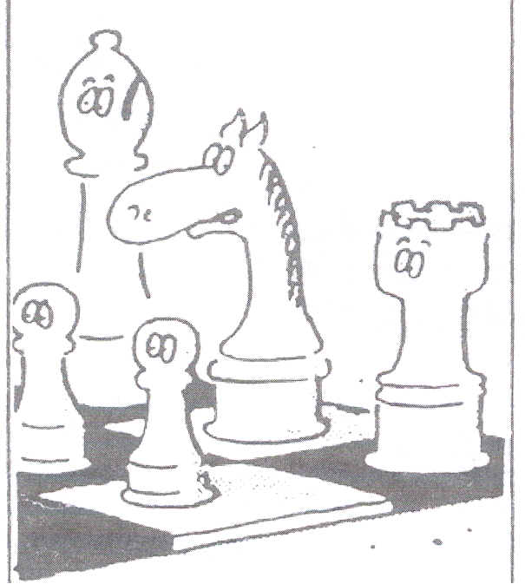
Finally I would like to thank my fellow arbiters for adding to my stories and to assure arbiters that, despite some or the horror stories contained in the article, controlling Juniors and seeing their obvious enjoyment of chess is a very rewarding experience and one that I intend to continue, if asked. for many years.

“Psst – I’ve been offered a backhander to lose this game!”

LIVE FROM THE SAVOY

What witty lyrics would have stemmed from the pen of W S Gilbert if he and Sullivan had been in partnership in 1993. “The Mikado” opened at the Savoy in 1885. One of its most popular songs – I have seen it encored 9 times – with antics by such Doyly Carte stars as Martyn Green, Peter Pratt, John Reid, was “Here’s a How de Do, Here’s a Pretty Mess”. This seems to sum up the World Championship situation admirably.

What modern day castings would be appropriate? Kasperov as Ko-Ko, Lord High Executioner. He’s certainly given Nigel the chop. For the Three Little Maids it would be Carol, Cathy and … and who? I’m uncertain about Nigel’s role. Nanki-Poo , the wandering minstrel, is a possibility, but he’s the hero. In my part of the country Nigel is anything but that. The parts of Pish-Tush, Go-To and other noble lords would be played by Daniel, Jon and David. We need someone to play the plump Poh-Bah, Lord high Everything Else. Remember he took the salaries of all the positions he held. I leave you to cast that one. For Bill and Dominic I would have to go to “The Gondoliers”. Isn’t there a song with words like, “The happiest of fellows are we”? Alternatively they could star in a revival of JB Priestley’s “The Good Companions”.

The high profile exhibition match in London has certainly boosted the image of chess, with publicity on a par with that for Spassky-Fischer in 1972 and unprecedented hours of live television coverage. It has given the cartoonist fresh inspiration and we have probably all been amused or irritated by the gaffs of the non-chess journalists and even by those of some of the better qualified writers.

Here are a few random jottings from the last few weeks. You will have to forgive the occasional Mancunian bias.

After Nigel’s crushing defeat in game 7
INTERVIEWER: “Did Nigel make any mistakes?”
NATHAN DIVINSKY: “ Yeah. He sat down.”

Do you remember Jane, the original “Daily Mirror” comic-STRIP girl of the 1930s and 1940s? Her little dog was called Fritz. Does Jon know?

RAY KEENE: “That’s what we chess experts call a Pin.”
A nice mixed metaphor from Daniel king, for me the undoubted star of the Channel 4 coverage: “Black’s Armada of pawns are flying down the board.”

Heard the one about the Irish ticket tout? He bought some bargain $45 tickets for a big match in London.

And from miles away in Birmingham we get a Second’s opinion. That’s what we chess experts call a Pun.

Do you remember the radio programme from forty years back starring comedian Ted Ray entitled “Ray’s a Laugh”? I hear its had an eight-week run in London.
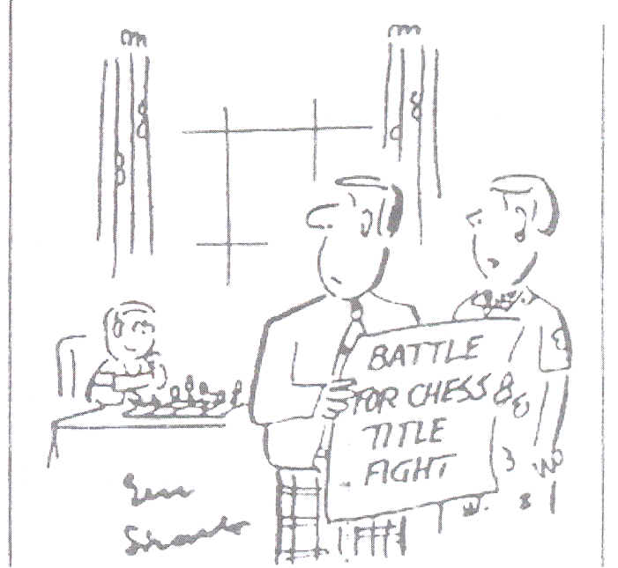'I was hoping he'd choose a less violent pastime'

OH DEAR
In early October The Funday Times (the children’s supplement to the Sunday Times) carried a double page feature on chess. It clearly explained how the pieces moved and there were excellent artist’s impressions of the pieces and of the starting position. The board was viewed from Black’s righthand corner (a8). I thought the feature was worth keeping as a good primary school visual aid.

A last check for accuracy revealed that there was a white square in the right-hand corner. Well done! The usual blunder had been avoided. But what’s this? When viewed from behind Black’s position, the Black king was to the right of the Black Queen. Similarly the White King and queen were wrongly placed. What a pity!

The following week I was pleased to spot a correction. It was entitled “OOPS” and read, “In last weeks chess feature on the centre pages, although the pieces were in the correct position ….” (but they weren’t) …”the queens were not on the correct colour squares. The board was the wrong way round!” … (but it wasn’t) … “The queen should be on the square of its own colour.” So sadly even the correction was incorrect. I didn’t see the next edition.

CREDIT WHERE CREDIT’S DUE – from one of the television listings publications we read:-

Nice one Carol. Were Garry and Nigel having the day off?
Despite her “Garry has this EVER happened to you before?” and Garry’s reply, “Oh yes, many times”, I think for a non chess expert she does a commendable job. Now I know why “Countdown” has such good viewing figures.

3 20 Photography. Animated homage to the creation of photography. [9800522]

3 30 World Chess Championship. With carol Vorderman [58831]

4.30 Fifteen to One. (T) (S) [744]

REWRITING HISTORY
Donald Telford was guilt of this in the Daily Telegraph. Reporting Game 1 he said, “The flag on his clock fell dramatically at the Savoy Theatre, London, on the 39th move.” The following day the same reporter had this to say. “After the elementary error that lost him the opening game on Tuesday, when he failed by one second to make his 40th move”. What does the truth matter if varying it makes a better story!

In the same newspaper even Malcolm Pien exercised journalistic licence to make his story more dramatic. “The margin of victory was just the tremble of the hand”. But even if the 39th move had been made, there was still a 40th. Rather more than a tremble.

FEELING THE PRESSURE
On September 13th the Telegraph carried an excellent photo which showed Game 3 in progress. Garry had hand on brow. The caption read. “Body Language: Garry Kasparov feeling the pressure on Saturday as Nigel Short, right, plans his audacious attack”. I looked at the photo to see what audacious attack had put such pressure on the champion. The following moves had been made:- 1 e4 e5.

FROM THE FINANCIAL PAGES – Wednesday 15th September
“WH Smith reports that sales of chess sets in its 400 High Street shops rose threefold last week as the Short-Kasparov championship got underway. The only shop not to report an increase was in Bolton, Lancs – Nigel Short’s home town.” Explain yourself Harry. I know. You’ve done such a great job promoting chess in Bolton over the last 30 years that everyone already owns a set.

NIGEL IN WONDERLAND
Not surprisingly Bill hartson has sharpened his wit on the subject during the year. I particularly liked his piece entitled “Nigel in Wonderland” featuring Nigeldum and Garrydee. “Nobody consulted me,” howled Nigeldum. “We couldn’t consult you if you’d faded away”, said the Red Queen. “Contrariwise”, shouted Nigeldum. “The more I wasn’t there the more you should have consulted me. It stands to reason.” And Garrydee agreed. And so it went on.

“THE MATCH” REACHES THOSE PARTS OTHER BEERS CANNOT REACH
It has even been mentioned in classical music critic Robin Ray’s column in the “Sunday Express”. A recent record release is “Jesus Blood Never Failed Me Yet”. This is based on the croaking voice of a tramp perpetually repeating “His blood neve failed me yet” for about 25 minutes. What has this to do with chess? Well, Robin goes on to say, “The emotional sum total is of inner resignation in circumstances of appalling despair like Nigel Short incessantly whistling God Save the Queen during his chess match with Garry Kasparov.”

PRACTICAL PAIRINGS
The enclosed loose sheet covers two pairing situations. Cut out the eleven min-pairing cards. The top five are marked A, the bottom six are marked B. These little pairing exercises are not meant to be difficult; just typical situations you meet at every weekend congress.

Pair each set. Then check your pairings against the solutions which are given on page 12. In A there is no problem finding an opponent for whoever you choose to downfloat.
READ ANY GOOD BOOKS LATELY?
In September my wife and I took a short break in Ludlow. The bedside cabinet of our guest house bedroom had a few books. Rummaging through them I came across “The Queen’s Gambit” by Walter Tevis (Pan 1983). It was about an American child being brought up in an orphanage. The child rapidly picked up chess from watching the orphanage janitor. Amazing talent was soon revealed, with our prodigy giving a simultaneous at the nearby High School.

Problems with drugs resulted in chess being banned for several years. After adoption, chess playing is once more possible. There is immediate success on the American congress circuit for the teenager, and eventually qualification to challenge the Russian Bargov for his world title. The chess content is amazingly detailed and accurate. Bruce Pandolfini is named amongst the acknowledgements. Oh, our prodigy is a girl. But in 1983? Well Zsuzsa Polgar was 14 at that time. Could she have been the inspiration for the story?

HERE AND THERE

SILENCE IS GOLDEN
Whilst arbiting at the Ormiston Girls’ International Tournament at Ipswich this summer, I twice had to wander across the pedestrianised square in front of the Town Hall (the tournament venue) to ask the local constabulary if they would move various street musicians, since their music was disturbing the players as they concentrated in the funerial silence of the Council Chamber. Happily each group obliged without too much dissent and peace was restored.

GALE FORCE (from the Daily Telegraph reporting the Citta D’Amantea Open in Southern Italy, where play was in a marquee next to the beach)

After about an hours play, the marquee was hit by howling winds. Large amounts of sand blew through gaps in the marquee and obscured some of the empty squares. Scoresheets started to flap around and had to be held down with captured pieces.

Play continued until a gust sent a Union Jack crashing into an adjoining board, destroying a Russian master’s pawn structure. Pieces started to move from their squares in other games, an argument started in one and, at this stage, the tournament arbiter decided to transfer play to the bar.

I note that soon after moving into the bar, David Norwood won his game.

BLACK MARK
Did you see the first of the rapidplay games between GK and NS? Did you see Gazza waiving his arms to attract the attention of an arbiter to tell him he was in urgent need of a second queen? Why hadn’t the TWO arbiters anticipated this, after all they only had one game to supervise! Perhaps they were too engrossed in that new book, “Ray Keene’s Best Games” by Garry Kasparov, or perhaps Ray’s next one, “OutFLANKing Manchester’s OPENINGS”.

BIEL INTERZONAL (from “BCM” September 1993)
“The pre tournament players’ meeting also requested that the arbiters strictly enforce the rule that players should not talk during the game, but more of this later.”

And on a later page ….

“The only protest of the Biel Interzonal came after 6 hours play in the tenth round when Yasser Seirawan accused Alexei Shirov of cheating by leaving the playing hall on numerous occasions and talking to others. Seirawan claimed to have been distracted by Shirov’s repeated absences and asked that the game be replayed.

Fortunately the arbiters had taken the precaution of following Shirov on three of his forays outside the playing hall and had seen nothing untoward. He was usually just using the less crowded toilets downstairs or meditating in the fresh air outside the Congresshaus.

The meeting of the two players and the Appeals Committee was remarkably free of personal animosity. Shirov apologised to Seirawan for talking during the game, usually answering questions from people about his position. However he added that he was rather saddened that Seirawan had seen fit to question his integrity.”

PLEASE SEND ME DETAILS OF ANY INCIDENT WHICH MIGHT BE OF INTEREST OR AMUSEMENT. I ONLY SEE A FRACTION OF THE CHESS PRESS.

THE NEW RULES FOR SEEDED SWISS PAIRINGS

These have been a long, long time in the making … or more correctly in the revising. Work began in Spring 1991 immediately after the publication of the revised rules for RAPIDPLAY GAMES and for QUICKPLAY FINISHES. The revision was done by the triumvirate of Principal Arbiters (David Welch, Stewart Reuben and Richard Furness) at that time, and before David was appointed BCF Chief Arbiter.

An early draft was distributed to those arbiters present at the Eastbourne British Championships of that year but provoked no reaction that I was aware of. Some key clauses have been changed many times as the proposed rules went through several drafts (four in three days at Dundee!) In July 1993 copies were sent to all BCF Senior Arbiters and, with one accidental omission, to those listed as going to Dundee. A few replies were received and some of the suggestions have been incorporated into the present rules. You should have received your copy of the rules in early September. I hope you have had time to study them. Ideally the Chief Arbiter should be taking you through some of the rules, but since he has to work for a living, I will have a try. I consider there to be four main changes.

RULE 6 – THE BYE
One, stemming from input by Harry Lamb, concerns the allocation of the bye. Previously it has gone to the lowest rated player on the lowest score group (subject to certain restrictions which are unchanged).
It seems odd, and I concur fully with Harry’s view, to give a full point to the player least likely (if grading means anything!) to win. They then go into an artificially high score level where in all probability they will be repeatedly chopped. What a happy weekend – a full point bye and three or four zeros!
In allocating the bye we now search from the median downwards, seeking a player who fulfils the same criteria as before. Except for these criteria we find the bye in the same way as we find the downfloater on all the other score levels.

RULE 21 – THE UPFLOATER
Previously we have sought the player to upfloat by working from the highest rated downwards. Now we first search from the median upwards. This is a big change. An important reason for it is the belief that upfloats are now less likely to be targeted at the same players. Time will tell whether this belief is valid.
The initial exclusions from the search (clauses a), b) and c)) have all changed slightly, but we cling to the opinion that some float history should be considered.
Please note that on a score level having an even number of players (say 8), the search for the upfloater will begin at Player 4. The upfloater should if possible come from the top half. Player 5 still remains the first candidate when seeking the downfloater.

THE LONE LEADER
Having changed the manner in which the upfloater is selected in the way we have, there is now no need for a special set of Lone Leader rules. Hurray, did I hear you cry!

RULE 17 – COLOUR TRANSFERS
Read it carefully as it introduces a new concept. “Linked score levels” are adjacent score levels and are linked by the floats between them. Remember the score groups should be balanced as far as possible first (Rule 16). In most cases this rule will not cause the pairings to be different from those you have done before, but it does require you to think ahead and to have sorted out from your point count which scoregroups are linked. (What about that Rapidplay with only minutes to do the pairings? Consider it a challenge.)

The purpose of the rule can best be illustrated by taking the simplest scenario (No this isn’t Stewart writing). Suppose we have three players on score level A and just one player on the score level below (B). Their records are:-
White seekers Black seekers
A Player 1 Grade 118 WB-WB
Player 2 Grade 115 BWBWB
Player 3 Grade 110 WBWBW

B Player 4 Grade 116 BWBWB

Under the old rules we would immediately downfloat Player 2 and give a colour transfer to Player 4. Pairings 1v3 and 2 v4. Having the new rule, we transfer the player least deserving of white from the two score levels. Because of his HPB in Round 3, this is Player 1. Player 3 is now the downfloater and the pairings are 2v1 and 4v3.

These are now the official BCF rules for seeded pairings. If you are doing a seeded draw, please use them so that those players who compete in different areas and meet a variety of arbiters, know where they stand and have confidence in what we are doing. This applies especially to the choice of upfloater.

ODDS AND ENDS

TV ANNOUNCER (Savoy Exhibition Match, Game 5)
“We apologise for the loss of sound on the chess.”

Overheard at Dundee:-
First English boy: “Of course the Scottish people are used to the accent.”
Second English boy:- “Yes and they can’t help it.”

