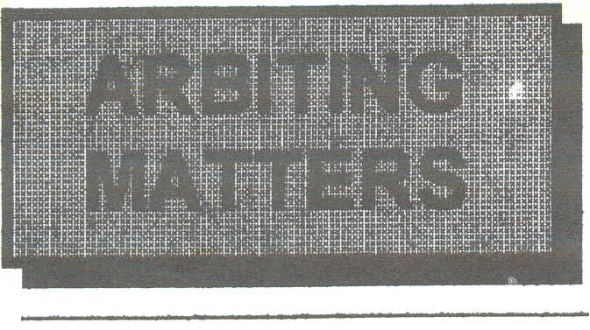

Number 10 Christmas 1996

The Newsletter of the Chess Arbiters' Association

EDITORIAL
The new Laws of Chess are with us! At least they are with some of us. Members of the CAA committee received copies towards the end of November. The British Chess Federation promises to distribute them to all known arbiters as soon as possible. If you haven't got yours by early January, then give the BCF Office a ring.
Although they do not come into effect until July I know many of you will be curious. If you really cannot wait, then send me four first class stamps to cover photocopying and postage and I will supply. I shall be at the Hastings Congress from 27th December.
To whet your appetite John Robinson gives the background in the first article in this issue of ARBITING MATTERS.
Thanks to all those of you who have submitted copy for AM10. In addition to John's article we have excellent meaty stuff from Neville Belinfante, John Tumock and Roger Edwards extolling the virtues or otherwise of no less than three systems of pairings.
For the last two years our President has been threatening to retire. This year I really do believe he means it. If Eric does step down at our 1997 AGM then I think he can be delighted with the healthy state of British (I hope I can use this term, for the CAA has always attempted to be more than an English body) arbiting.
Experienced arbiters are experimenting with different systems of pairing and we are benefiting from their feedback. We are at least investigating what computers have to offer and I understand that our stock has risen within FIDE due to the input we have made to the new Laws. I hope our British players realise our dedication and desire to provide a professional service, which is generally achieved in all but the remuneration aspect.
Please keep supplying me with copy. Let me have news, gossip, incidents, newspaper and magazine references to arbiting as well as your own original articles. Supplying on 3½“ disk is a blessing (Thanks John R). Microsoft Write format is just one I can readily import.
A Happy Christmas!

THE NEW LAWS
or "Straight from GG's Mouth"
by John Robinson

Six days before the 32nd FIDE Olympiad, Bob Wade was forced to pull out due to indifferent health. His place as an arbiter was taken by our own John Robinson and he joined Stewart Reuben (Senior Arbiter) and David Wallace at Yerevan on September 13th.
During the second week the Olympiad ran alongside the 67th FIDE Congress. John was invited to go along to meetings of the Rules Committee where the draft, first prepared by David Welch in August 1995 and much amended since first published in Paris in 1995 was to be discussed in the light of comments from (rather less than) the 127 nations playing next door, before being presented to the Central Committee and formally approved by the General Assembly.
Members of the CM will be among the first to receive copies of the new Laws which are to come into effect on 1st July 1997. John has provided the following article on the final stages of their path into the world, begun by Stewart Reuben and David Welch well over a year ago.
John writes,
When I first travelled abroad (in 1960) under an exchange scheme spending four weeks in a German steelworks, my first reaction was not about the differences in approach between Germany and the UK to day to day metallurgical problems, but in the observatlon of German mores. I soon learned that it was done to shake hands with absolutely everybody on the first meeting of each and every day. I was reminded of this at Yerevan. Armenians and Germans are at one in the matter of a daily greeting. After a week at the Olympiad, I had found myself wafted like Koko in the Mikado 'by a set of curious chances' - Into the post of minutes secretary of the FIDE Rules Committee (akin to being appointed Lord High Executioner after flirting with the Laws of Chess?).
We soon got round to consideration of the draft for Article 7: (now 12) The conduct of the players, which read '7.1 High standards of etiquette are expected of the players. Players are expected to shake hands at the beginning of the game.' "What is this word eatikwet ?" enquired the Danish delegate. The temptation to refer to a cocking of the little finger when capturing a piece was resisted, and various Anglo-Saxon explanations given.
Our definition unexpectedly convinced the majority that the second sentence of 7.1 was tautological, and a blue pencil was duly applied this and to '7.2 A player should try to arrive at the chessboard before the scheduled start of the session', A pity that. I had been rather pleased to see it in the draft. It also transpired that the Russians had been rather pleased with the reference to shaking hands, and on the following day the matter was raised again, with the suggestion that unless this clause was restored in its full glory, an amendment would be put to the FIDE General Assembly, which body would be expected formally to approve our deliberations in much the same manner as the Queen assents to Acts of Par1iament back in UK. The threat was not implemented.
There were two points the Rules Committee found especially difficult. The first was in the attempt to define how a game might be drawn in the absence of stalemate or mutual agreement. The draft offered the alternative of a short list (king v king and knight etc.) or the blanket definition that the game is drawn when a position is reached from which a checkmate cannot occur by any possible series of legal moves. Many delegates wanted the list extending to include examples of blocked pawn positions, but others insisted that it is impossible to quote a completely exhaustive list, and that even the draft list, substantially the current Article 10.4, represents a venture onto a very slippery slope.
After a number of inconclusive votes on this issue, a special sub-committee was set up to draft new recommendations. They came down in favour of the latter viewpoint, but made the suggestion that a completely new Article "The Drawn Game" should be created, which also required some amendment to the numbering of other articles, Their ideas were accepted by the full committee the following day, (creating a minefield in that dozens of cross references needed to be amended).
Towards the end of the session we stalled again as a result of the 'new' concept that a move could be 'made' on the board, but 'completed' only when the clock is pressed. Personally I had assumed this to be the current position, but it seems that the definition currently applies only to the last move before a time control, in all other cases the move is complete when the hand quits the piece. 'What is to happen if a move not completed in the new sense receives a reply?" asked a delegate, who might just as well have lobbed a grenade on to the table.
The situation was resolved in the final session with minor changes in wording which hardly seem to face this question. It is of course important that the clock is pressed the appropriate number of times when playing in, for example, the Fischer mode, but for manual clocks it does not seem to me to be a very serious issue.
The big bugbear, which last Spring threatened to place players on a par with Trappist monks for the duration of a game, had been dropped from the draft before we began our meetings and the suggestion that arbiters should no longer call a flag-fall had also been abandoned.
However the CAA certainly didn't get its way on everything. Our view that the Preface is too long and includes matter better left to Article 13: The role of the Arbiter, was universally rejected and in spite of reservations expressed at Peterborough on April 20th, it will no longer be possible to lose on time with an unsound claim of a draw by repetition. (You will just have to learn how to reduce the time available from 40 seconds to 20 seconds on that battered mechanical clock Richard!) On the whole though I was full of admiration for the way Guert Gijssen (GG), the Chairman of the Rules Committee, handled the exercise. He was scrupulously fair, receptive of all viewpoints even when expressed in stilted versions of what is after an his second language. I did manage to teach him one thing (that fysical is spelt with a ph!).
He realised only too well that his proposal on day one that the scheduled two days for discussion be extended to three, Inevitably invoked Parkinson's Law. The extra day's discussion was certainly valuable, but the proof reading in the hours before our proposals were put before the Central Committee was abominably rushed and I would not be in the least surprised to hear of errors.
Later, when the re-elected President of FIDE Kirsan Ilyumzhinov, formally approved our efforts (he preferred English to the Norman French used by Elizabeth II when giving the Royal Assent) I personally felt that that whole exercise had been a vindication of our efforts over the last two years. Several members of the CAA will recognise their own wording here and there. For anyone who disagrees there is always 1998, but I suspect that there will be no more major changes in the Laws for some time.

THE CROUCH SYSTEM FOR A CLUB RAPIDPLAY TOURNAMENT

by Neville Belinfante

INTRODUCTION
Yeovil Chess Club holds a six-round Rapidplay Tournament every year. In September 1995 I decided to run it using the Crouch Pairing System instead of the usual Seeded or Random Swiss.
The Crouch System, which Colin Crouch described in ARBITING MATTERS 2 and 3, dispenses with the concept of pairing players within distinct score groups. Instead it treats each pairing individually by taking the highest graded player with the highest score and pairs him or her against the strongest opponent based on a simple

formula including score, grade and due colour. This means that in general strong players meet more strong players, and medium strength players mainly play medium strength players unless they are near the lead, in which case they play strong players.
I tried the Crouch System partly to see how it would work and also to avoid things I dislike in other systems. The Seeded Swiss system is biased against players just below the median (this is well documented). Also, as the games between top players are delayed to later rounds, important games may not take place.

For instance if the top three players are strong enough to beat everyone else in the tournament, unless all three play the other two, there cannot be a fair result. Accelerated and Random swisses avoid mismatches in Round 1 but these lead to mismatches in later rounds as some medium/strong players can get 0/2 and then play players a lot weaker than themselves and have an easy ride to 3/5 or 4/6.The tournament results table shows there were no real surprises. "Jumping Jack" Rudd was expected to win, being graded 40 points ahead everyone else, but he did it against the six strongest opponents in the tournament, rather than starting with rabbits (like me in 1993). His weakest opponent was player 7 in the last round. His winning margin was two points, as those around him played each other more often. Normally one or two players get 5/6 behind Jack.

RESULTS
Posn | PIN | Name | Grade | Results (Numbers are of opponent’s PINs) |  |  |  |  |  | Score | GP
I | 1 | J Rudd | 197j | w5+ | B4+ | w2+ | b3+ | w6+ | b7+ | 6 | 207
2 | 6 | D Freeman | 137 | w2- | B10+ | Wl3+ | B4+ | B1- | W9+ | 4 | 150
3= | 2 | C Winch | 156 | b6+ | W3= | b1- | B11+ | W5- | W12+ | 3½ | 151
 | 3 | J Fewkcs | 152 | w7- | b2= | W11+ | W1-. | b14+ | b5- | 3½ | 149
 | 5 | l. Cutting | 140 | bl- | B11- | w7+ | wl2+ | b2+ | W3+ | 3½ | 148  Table cannot be read in my copy – your guess is as good as mine
6= | 4 | P Chapman | 152 | o8 | wl- | b<)- | w6. | 018. | o13l | 3 | 132
 | 11 | M Bumell | 100 | bl21 | w" | h1- | w2- | hlO- | wHt | 3 | 118
 | 9 | A Ruston | 110e | wlO- | h15. | w4 | h131 | w7 | hh. | 3 | 114
 | 11 | N Mill, | 86 | 0171 | w8' | 06- | w,>. | hlol | w4- | 3 | 106
 | 10 | R Knight | 105j | 001 | w6. | 08- | w14- | will | bl<)' | 3 | 100
 | 12 | D Mason | 98 | wll- | b201 | wl" | b<- | w17+ | b2- | 3 | 99
 | 14 | K Shcdock | 85 | wl81 | b7- | wl61 | hlOI | w- | bll- | 3 | 95
 | 15 | T Chapman | 82 | hlol | "I). | h12. | w17. | ,,201 | hl81 | 3 | 81
 | 17 | R Freke | 80 | w1.1- | hl61 | wl<). | 0151 | b12- | w201 | 3 | 71
15 | 7 | R Pinder | 121 | b.1' | wl41 | b5- | wl8 | ho | wl- | 2 ½ | 115
 | 18 | M Girling | 73 | h 14. | bioI | W201 | h7 | ,,4- | w15- | 2 ½ | 77
17 | 20 | R Heaton | 50 | h16+ | w12- | 018- | wlOI | hi <- | b17- | 2 | 64
18 | 8 | S Gray | 118 | w4'" | h13. | wlOI |  |  |  | 1'/, | 114
20 | 19 | AJ Alsop | 70 | w15- | w18- | 017. | h20- | w1.1- | wlO- | 1 | 46
20 | 16 | IA Alsop | 80je | w20. | w17. | b14- | --- | --- |  | 0 | 22

The player who had the toughest time was Phil Chapman (seed 4) who kept getting tough opposition until the last two rounds, even though he had a poor start. The "rabbits" that he played at the end had scores of 2½/4 and 3/5 and had both beaten, or drawn with, stronger opposition.
PAIRINGS
Doing the pairings for each round took about the same time as would be expected for a Seeded Swiss. First I calculated a "Crouch Score" (for want of a better name) for each player. This was defined as Grade minus twenty per point conceded in the tournament. The cards were then sorted into score and grade order, with separate piles for white and black seekers. It was thus very easy to pick out the highest graded in the top score group. His opponent was then the player with the highest Crouch Score, taking an extra penalty of 20 if a colour transfer is involved.
This is an easy process, until the number of players left equals about twice rounds played, when I found there was one person who had already played all those remaining. The way round this was to treat the last boards in reverse order; i.e. find the lowest graded on the lowest score and pair him against the weakest possible opposition.
CONCLUSIONS
The comments of the players afterwards was generally favourable. There was one person who thought it was all unnecessarily complicated and could not see the benefits. Another criticism made was that it is a meaningless tournament if half the competitors finish on exactly 3/6. I have some sympathies with this and can see that there are likely to be more need of tie-breaks if grading prizes are to be awarded.
I thought the tournament went well and will use the Crouch System again whenever I get the chance.

SURPRISE! SURPRISE!

From the July 1996 FIDE Rating List
Zone 3.1 (IRQ)
1 Hussain, HA f IRQ 2435
2 Hussain, NA f IRQ 2400

Yes, I know it's a common name in Iraq, but out of 61 players listed under Iraq they just happen to be the only two players called Hussain.

OOPS!!

After, as he says, "chuckling" his way through the various spellings of CULCHETH in AM9, Ewart Smith must have been highly amused to find your Editor had mis-spelled his village. "Old Basing" came out as "Old Baring".
If there are any inaccuracies in your address as printed on the envelope AM10 came in, please let me know. !
Incidentally I now have another for my collection :- CULHETH. I
That makes fourteen !

THE DUBOV EXPERIENCE by John Turnock

I hadn't heard of the Dubov pairing system until I read the article by the Editor entitled "Russian Roulette?" in ARBITING MATTERS 9. I was immediately interested because the aim of the system - "to balance the strength of opposition met by players on the same score level" is exactly in line with the comments of mine which were published two years ago in ARBITING MATTERS 3
It was not long before I gained practical experience of using the Dubov system. It was decided that the single week open events at the British Championships at Nottingham would use Dubov, and it fell to John Robinson and I to implement this. Both these tournaments had grading ranges of well over 100 points and so provided much scope for wide differences in ARO (Average Rating of Opponents). The first week tournament contained only 22 players so that in the later rounds the number of pairing options was in any case quite small. The second week tournament had 40 players. Since Nottingham I have employed the Dubov system in one other event - the Open section of the Tyne & Wear Congress which again had 22 players. All the above events were of five rounds duration.
It is difficult to assess the success (or lack of it) of the Dubov system because one can never know how the same tournament would have turned out if the Seeded Swiss had been used. There are some encouraging signs in that the Week 1 Open at Nottingham was won by the player who had faced the strongest opposition and only one player who finished in the top half had an ARO lower than the average rating of the tournament. At the Tyne & Wear, all players who finished in the bottom half of the tournament had an ARO lower than the average rating.
Week 2 Open results show less of a pattern, but this may be due to some surprisingly modest performances by high grade players - with one round to go we had a 205 on 2½/4, a 188 on 2/4 and a 177 on 1/4! For comparison I analysed the Under 125 Championship at Nottingham (paired by computer on Seeded Swiss principles) and found that the player who had the strongest opposition finished 33rd ! On evidence so far, I am prepared to believe that Dubov does more to even out the strength of opposition faced than the Seeded Swiss but that the extent to which it achieves this can be marginal.
Does Dubov have drawbacks? For the controller there is the chore of having to calculate the AROs but this can be done in the time available after the round has started. The actual pairing is probably less time consuming than the Seeded Swiss. There are however some rules which need to be defined more clearly and some situations not covered by the rules. The Editor stated in his article "It is not clear whether the upfloater is placed as the last player in the WS/BS pile or in the appropriate position, that is by ARO of WS and rating of BS," I simply took it as the latter, as it was in the spirit of the system. Dubov is in any case rather casual about floats as the same player can upfloat three times in a five round tournament.

Two other problems arose - how do you deal with competitors who have taken a bye in Round 1 and have no ARO? Also I found at Tyne & Wear a situation where if I promoted the correct player to a higher group, the two remaining players could not be paired. The rules suggest that both these players should be paired with players from below them rather than to choose a different promoted player and avoid the extra floats. I chose a different promoted player, but I may be guilty of introducing Seeded Swiss thinking into Dubov pairings.
One interesting paradox about Dubov is that because you can only compensate one side of the draw (the White seekers) sometimes the Black seekers can actually get a more unfair pairing than would have occurred in the Seeded Swiss. In the first round of the Tyne & Wear on Board 1 White, graded 161, defeated the highest rated player in the tournament, graded 209. The Winner turned out to be the lowest-rated Black seeker on 1 point and therefore in Round 2 played the White seeker with the highest ARO, who happened to have a grade of 206! Our hero was at last compensated for his efforts in Round 3 with an opponent graded 138 and I am pleased to relate that he went on to finish equal second in the tournament! No competitor has complained about the use of the Dubov system, in fact at Nottingham in Week 1 I don't think that anybody noticed! In Week 2 some competitors did find that some of the pairings were a trifle unusual, but were interested in the reasons for them. At the Tyne & Wear I posted a photocopy of the Editor's article together with a message that Dubov pairings would be used. Again, the only comments I got were motivated by interest rather than by opposition.
The Dubov system is certainly worthy of further experimentation and more evidence is needed particularly from longer tournaments of 9 or 11 rounds. I like it because its heart is in the right place - it has a rationale with which I have sympathy.
I cannot say the same for the Seeded Swiss. I follow the seeded rules as an intellectual exercise (almost as good as playing chess!) but I do not see why the principle of top half v bottom half necessarily produces a fair outcome.

And now for a little light relief...
Are you aware that in the grading Master List there are players called "Wildgoose" and "Chase"? What Arbiter could resist that ? Thanks to Neville Belinfante who also sends Gay-Fellows (Frome Major, Round 4, Board 2).
A sweet pairing from the 1996 British Championship :- Tait and Lyle. What a pity Tait had black!
PROMOTION?
My thanks to John Dunleavy for sending this snippet from Jon Speelman's column in The Observer a few months ago. Jon said he witnessed "a most interesting dispute".

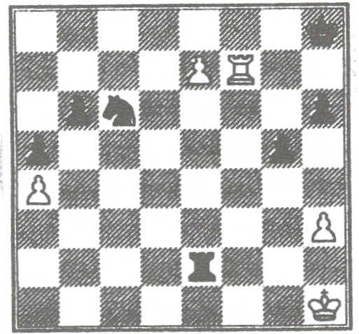
He continued. "White has the advantage since after 1.Rf8+ and 2.e8=Q he wilt win the exchange. But in the confusion. Zvjaginsev attempted to promote first. He did so by picking up his queen and placing it on e8. But he didn't touch the e-pawn with either his hand or the queen. Was this a case of touch move - the rule whereby one must move a piece if one touches it ?
The players stopped the clocks and after a few minutes the arbiter ruled "No". Zvjaginsev played 1.Rf8+ and finally won on time in a drawn position. To the Immense credit of both players, there were absolutely no histrionics: I can think of many who would have created considerable decibelage in these circumstances '" (So can I. It would be enough to make my friend, the "unluckiest Russian in England" explode his plastic bag - Editor)
Your views on this Incident

ANOTHER DRAW CLAIM

Here is a situation from a league game. The above diagram shows the position after Black's 33rd move (a2). The "no arbiter present" rules apply.

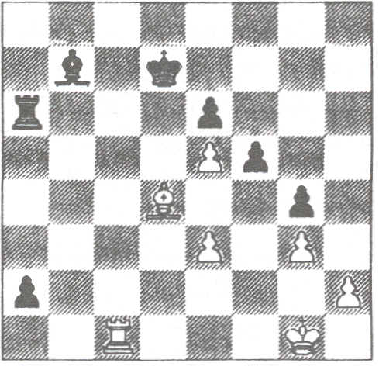
34.Kf2 Be4 35.Ke1 Bb1 (time control; clocks back 15 minutes) 36.Rd1 Kc6 37.Ba1 Kb5 38.Ke2 Rc6 39.Rd2 Kc5 40.Bd4+ Kc4 41.Ba1 Kb5 42.Rb2+ Kc5 43.Rd2 Kb6 44.Rb2+ Kc7 45.Rd2 Bc2 46.Bd4 Rc4 47.Ba1 Bb3 48.Rb2? Rb4? (48...Rc1 49.Rxb3 Rxa1 50.Rxa3 Rh1) 49.Rd2 Bd5? (49...Bc4+ 50.Kf2 Rb1) 50.Rc2+ Kd7 51.Kd2 Rb1 52. Rc1 Here White stopped the clocks and claimed a draw on the grounds that his opponent was not trying to win by normal means.

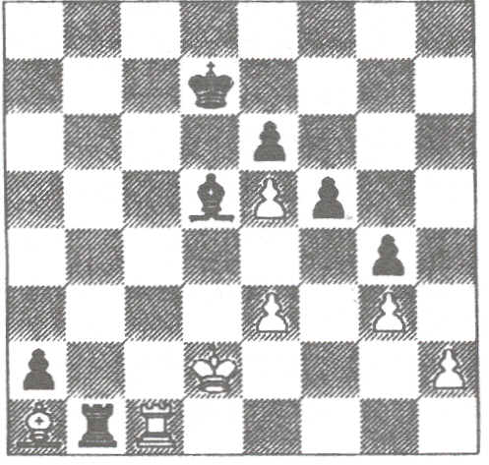Once again, comments please

SEEDED PAIRINGS FIGHT BACK
by Roger Edwards

Recently I have read and heard a lot about the unfairness of the Seeded Swiss pairing system. About how it discriminates against players at the top of the bottom half. However in my experience it very rarely does. In theory it may do, but practice is a lot different from theory.
In Open tournaments, there does seem to be a distinct bias against those in the bottom half. I would suggest this is usually because there is such a wide range of grades and games are much more likely to go with seeding. In a lot of the congresses I am involved with, many of the players in the bottom half of Open sections
. would be eligible to play in other sections. The fact that they choose to enter the Open means that they hope the draw does discriminate against them and lets them have the odd game against players such as Arkell, Hebden and Howell. When else would they get the chance?
In grading limited tournaments, the difference between players' grades is much less and therefore there is more chance of the result not going with seeding. In a recent section I controlled with 22 players graded 140 to 169, only three of the top eleven seeds won in Round 1. In the last round my top three pairings were :- 12-14, 11-17 and 19-15. I also had a pairing of 1-2, but this was on board 8. I would guess that every controller has at one time or another been in charge of a section where the top players all lost in the opening round. Who has been disadvantaged in those instances?
The great advantage of the Seeded Swiss pairings is that the large proportion of regular congress players now know the basic rules and can see that they have been applied fairly. When using a random system a player who has a series of tough pairings could become convinced the controller is biased against him as I found out many years ago.
I was controlling the local league's Swiss event about twenty years ago using random pairings (because I didn't know any other system) when I was accused of deliberately giving a player tough games. He thought I was doing it intentionally just because he had beaten me in a league game a couple of weeks before. As if I would do something as obvious as that!
When you get down to the bottom section in congresses then the results always seem to bear no relationship whatsoever to seeding and in most cases, you might just as well have done a random set of pairings anyway. The problem with Minors tends to be what to do with the ungraded players. This has become less of a problem in recent years with more and more players appearing on the grading database (We must all thank the National Grading Offlcer for that - whoever he happens to be Editor) so that some information is known about them.
A far bigger problem I have found is with half-point byes in the first round. You almost invariably get more HPBs than you get genuine half-points and so you finish up with HPBs playing each other. Then if one fails to show you get someone on one and a half from two games without actually having played a game. Yet nobody I know has come up with a remedy for this situation. Perhaps if two byes have to play each other, then the pairing should be broken and both players floated, but this breaches one of the basic principles of Swiss pairings.
The conclusion I have come to is that seeded pairings will discriminate against some players in Opens, and usually the same players in event after event, but as Opens only provide 10% of entries (on a good day) the advantages outweigh the disadvantages for the majority of cases. There is no totally fair system other than APAs, but the BCF seeding system is better than any I know, especially the FIDE system. In the Major Open at the British Championship we got the slightly ludicrous pairing of 2-115 in the second round of a 115-player event (using a computerised FIDE pairing system). Even APAs are only totally fair if you have an odd number of players so that everybody has an equal number of whites and blacks (or make it a double-round event).

CHESS TIE-BREAKS by Leonard Morrell
In ARBITING MATTERS 9 the question is asked, "What do you think about chess tie-breaks ?
They are unfortunate especially in a championship situation. The important point when having to use a tie-.break is to find the method which is fair. The current system in operation in my opinion misses out certain factors.
The following procedure may be fairer.
In the first instance see if the players have played each other.

If they have not, or if a winner can not be established, discount anyone who had a half-point bye. I consider points gained in playing a round more valuable than points obtained by byes, although discounting a one point bye which the player has not requested may be unfair.

For each of the contenders, calculate the average grade of the opponents. The one with the highest being deemed the winner because they have had a more difficult tournament. The one main drawback with this is where there are ungraded players but in a main championship it should work.
If a winner cannot be found by the above methods then I would go for more traditional means.
Sum of opponents' scores.
Sonnebom-Berger

Lastly comes Sum-of-Progressive Scores which takes into account neither the strengths nor performance of the opponents in the event.
Glad to see I have a supporter here - Editor

SNOOKERED

sent by a member who found it amongst his papers after the BCF AGM at Warrington in September last

Aim : To brighten up the game and replace some of the archaic terminology with concepts the wider public can identify with and to smarten up the dowdy image that players currently project.
Replace the following terms :
1 Laws by Rules.
2 Board by Table.
3 White by Colours (one pawn and one piece in each of the six colours Yellow, Green, Brown, Blue, Pink plus White and perhaps Orange (with an eye to sponsorship)
4 Black by Reds (the fifteen reds with which Joe Public is familiar plus one to make up the set).
5 Move by Shot (except for the first shot which would of course be called Break).
6 Captures by Pots.
7 Mate by Clearance.
8 Stalemate by Snooker.
The change of colours will get rid of the present racist tone and make the game much more suitable for TV. The much brighter image will help to broaden the appeal of the game to women and children in particular.
Another change we must carry through is to stop the players from touching the pieces altogether; this is the job of the Referee (The term "Arbiter" is much too old-fashioned).
There must only ever be one player at the table at a time and he must have space to walk right round it while considering his shot (this will make a much better visual impact and neither player nor spectators will be distracted by the opponent).
The reference to the recording of shots in writing is absurd. We live in an electronic age and this must be replaced by Video or some other electronic means, preferably the former to facilitate playbacks.
Lastly, we really must take dramatic steps to move the game upmarket. There must be a mandatory dress code: DJ and white gloves for the Referee and for the players either snazzy waistcoats or possibly coloured pyjamas like those worn by cricketers in Rapldplay matches. The latter approach could lead to the generation of considerable additional revenues through the sale of home and away strips.
Not quite so urgent but worth thought is the addition of "cushions" to the table so that shots by the pieces which move diagonally can be bounced off them.

THE THINGS THEY SAY
Headline in The Daily Telegraph (Sports section) on 12th August

"Knights move for maiden Test century checkmates Pakistan"

