[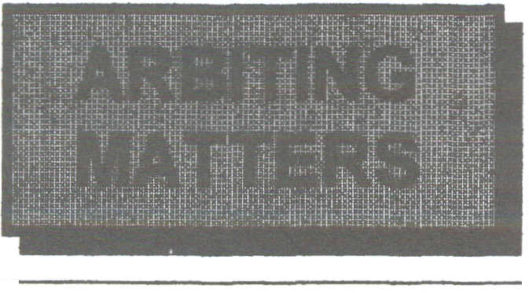
Number 11 Spring 1997

The Newsletter of the Chess Arbiters' Association

CHAIRMAN Eric Croker, 3 Berridge Green, Edgware, Middlesex, HAS 6EQ 0181-9523129
SECRETARY Geoff Jones, 27 Clarke Street, Leigb, Lancashire, WN7 400 01942.604262
TREASURER David Eustace, 3 Yarrow Cresc., North Beckton, London, E6 4UH 0171-4766324
CHIEF ARBITER David Welch, 63 Croxteth Road, Toxteth, Liverpool, L8 3SF 0151-7331866
NEWSLEITER Richard Fumess, 9 Cranwell Ave, Culcheth, Cheshire, WA3 4JX 01925-762654

EDITORIAL
Around the end of January all members of the CAA should have received their copy of the new Laws of Chess. If you did not, then contact the BCF Office to request one.
I think we can be well satisfied with the eventual outcome and also with our significant contribution to the content. I leave you to spot the spelling error.
I have just two quibbles. One concerns keeping score. I am aware that over the years we have observed the law requiring players to record their moves one by one more closely than much (most?) of the rest of the world. We have not got our way on this point and the new law is weaker and now contradicts itself.
Although law 8.1 still says, "each player is required to record his moves and those of his opponent, move after move", the next paragraph says, "A player may reply to his opponent's move before recording it, if he so wishes." So players are required to record moves one by one but need not do so if they do not wish. Jabberwocky!

Apart from this obvious contradiction I think it will be more difficult for an Arbiter to monitor the recording of moves especially if he is watching more than one game.
My second quibble is the alteration to the time penalty when a claim for a draw by repetition is not upheld. Again I believe the Arbiter's task has been made more difficult. We will not only have to do some arithmetic but must adjust both clocks instead of just one.
I think an illegal move, such as the one by Malaniuk against Bronstein (Hastings 1995), needs a stronger penalty. An illegal move in time pressure which gives free time to think whilst the Arbiter is summoned should be met by a direct penalty (the offender's remaining time reduced) rather than by an indirect penalty (a time bonus to the opponent). If that causes the offender to lose on time, so be it! Why should the offender benefit from his misdemeanour ?

Despite these few criticisms I am pleased with the result.

AFTER TOBACCO - ATTACK by Steve Boniface

Ever failed to receive a result after a game? No result slip, no score marked upon it, or the enigmatic contrary results on a pair of scoresheets. Do not despair. Using the ATTACK acronym you can improve your chances of avoiding the authorised but brutal double-loss result.
A is for the ANALYSIS ROOM. That’s where you'll find your missing players and/or the absent scoresheets. If not, try :

T is for TEA ROOM ( or TAP HOUSE if you have a well-endowed event). This is where your clients will have retired to after analysis.
T stands for the TABLE where the competitors were playing. They may well have left the scoresheet there, being simply careless or desperate to get away for food, drink or other vital entertainment (or just plain unhelpful it's the arbiters job to find out the result - RAF)
A suggests that you try ADJACENT boards, including the players thereat. They may well have witnessed the end of the next-door game. Of course to find them you may have to re-visit the analysis room and the tap house again... By now if you still have no evidence (despite feeling happier because of further trips to the bar) so proceed to the next stage of the search.

C for CLUB MATES. Check out the team members of both players who may still be at their boards, in the analysis room, in the bar ... Having followed this route several times now, you may well feel justified in executing a more drastic plan. So now proceed to :
K for KIDNAPPING. Happily this does not involve incarcerating close relatives and threatening illegal actions. Rather it is a direct way of ensuring that the players see you again at the next opportunity. Did you notice when checking the TABLE that a coat was hanging on the back of one of the player's chairs? Take it to the controllers' table and leave a note on the board explaining the price of regaining the missing clothing. Soon an embarrassed player will reappear and as well as tendering the missing result may well offer you another visit to the TEA ROOM.
So. Ladies and Gentlemen of the Jury, that is the case for the defence. And I know it does work, because I was that controller.

THE THINGS THEY SAY

"Liverpool's chess-like approach in midfield hasn't been working in recent matches."
Whatever that means!

JAMBOREE PAIRINGS by Len Morrell

Having organised Jamborees for five years one problem has been sorting out the pairings, especially in a three round tournament. The main problems were colour coding for each player to play 2W/1 B or 2B/1W. This problem mainly occurred when there was an odd number of teams playing.
When sorting out the pairings " as most organisers do, looked at a pairing chart such as the Hutton Pairing System, used that for the first round and then tried to solve the second and third rounds by a bit of juggling.
I came to the conclusion that a new set of pairings is required which looks at three rounds rather than just at one. The following examples are based on a three-round jamboree with twelve players per team and up to eleven teams taking part.

In some rounds a team may have more than half its players having white or black, but over the three rounds it works out equal with eighteen games played with each colour.
The calculation of the pairings is not easy to explain but the method can be adapted for more or less players in a team and for more rounds, where it becomes more difficult sorting out the other way round by round.
If anyone wishes to try my method for a combination not covered in the following examples, I would be pleased to supply pairings.

(Perhaps someone will do an evaluation, comparing Len's pairings with the Huttton Pairings and taking into account colour balance, number of games against each team etc.)

Len's address: 2 Fairham Close, Ruddington, Notts, NG11 6BE and telephone: ()115-9844 356

6 TEAMS
Board N' | Round 1 |  |  |  |  |  | Round 2 |  |  |  |  |  |  | Round 3
1 | A-E | D-B | F-C |  |  |  | B-A |  |  | D-F | E-C |  |  | A-D |  |  | C-B | F-E
2 | B.A | D-F | E-C |  |  |  | A.D |  |  | C.B | F-E |  |  | A-F |  |  | B-E | D.C
3 | A-D | C-B | F-E |  |  |  | A-F |  |  | B-E | D-C |  |  | C-A |  |  | E-D | F-B
4 | A-F | B-E | C-D |  |  |  | C-A |  |  | E-D | F-B |  |  | A-E |  |  | D-B | F-C
5 | C-A | E-D | F-B |  |  |  | A-E |  |  | D-B | F-C |  |  | B-A |  |  | D-F | E-C
6 | B-D | C-F | E-A |  |  |  | A-B |  |  | C-E | F-D |  |  | B-C |  |  | D-A | E-F
7 | A-B | C-E | F-D |  |  |  | B-C |  |  | DA | E-F |  |  | C-D |  |  | E-B | F-A
8 | B-C | D-A | E-F |  |  |  | C-D |  |  | E-B | F-A |  |  | A-C |  |  | B-F | D-E
9 | C-D | E-B | F-A |  |  |  | A-C |  |  | B-F | D-E |  |  | B-D |  |  | C-F | E-A
10 | A-C | B-F | D-E |  |  |  | B-D |  |  | C-F | E-A |  |  | A-B |  |  | C-E | F-D
11 | A-E | D-B | F-C |  |  |  | B-A |  |  | D-F | E-C, |  |  | A-D |  |  | C-B | F-E
12 | B-C | D-A | E-F |  |  |  | C-D |  |  | E-B | F-A |  |  | A-C |  |  | B-F | D-E
7 TEAMS
Board N' |  |  |  |  | Round 1 |  |  |  |  |  |  | Round 2 |  |  |  |  |  |  | Round 3
1 |  |  |  | A-G |  | F-B |  | C-E |  |  |  | B-A | G-C |  | D-F |  |  |  | A-D |  | C-B | E-G
2 |  |  |  | A-C |  | D-G |  | F-E | B2-D1 |  |  | C-F | E-D |  | G-B | A2-E1 |  |  | B-E |  | D-C | F-A | G2-F1
3 |  |  |  | B-A |  | G-C |  | D-F |  |  |  | A-D | C-B |  | E.G |  |  |  | A.G |  | F-B | C.E
4 |  |  |  | C-F |  | E.D |  | G-B | A4.E3 |  |  | B-E | D-C |  | F.A | G4-F3 |  |  | A-C |  | D-G | F-E | B4-D3
5 |  |  |  | A.D |  | C-B |  | E.G |  |  |  | A-G | F-B |  | C-E |  |  |  | B.A |  | G-C | D-F
6 |  |  |  | B-E |  | D-C |  | F-A | G6-F5 |  |  | A-C | D-G |  | F-E | B6-D5 |  |  | C-F |  | E-D | G-B | A6-E5
7 |  |  |  | A.F |  | C-D |  | E.B |  |  |  | B-G | D-E |  | F-C |  |  |  | C-A |  | E-F | G-D
B |  |  |  | B-C |  | D.A |  | G-E | F8-G7 |  |  | A-B | C-G |  | F-D | E8-A7 |  |  | B.F |  | E-C | G-A | D8-B7
9 |  |  |  | B-G |  | D-E |  | F-C |  |  |  | C-A | E-F |  | G-D |  |  |  | A-F |  | C-D | E.B
10 |  |  |  | A-B |  | C-G |  | F-D | E10-A9 |  |  | B-F | E-C |  | G-A | D10-B9 |  |  | B-C |  | D-A | G-E | F10.G9
11 |  |  |  | C-A |  | E-F |  | G-D |  |  |  | A-F | C-D |  | E-B |  |  |  | B-G |  | D-E | F-C
12 |  |  |  | B-F |  | E-C |  | G-A | D12-B11 B-C |  |  |  | D-A |  | G-E | F12-G11 A-B |  |  |  |  | C-G | F-D | E12-A11

8 TEAMS
Board N' | Round 1 |  |  |  | Round 2 |  |  |  | Round 3
1 | A-G | C-E | F.B | H-D | B-A | D.F | G-C | E-H | A-D | C=B | E-G | F-H
2 | B.A | D-F | G.C | E-H | A-G | C.E | F-B | H-D | B-E | D-C | F-A | H-G
3 | B-F | D-H | E-C | G-A | A.D | C.B | E-G | F.H | A-C | D-G | F-E | H-B
4 | B-E | D-C | F-A | H-G | A-H | C.F | E-D | G-B | B-D | C-H | E-A | G-F
5 | A.H | C.F | E-D | G-B | B-E | D-C | F.A | H-G | A.G | C-E | F-B | H-D
6 | A-C | D-G | F-E | H-B | B-D | C-H | E-A | G-F | B-C | D-A | G-E | H.F
7 | B-D | C-H | E-A | G-F | A-C | D-G | F-E | H-B | B-A | D-F | G-C | E-H
B | A-E | D-B | F-G | H-C | B-H | C-A | E-F | G-D | A-H | C-F | E-D | G-B
9 | A.D | C-B | E-G | F-H | A-E | D-B | F-G | H-C | B-H | C-A | E-F | G-D
10 | B.G | D-E | F-C | H-A | B.C | D-A | G.E | H-F | A-F | C-D | E-B | G-H
11 | A-F | C-D | E-B | G-H | B-G | D-E | F-C | H-A | A-B | C-G | F-D | H-E
12 | B-C | D-A | G-E | H-F | A-B | C-G | F-D | H-E | B-F | D-H | E-C | G-A
HASTINGS INTERNATIONAL CHESS CONGRESS
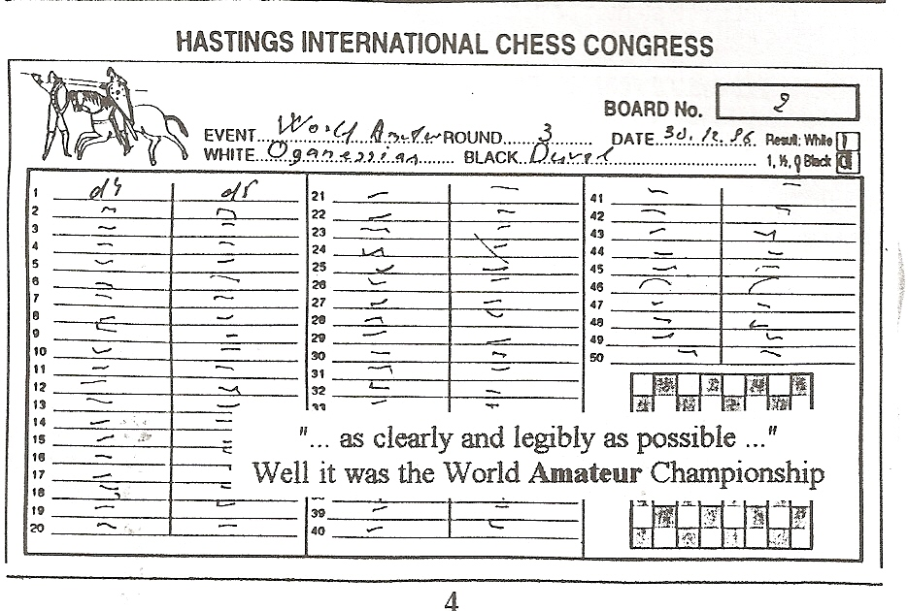
It was the W orId Amateur Championship ..
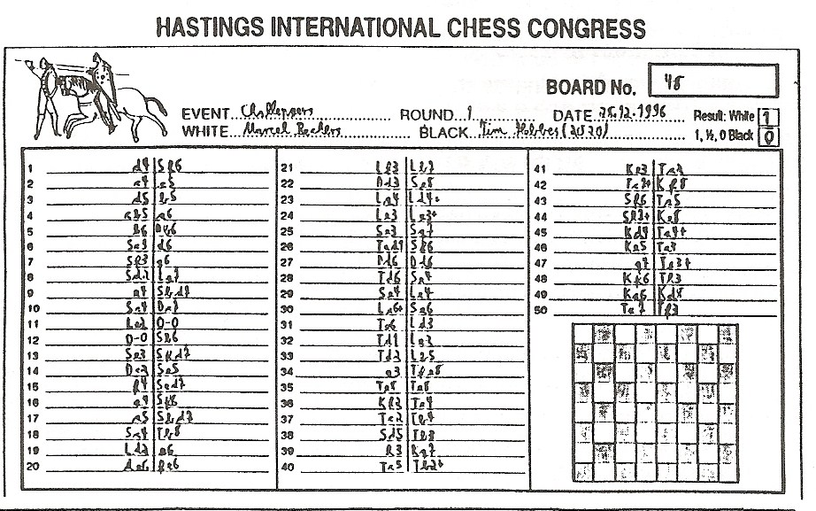
'

"FISCHING FOR NEW IDEAS? by Colin Axon

Having random - though "legal" - starting positions, the Fischerrandom variant (deviant ?) has been billed as a leveller of standards. In principle, by removing the use of opening theory, the person who understands how to co-ordinate their pieces best will win through,
Recently Grendel Chess Club in Bristol - a club with an excellent record of trying new ideas to attract new members - held their (the ?) first Fischerrandom tournament. Having to fit six rounds into one evening meant using blitz time controls (10 minutes for all moves). However it was never designed that it would be a serious tournament rather more a social gathering to play chess.
So what about these starting positions then? One example used on the night was (from a1 to h1) :- QRBKNBRN. Black's pieces mirrored White's.
A different position was used for each round. This was to prevent the better players "learning" too much strategy too quickly. A "legal" Fischerrandom start position requires three elements.

The Pawns must remain in front of the pieces
There shall be a Bishop on each colour of square
The King shall be positioned between the two Rooks
Additionally the black and white pieces are mirrored.

..When castling, the King and Rook end up on the same squares as for normal chess (either king or queenside). So for castling in the position given earlier, the Knight on e1 and the Bishop would have to have moved for kingside castling to be possible, but only the Bishop (on c 1) for queenside castling. Note that the Queen and the h1 Knight are not required to have moved.
The concept of king safety took on a whole new meaning. Often castling was simply not sensible, there being some rather bizarre pawn formations necessary to allow piece development.

This may sound tricky and as controller I expected all manner of problems and disputes, especially with players under extra pressure from such a short time limit. However there was only one! Two players of reasonable strength became confused as to which was kingside and which was queenside, but they sorted themselves out without requiring the controller.
I said Fischerrandom was a leveller. Well, the lowest-graded player (82) took this to heart and went through the field like a dose of salts to reach 3 1/2 /5. The final round pairings had the bottom seed drawn to play the top seed (219)!! The "bunny" did give the Heffalump a run - taking him to the endgame - but dropped a Pawn and then experience saw the top seed through to win the tournament.

Although only a relatively small sample and a short time limit, I would suggest that the results tended to back the equalisation idea. However perhaps a better claim might be that anyone's opponent who was say 50 grading points higher could definitely be considered fair game since, after twenty moves, most games look reasonably "normal". This was a tournament which also favoured the endgame fans, with one or two notable bookworms having a very hard time.

Everyone enjoyed the evening and there were calls for it to be repeated. I suspect it will become an annual event. If you think that you would like to hold a Fischerrandom and would like a copy of the thirty positions I had at my disposal, please don't hesitate to contact me.
Colin's new address is :- 20 Duchess Road, Clifton, Bristol, BS8 2LA (tel : 0117-9237756; fax: 0117-925 5624; Email: c.axon@bris.ac.uk)

During the last year or so, the following have been confirmed as BCF Arbiters.
January 1996 lan Campbell Merseyside Tyson Mordue Bristol Susan Howell Crawley Ewart Smith Basingstoke

June 1996 Chris Carter Bristol Barry Gale Wimbledon

November 1996 Neville Belinfante Wembley/Yeovil Geoff Brown Rotherha
Congratulations to them all.

Room 101
In AM7 (Autumn 1995) I invited members to make their suggestions. Only Neville Belinfante came back to me on this one and he suggests :

Blue Pens
He says the meaning of Red, Black and Green on Pairing Cards is obvious. Blue ink only leads to confusion.
I am sure one of our eminent arbiters would like to respond to that! - RAF

Overheard at the Stroud Rapidplay

SB (an anonymous arbiter)
"I can't find who is supposed to be giving me a lift back to Bristol. I think he's gone off in a huff."

NB (another anonymous arbiter) "That’s a strange vehicle to go off in !"

A CHILLING WHO DUN IT by??

Earlier this year I was officiating at an event in the Polar Region south of Watford and shortly before three in the afternoon I had in my possession no less than four adjournment envelopes.
10 points if you know what they are and another 10 points if you know what to do with them.
When the clock struck three I was left with one envelope but no players, so I did what I thought was the correct thing to do and I started one of the clocks, probably the correct one.
After some fifteen minutes I began to go walkies to the control desk and relate my predicament to my colleagues. The lady arbiter found my story amusing but had no wish to become involved on a number of grounds.
- Her four games were up and running with all players present.
- She didn't know what my players looked like either.
- It was too cold to go looking for lost chess-players.
- In 45 minutes time they might both be defaulted.
10 points if you can identify the lady arbiter.

My male compatriots, three of them, were either at lunch or otherwise engaged (ie. hiding). I ventured back into the arena hoping to conceal my dismay when all of a sudden my gast was flabbered, because there before my eyes were my two lost souls playing chess in the area reserved for analysis (and adjourned games).
I enquired, politely of course, why they were playing over here whilst I was waiting for them over there. The reply brought a tear to my eye. "You were very busy," they said, "so we agreed the position and the sealed move and continued the game."
These two considerate contestants had sat down at a board with the clock times set at 4.00 and by the time I had disturbed them had made seven moves each and the clock times were 4.19 and 4.07. Two minutes later I was having lunch in the Bar.
10 points for stating what I did before going to the Bar.
10 points for what you would have done.
For a further 30 points name each of the male arbiters present but not involved.
10 points for naming the writer of this anecdote.
10 points for naming the venue.
One hundred pints - sorry points on offer - but sadly no prize.

There are several clues in this story. Perhaps it would help if I made it clear that I was not the author - RAF

FORTY YEARS AGO CONFUSION IN THE BIG APPLE
by John Dunleavy

Whilst searching through some old magazines I came across the following report and a letter which it prompted.
CHESS (September 1957)
A JUNGLE OF CLAIMS
A match between Samuel Reshevsky and Donald Byrne, both inveterate "time-rushers", in New York, has produced the most fantastic series of claims and disputes in chess history. In the first game, Byrne overstepped his time but Reshevsky, who had only a few seconds left himself, did not notice. Byrne proposed a draw; Reshevsky accepted, then noticed Byrne's flag was down and claimed a win. The referee Hans Kmoch disallowed the claim saying the game had been over - agreed drawn - before it was made.

In the second game, both flags fell. Reshevsky noticed Byrne's was down and claimed the game. Kmoch said no, it is Byrne to move, and only the player whose turn it is to move can claim. Whereupon Byrne claimed and was awarded the game! !
Reshevsky lodged appeals against both decisions and the committee upheld the decision in the first game but decided the second should be considered drawn.
Apparently in protest against these decisions, Byrne did not turn up for the fourth game; his clock ran out and Reshevsky was declared the winner. Negotiations went on behind the scenes and the committee decided that Byrne should not be penalised but that the game should be played later. Now Kmoch threw up the job of referee! He has been replaced by Kenneth Harkness.
The three games finished have been drawn. The match is for the best of ten.
CHESS (October 1957) LETTER
Surely the referee in the Byrne v Reshevsky match was only trying to make a mock (!) of Reshevsky when he ruled that only the player who has the move can claim a win on time? Otherwise anyone caught short can just sit it out to the end of the tournament - and he has a draw! I've always understood the game was finished when a flag fell (and often it is a spectator who points it out) so the first decision was also wrong. The game was over, won by Reshevsky, before he agreed to a draw. Byrne thus had two half-points undeservedly and sportingly gave them back in the fourth game - only to be thwarted by the committee. Presumably Sammy is so immensely popular that everyone is afraid of being suspected of showing favouritism to him - H M LAWRENCE

BH Wood, as Editor of CHESS, offered the following comments on the bizarre decisions. 'When the law-makers introduced the idea that, to win on time, a player must claim, they started on a slippery slope. This being accepted they found they had to legislate against the possibility that a claim might be merely a ruse to disconcert the opponent and gain time (Now where have I come across that tactic recently? Try the end of my Editorial- RAF), so they enacted that only the player whose turn it is to move might claim.

The outcome is a farce such as that Reshevsky v Byme game, where a man who had already won on time was debarred from claiming and his opponent who had already lost, was allowed to claim – and was awarded the game!

For, make no mistake, Byrne had lost; his clock flag fell first when he had not completed his quota of moves. There was no need for Reshevsky to make any more moves- the game was over. Poor law drafting!!

Why not this simple procedure: the referee watches for the flag to fall and, as soon as either flag falls, if the number of moves played is not clear, stops the game. The number of moves made is worked out. If that player had made enough, the game is resumed; if not he has lost.”

Well done Barry! Some common sense at last.
______________________________________________________________________________________

lsaac Kashdan, for many years America's strongest player, commenting in the Los Angeles Times, had this to say.
"Reshevsky is notorious for taking a great deal of time in the early portion of a game and then having to play almost instantaneous chess for his last few moves. He will frequently play 30 moves in an hour and 59 minutes. This is about four minutes per move. He then has one minute (often less) for ten moves, which averages six seconds per move. Part of those precious seconds must be lost in looking at the clock and in keeping track of the number of moves to be made yet.
Our suggestion is to avoid this extreme by giving each player a minimum of one minute at all times ... When he does not make the required number of moves on time, he is not forfeited. Instead, the referee notifies him that he now has a maximum of one minute for each move until the proper number has been reached,

Take the Reshevsky illustration. After 30 moves, his clock shows two hours. The referee gets out his stop watch and tells him he is on the one minute rule. He might give out some warnings, for example by saying “20” with that many seconds remaining, then “10” and finally, with three seconds to go, “move!”

Editors comment – I don’t fancy the stopwatch, especially if both players were on the one minute rule, but all Kashdan needed was someone to invent an electronic clock and we might now have his time control instead of those of Bronstein and Fischer. Good anticipation Isaac - RAF

LAST ROUND PAIRINGS
Whlilst all Swiss pairings are important, those for the final round have an even greater significance. Add a sizeable prize fund and the Arbiter can find he is being bombarded by "advice" from interested parties.
Consider the following situation prior to the last round.
5 points
Player 1 WBWBWB
Player 4 BWBWBW
4 ½ points
Player 2 BWBWBW
Player 3 WBWBWB
Player 5 WBWBWB
Player 9 WBBWBW
Player 11 BWBWBW

Yes, you've probably guessed. Player 1 has already played Player 4, so both must downfloat.
1 has also played 2, 9 and 11.
2 has played 1 and 3.
3 has played 2,9 and 11.
5 has played 9.
9 has played 1, 3 and 5.
11 has played 1 and 3
2 upfloated in Round 6 and 11 downfloated in Round 5.
Where there is only one player to downfloat, the BCF Seeded Pairing Rules are quite explicit. But here there are two. What would your pairings be on the top three boards?
Don't duck the issue. It could be you at your next congress I

_________________________________________________________________________________________

An impressive scoresheet from the young German player Marcel Beckers

HASTINGS INTERNATIONAL CHESS CONGRESS

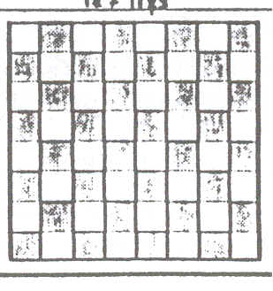

STRANGE GOINGS-ON ACROSS THE POND
by Richard Furness

Some time last year I came across the following story in one of the chess magazines. I imagine a number of you read it at the time. Hopefully I have remembered the salient points.
I think the article had the headline "Rating Fraud". Over a period an American Tournament Director submitted to the USCF Rating Officer details of a number of fictitious events. From these events the Tournament Director, an Expert-rated player from Vancouver, managed to raise his USCF rating from 2189 to 2342 by scoring a rather impressive 40X out of 41. His performance in these events was 2508.

He used a combination of make believe players whose ratings he manipulated over the series of events, and genuine players whom he thought would never know of their "participation".

The fraud was uncovered when Lloyd Kawamura from Hawaii found his rating had dropped from 2330 to 2200 despite not having played. It later transpired that he had never visited Vancouver where it was claimed the tournaments had taken place.
Could it happen here? Has it happened here?
__________________________
Overheard at the Somerset Chess Association Centenary Tournament in 1995 Player to Controller :
This is a good tournament. Can you hold it again next year !"

NOT SO SUPER NINTENDO
Liverpool goalkeeper David James has vowed never again to play computer games continuously for up to eight hours prior to a match. This came after the recent 4-3 victory against Newcastle where he blamed himself for the three goals conceded. He said it dulls the brain and slows down the reactions.

According to hurdler CoIin Jackson, British athletes are banned from playing computer games before a major meeting for similar reasons.
There must surely be a message here for our young (and not-so-young) chessplayers. I hope schoolteacher members of the CAA, parents and Junior coaches generally, are aware of the danger.

LETTERS' PAGE
unfortunately for this issue it has to be
LETTER PAGE

Thanks to John Tumock who was the only member to respond to a number of the issues raised in AM 9 and 10.
AM10 page 9 THAT PROMOTION? John writes :- "I think that White got away with murder. Many players (including myself) promote incorrectly by simply putting the new queen (or whatever) on the eighth rank and then removing the pawn from the seventh. This should not give them extra privileges concerning the "touch move" rule.

The crucial point for me is that the queen was actually placed on e8. There can be no other interpretation of this than that the player was actually promoting the pawn and in my view he should have been forced to do that.
What if the player simply touched a queen, waved it about in the air and then put it down by the side of the board? Here I don't think any penalty could be imposed as the board has not been affected and players often move a queen to a handy spot if they are about to promote in the next few moves."

also p9 ANOTHER DRAW CLAIM
"I would not accept the claim. It is not sufficiently clear cut and 'the benefit of any doubt should be given to the opponent of the claimant. "John also points out that White has made a mere 17 moves in his last 13 minutes.

EDITOR'S TAILPIECE
Amongst the enclosures with your copy of AM 11 you win find an A4 sheet which I have prepared In consultation with Eric Croker, Stewart Reuben, John Roblnson and David Welch. This is being distributed for us by the BCF. It is being sent to all Game Fee registered events for display at those events.
I believe it is in our interests to see that players are properly informed of the most significant changes in the Laws. Please make copies of your copy and help with this dissemination of information.
Two years ago members received a booklet which gave a detailed explanation of the BCF Seeded Pairing Rules as they were applied to the last six rounds of the 1994 British Championship at Norwich. A second enclosure is a replacement for the last white page of this booklet. I am grateful to David Welch for correcting my faulty explanation of the pairings on one score level in Round 10.
Any member who has joined since the Norwich booklet was distributed and who would like a copy, together with the pairing card sheets that go with it, should let me know before the end of April. I will reprint an appropriate number.

My thanks to all who have sent contributions for ARBITING MATTERS. It has been especially pleasing to welcome some new contributors. What about your article for the next issue?

Finally here is another reminder that we shall need to appoint a new Chairman at this year's AGM.

