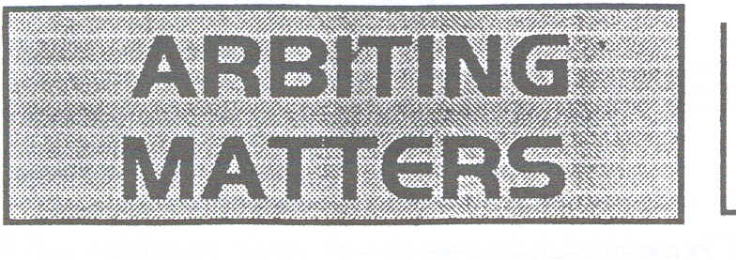
Number 17 Autumn 1999

The Newsletter of the Chess Arbiters' Association

EDITORIAL

You should find enclosed with this issue two documents. One is the minutes of the 1999 Annual General Meeting at Scarborough, and the other is a request for subscription renewal. You may feel that this comes rather uncomfortably close behind the last request; the reason is that the 1998-99 subscriptions were sought at the end of that financial year, while those for 1999-2000 are being requested slightly earlier.

We welcome Steve Boniface to the post of CAA Treasurer, and warmly thank David Eustace for the work he has done in this capacity in past years.

You will find in the centre of this issue (pages 8 and 9) a useful summary of the Laws of Chess as they apply to Quickplay Finishes, Rapidplay and Blitz Games. This is a handy side-by-side summary which members may like to photocopy. It was designed by Chief Arbiter David Welch some years ago.

Stewart Reuben's article in the last issue on the FIDE revision of the Laws in 2000 has provoked two significant responses, one from David Welch (pages 2 & 3) and one from Steve Boniface within his general comments on the material in AM 16 (pages 5 & 6)

A considerable portion of the issue is devoted to an incident which occurred at the Mind Sports Olympiad. Gerald Jacobs wrote the original letter and as it raised issues of considerable interest I sent a copy of it to a number of senior arbiters. This issue contains the detailed responses of Richard Furness and David Welch. I am sure that many members will find their comments helpful and instructive, and thanks to Gerald for raising the matter.

Also in this issue we have two pieces from the indefatigable Steve Boniface. His views especially on British Championship qualification may well provoke a response. On the lighter side, Lara Barnes has provided us with a series of dubious and droll adjournments from the British Championships.

You will see from the AGM minutes that Guert Gijssen has been made an honorary member of the CAA. I would like to give him a warm welcome.

Hopefully I will be able to maintain the current frequency of the newsletter, so February 2000 is the target date for AM18 but that depends on you.
JOHN TURNOCK

FIDE LAWS OF CHESS I 996 AND 2000

David Welch, International Arbiter (ENG), Chief Arbiter of the British Chess Federation.

The present Laws of Chess were built around a document submitted to the Rules Commission by the BCF. I wrote this document at the British Chess Championships at Swansea in 1995. It was refined in April 1996 by many BCF arbiters and submitted at Yerevan later that year. Our Quickplay Finish and Rapidplay Game rules also formed the basis of the present Article 10 and Appendices B, C and D.

After the Laws were ratified Richard Furness and 1 decided to inform the arbiters and players in England of the full effect of the new Laws. We produced two documents for general circulation to chess congresses, and one for league chess matches, which rarely employ an arbiter. These 3 documents stated the Laws and concluded with guidance for players and arbiters. I am sure that this guidance has contributed considerably to our smooth transition to the 1996 Laws and I think the advice given in them would !:,'1lide most Arbiters to a satisfactory decision.

We also produced a one-page document showing the regulations in the form of a condensed table: 3 columns showing QUICKPLA Y FINISH, RAPIDPLA Y and BLITZ, and covering I) recording, 2) claiming a draw, 3) illegal moves and 4) flagfall. We also suggested in August 1997 that C4 should become part of the main Laws at the next review.

During the last year or so, Guert Gijssen has contributed 16 erudite articles to chesscafe on the internet. I think that they should be compulsory reading for all arbiters and they may save many a player from falling foul of

the Laws of chess. Most of the readers' letters referred to Quickplay, Rapidplay and Blitz; our !:,'1lidance covered many of the points raised.

More recently, Stewart Reuben wrote an article on the FIDE Laws as he hoped to see them in the Year 2000. This is in Issue 16 of Arbiting Matters, the official publication of the Chess Arbiters' Association. He made many good points and I hope that most of the ideas will become law soon. I agree totally with Stewart that C4 should be part of the main laws, preferably added to 6.9 - this is the Law about mating potential. It is sensibly worded and would avoid many miscarriages of justice in both Rapidplay games and Quickplay finishes. Very occasionally it would apply to the long time-limit games. It is also suggested that Article 10.3 (time penalties for illegal moves) should be applied to the whole game, by placing it in Article 7. I agree with this, but would hope that we could find some way of avoiding awarding a loss for a player who has only recently learned the game. Peter Purland thinks the automatic addition of 2 minutes removes the arbiter's discretion and often does more harm than good. If I thought that there was any chance of scrapping this rather petty bureaucratic gesture I too would push to see it go.

However, I disagree strongly with any other major changes to Article 10. I ask you to read through the British Chess Federation guidelines, then work through the situations mentioned in the letters to Guert Gijssen's column. One minor omission from the laws is that Article B7 should apply to Quickplay finishes at events which do not employ an arbiter.

The guidance given to players and arbiters in England referred to above is listed below for both domestic and foreign readers:

Guidance to Players in the final stages of a Quickplay Finish

If, when short of time, you continue to play for a win, you risk losing unless your opponent has only a King.
If you are holding a position so that your opponent cannot make progress, offer him a draw. If he rejects the offer, stop the clocks, summon the Arbiter and claim a draw.
If your opponent claims a draw and you wish to try to win, the Arbiter will often allow play to continue. If you blunder and no longer wish to try to win, offer a draw. If your opponent refuses the draw, he loses all rights under "Claiming a Draw" as explained above

Guidance for Arbiters in the final stages of a Quickplay Finish

An Arbiter would only be expected to step-in during the closing stages of a Quickplay Finish to avoid a miscarriage of justice. e.g. in a junior or beginners' event.
In a Quickplay Finish an illegal move may be found to have occurred several moves previously. In the absence of a record of the moves the Arbiter should use either Article 7.4 (last identifiable (legal) position) or C3 (illegal move cannot be corrected), whichever seems the more appropriate.
Under "Claiming a Draw" the Arbiter should refrain from awarding extra time unless it is an unreasonable claim. Remember that the claimant might benefit due to the time taken to reset the clocks.

The Arbiter is not expected to adjudicate a position; but should make himself aware of the circumstances, usually by watching a few moves. For example if a player :
a) makes tangible progress before his opponent's flag falls he will be awarded a win.
b) makes no progress, either because of lack of ability or because of his opponent's sound defence, the player will not be awarded a win.
c) makes no progress because his opponent makes little effort to move, the player will be awarded a win when his opponent's flag falls.

Guidance to Players in the final stages of a Rapidplay Game

If, when short of time, you continue to play for a win, you risk losing unless your opponent has only a King.
If you are holding a position so that your opponent cannot make progress, offer him a draw. If he rejects the offer, stop the clocks, summon the Arbiter and claim a draw.
If your opponent claims a draw and you wish to try to win, the Arbiter will often allow play to continue. If you blunder and no longer wish to try to win, offer a draw. If your opponent refuses the draw, he loses all rights under "Claiming a Draw" as explained above.

Guidance for Arbiters in the final stages of a Rapidplay Game

In a Rapidplay Game an illegal move may be found to have occurred several moves previously. In the absence of a record of the moves the Arbiter should use. either Article 7.4 (last identifiable (legal) position) or C 3 (illegal move cannot be corrected), whichever seems the more appropriate.

Under "Claiming a Draw" the Arbiter should refrain from awarding extra time unless it is an unreasonable claim. Remember that the claimant might benefit due to the time taken to reset the clocks.
The Arbiter is not expected to adjudicate a position; but should make himself aware of the circumstances, usually by watching a few moves. For example if a player :
a) makes tangible progress before his opponent's flag falls he will be awarded a wm.
b) makes no progress, either because of lack of ability or because of his opponent's sound defence, the player will not be awarded a wm.
c) makes no progress because hjs opponent makes little effort to move, the player will be awarded a win when his opponent's flag falls.

Guidance for the Players and their Captains in Quickplay Finishes where no arbiter is present i.e. Appendix D of the Laws

This appendix may be applied to Rapidplay games. .
Any claim should be discussed by the players and if it is not resolved it should be submitted to the two team captains. Claims remaining unresolved should be referred to an Arbiter.

Guidance for the Appeal Arbiter in the above situation

Some chess judgement is required. This is not an adjudication, but an attempt to determine the probable result of the game. The benefit of any doubt should be given to the opponent of the claimant
A player with a king and rook claiming a draw against an opponent with a king and a knight would be awarded a draw under situation (a) above (opponent cannot win by normal means)
A player with a lone king blocking his opponent's king and solitary central pawn would need to rely on his scoresheet to show that his opponent was making no attempt to advance when the opportunity arose. The claim would be under section (b) above (opponent making no effort to win by normal means), and would be likely to fail if the opponent was trying to make progress.
A good rule of thumb is that the award of a win to the opponent should not bring the game into disrepute.

Note: The condensed table of Quickplay Finish. Rapidplay Game and Blitz rules mentioned in David Welch's article are reproduced in the centre of this issue.

IT’S A DANGEROUS GAME!

From the Daily Telegraph:

A man was found guilty yesterday of the manslaughter of a close friend in a game of Russian roulette after he became bored playing chess.
Stephen Cartwright 30, of Eastfield, Wolverhampton left William Burnsen-Hicks, 30, in a chair with a bullet hole between his eyebrows and a smile on his face. Sentence at Wolverhampton Crown Court was adjourned until July 9.

supplied by Steve Boniface

FEEDBACK
Steve Boniface writes:

Thank you for the latest Arbiting Matters. A slim but important issue.

The Forbes incident must be dealt with as a general principle, and I have a suggestion for this later. I am surprised that Lara Barnes detects "an unhealthy trend towards psychological 'tactics' in especially minor tournaments at weekend congresses". I believe in general that such sharp practices are becoming less common, partly because of greater vigilance by arbiters. Secondly, I am puzzled as to why she singles out minor events. Most events have effectively rooted out the 'sharks' by limiting the amount of prize-money that can be won; any problems that do arise tend to be associated with the prize-fund where it is worthwhile to employ such tactics. Thirdly, I believe that the standard of sportsmanship and etiquette is far higher now than twenty years ago. Players positively help each other, and I recall few recent events where I have had to chastise a player for inappropriate behaviour.

Nevertheless, the twin malaise of racial and sexual discrimination and harassment have to be guarded against, and organizers given the power to deal with miscreants effectively. One Law change which would cover this is to give arbiters the explicit right to disqualify players who behave in an anti-social manner in an event. It should encompass the established notion of 'ungentlemanly conduct' but include arriving at the event under the influence of alcohol or drugs, or behaving in a manner prejudicial to the good
name of the game, whether at the board itself or not. This should be at the arbiter's discretion, bearing in mind the well-being and safety of other competitors.

Stewart Reuben is right that we should not tinker with the Laws for another eight years fundamentally, there is nothing wrong with the Laws of Chess themselves and changes should be restricted solely to clarifications and removing ambiguities. Only new items, such as the introduction of Fischer timings, should lead to new Laws.

The last lot of changes purported to do this, but they instead introduced new confusion, hence most of the changes Stewart suggests were only introduced last time! His specific items fall into three categories.

i) Yes, unify the illegal move and unskilled play rules. (i.e. 7.4 and 10.3 - ed.)

ii) No, don't mess with the repetition rule. Personally, I didn't like the last lot of changes, because it is no longer
disadvantageous to claim a draw when there isn't one tl1ere in order to gain time on the clock. That is precisely why the five-minute rule existed; to discourage frivolous claims. Perhaps five minutes was too harsh; two minutes would be a neat solution, fitting in with tl1e other 2-minute rule. Players should be aware that the right to claim a draw by repetition is akin to the right to move. Hence only the player about to move has the right to claim. To do what is suggested will only replace one kind of symmetry witl1 anotl1er one. The problem with Stewart's suggestion is tl1at after the move is made on tl1e board both players would now have the right to claim a draw! The current method is necessary to ensure that the right to claim, as the right to move, rests with one player only.
iii) Allowing a player to withdraw a claim once made, or to permit a deferred acceptance of a draw, is introducing an extremely dangerous principle into the game. So leave 10.2 alone. If it is "unfair that a player be able to claim a draw and then later be able to play for a win due to the opponent's blunder", then DON'T allow it to happen.! As soon as the opponent blunders (or at least as soon as the first player sees it) then AWARD THE DRAW THATS BEEN ASKED FOR. No, players shouldn't be allowed two bites, but we should deal with it in this way.

John Dunleavy has written a comprehensive list of anomalies introduced by the last group of changes. I suggest that these be addressed instead so that the 'Laws 2000' will be both just and clear.

Finally, the 3-points-for-a-win lobby. I have nothing against this in principle (it seems to work fine in soccer), but I fear that organizers may find that they get some 'unusual' results in the last round of their tournaments where 3 points will allow a player to leap over not one but two scoregroups. Not that I'm suggesting that a player might agree to throw a game in order to carve up the prize-money later....

MIND SPDRTS INCIDENT

Gerald Jacobs

The Mind Sports Olympiad has just finished. As one of the arbiters for the majority of the rapidplay and blitz' play games, I would mention that in a 9 day period we had 11 different events take place. We had 10 minute blitz, 5 minute blitz, 30 minute rapid, 25 minute rapid and finished with Fischer timings plus an allowance per move.

11 different tournaments involving over 820 participants, so that if you played in every available game over the 9 days you could have played 101 games. (There were quite a few who did!!!) The number of actual matches played in these tournaments was over 3700. The precise figure is awkward to calculate because of people withdrawing before the end of the tournament.

Remember the 3700 figure, because the arbiters hardly needed to make a decision of any note till the very last game of the whole tournament. 3699 easy games, followed by 1 big problem, which would affect the final placings. (Both players were GMs)

I think we made the best decision possible but any advice from other arbiters would be helpful. We felt that for every suggestion there was just a valid counter suggestion. Hence our final decision.

This last game was played at Fischer timings. 5 minutes for each player with 3 seconds added for each move. (Blitz play rules). We could not get near the last board as there were lots of spectators around. Suddenly a call came for an arbiter.

I fought my way through and found white had 17 seconds on his clock and black had about 5 seconds. Black claimed that white could not win, and was just making moves and had played approx 30 moves with no captures (confirmed by spectators). White said he was trying to win. (In fact from the position on the board black could not possibly win, whereas white might) They played on and black's flag fell and white claimed a win on time, which I awarded. Black counter claimed that the clock was faulty and that the 3 seconds were not being added on (also confirmed by the spectators).

I checked the clock and it appeared to be working satisfactorily. I put the clock down on the table, and the next time I turned round the clock had gone. Black still claimed the clock had been faulty and the decision I had made was unfair. We found a similar early DGT to the one they had been using. It appears when you start the game and play normally that the clock adds 3 seconds on. However as the time runs down and the players hit the clock harder the lever sometimes goes down and bounces back up without adding on the 3 seconds. Following discussions between the arbiters present, it was agreed that the clock was defective and the claim was upheld. (Someone will probably mention misuse of the clocks but both players were hitting the clocks hard)

If a player wishes to claim a draw by the 50 move rule in a blitz game, I presume he calls the arbiter who counts off the 50 moves and then gives the draw. Is this correct?

When called in I watched the last few moves of the game and saw black's flag fall. I awarded the game to white. I feel this was correct. However when black made the complaint about the clock, I had to listen to it and eventually this was upheld. His complaint was instantaneous, and therefore I had to listen to it despite his flag being down. (Someone will probably say that the flag fall when claimed finished the game and the complaint was too late)

In hindsight we could have handled things differently. Letting go of the clock in question was obviously my fault, but the type of defect appeared from a similar clock.

It was suggested that we could have asked the players to continue from the last position reached with time allowed on each clock. If
so how much time? 1 minute each, 30 seconds each, white having more time than black and if so how much. It was counter suggested that the above would be unfair as if black had been getting the 3 seconds he would not necessarily have reached the final position.

If you have read all the above, hopefully you may have reached the decision we made. This was to replay the game. However white refused saying he could now lose a game which he could not possibly have lost (true to a point but even GMs can make illegal moves). The chief arbiter was called. A non chess player but a highly qualified person. He listened to all the arguments and he also agreed the game should be replayed. White refused. He was eventually defaulted and the game was awarded to black.

Trying to check that every clock will add on 3 seconds is an impossible task as the symptoms do not always materialise till panic sets in. However it is the responsibility of the arbiter to provide suitable equipment. I have used DGTs for many years but normally with 30 second add ons, and no clocks have been found to be defective. It therefore raises the issue of using DGT s with very small add ons being used.

Has anyone had experience of faulty equipment at such tight time limits?

As Gerald specifically asked for advice I sent copies of the above to a number of senior arbiters. Thanks to Richard Fumess for supplying the following detailed analysis:

We are told that the final round game had attracted such a lot of spectators that arbiters could not get near it. I would have thought that the presence of such a lot of spectators would have obliged an arbiter to force his way in, if only to see that the players had sufficient room to breathe and to ease the spectators back a little if they were pressing too close.

The account describes the game as one which would affect the fmal placings. I am unsure whether this means it would affect the distribution of prizes. If it did affect the prizes there is a sound case for it to have been observed from the start and certainly once it began to attract so many observers. I usually find that when I am called in to give a ruling, the most difficult part of the exercise is to establish what has happened. Although two players may give an honest account, these accounts frequently differ in some significant way.

Spectators have a habit of "not seeing" when a question is put to them. This is rather like the football manager who always sees the offences against his team but who will "have a look at the video" before acknowledging one of his own players who may have offended. Rulings are so much easier to give when one has seen the events for oneself.

In a critical game a player may make an illegal move. I accept that in a Blitz game it is not the arbiter's duty to point this out, but supposing a player claims an illegal move has been made and the opponent denies it by saying the piece moved from a different square and so the move was correct. Without the presence of an arbiter it is likely to be impossible to establish the truth and certainly not without a significant delay. We can't observe all games, but last round games with prizes at stake should have priority even though the arbiter has many other things to do.

QUICKPLAY FINISH

10.1. A 'quickplay finish' is the last phase of a game, when all the remaining moves must be made in a limited time.

Recording Moves

8.4 If a player has less than five minutes left on his clock and does not have the additional time of 30 seconds or more added with each move, then he is not obliged to meet the requirements of Article 8.1 [Recording his moves)

Claiming a Draw

[Can the arbiter step in without invitation?
In adult events we would refrain from doing so, but in a junior event it might be necessary to intervene)

10.2. If the player has less than two minutes left on his clock, he may claim a draw before his flag falls. He shall stop the clocks and summon the arbiter.

(a) If the arbiter is satisfied the opponent is making no effort to win the game by normal means, or that it is not possible to win by normal means, then he shall declare the game drawn. Otherwise he shall postpone his decision.

(b) If the arbiter postpones his decision, the opponent may be awarded two extra minutes thinking time and the game shall continue in the presence of the arbiter.

(c) Having postponed his decision. the arbiter may subsequently declare the game drawn, even after a flag has fallen

RAPIDPLA Y

81. A 'rapidplay game' is one where all the moves must be made in a fixed time between 15 to 60 minutes.

82. Play shall be governed by the FIDE Laws of Chess, except where they are overridden by the following Laws. [10.1 and 10.4 do not apply)

Recording moves

83. Players do not need to record the moves.

84. Once each player has made three moves, no claim can be made regarding incorrect piece placement, orientation of the chessboard or clock setting.

Claiming a Draw

85. The arbiter shall make a ruling according to Articles 4 [touch-move] and 10 [Quickplay finish! only if requested to do so by one or both players.

10.2. If the player has less than two minutes left on his clock, he may claim a draw before his flag falls. He shall stop the clocks and summon the arbiter.

(a) If the arbiter is satisfied the opponent is making no effort to win the game by normal means, or that it is not possible to win by normal means, then he shall declare the game drawn. Otherwise he shall postpone his decision.

(b) If the arbiter postpones his decision, the opponent may be awarded two extra minutes thinking time and the game shall continue in the presence of the arbiter.

(c) Having postponed his decision, the arbiter may subsequently declare the game drawn, even after a flag has fallen.

BLITZ

Cl. A 'blitz game' is one where all the moves must be made in a fixed time less than 15 minutes.
C2. Play shall be governed by the Rapidplay Laws as in Appendix 8 except where they are overridden by the following Laws.
C5. Article 10.2 does not apply. .
82. Play shall be governed by the FIDE Laws of Chess, except where they are overridden by the following Laws (Neither Bl nor any of Article 10 apply!.

Recording Moves

83. Players do not need to record the moves

84. Once each player has made three moves, no claim can be made regarding incorrect piece placement, orientation of the chessboard or clock setting.

Claiming a Draw

85. The arbiter shall make a ruling according to Article 4 only if requested to do so by one or both players. [Article 10 does not apply)

Illegal Moves
10.3. Illegal moves do not necessarily lose. After the action taken under Article 7.4, for a first illegal move by a player the arbiter shall give two minutes extra time to his opponent; for a second illegal move by the same player the arbiter shall give another two minutes extra time to his opponent; for a third illegal move by the same player, the arbiter shall declare the game lost by the player who played incorrectly.

FlagfalI
10.4. If both flags have fallen and it is impossible to establish which flag fell first the game is drawn.

We hope that C4 will become a Law governing all three modes of play. Until then, 1.3 or 6.9 are the only hope for a player whose f1ag is. down unless he has already summoned the arbiter.
In a Quickplay Finish or a Rapidplay Game an illegal move may be found to have occurred several moves previously. In the absence of a game score use either 7.4 (last identifiable position) or C3 (illegal move cannot be corrected); whichever seems the more appropriate.

QUICKPLAY FINISH

Illegal Moves

10.3. Illegal moves do not necessarily lose. After the action taken under Article 7.4, for a first illegal move by
a player the arbiter shall give two minutes extra time to his opponent; for a second illegal move by the same player the arbiter shall give another two minutes extra time to his opponent; for a third illegal move by the same player, the arbiter shall declare the game lost by the player who played incorrectly

Flagfall

B6. The flag is considered to have fallen when a valid claim to that effect has been made by a player. The arbiter shall refrain from signalling a flag fall.

B7. To claim a win on time, the claimant must stop both clocks and notify the arbiter. For the claim to be successful, the claimant's flag must remain up and his opponent's flag down after the clocks have been stopped.

B8. If both flags have fallen, the game is drawn. [This over-rides 10.41

RAPIDPLAY

Illegal Moves

C3. An illegal move is completed once the opponent's clock has been started. The opponent is then entitled to claim a win before making his own move. Once the opponent has made his own move, an illegal move cannot be corrected.

Flagfall

B6. The flag is considered to have fallen when a valid claim to that effect has been made by a player. The arbiter shall refrain from signalling a flag fall.

B7. To claim a win on time, the claimant must stop both clocks and notify the arbiter. For the claim to be successful, the claimant's flag must remain up and his opponent's flag down after the clocks have been stopped.

B8. If both flags have fallen, the game is drawn

C4. In order to win, a player must have 'mating potential'. This is defined as adequate forces eventually to produce a position legally, possibly by 'helpmate', where an opponent having the move cannot avoid being checkmated in one move. Thus two knights and a king against a lone king is insufficient, but a rook and king against a knight and king is sufficient.

BLITZ

In the British Championship play-off at Torquay in 1998 David Welch and Peter Purland both sat beside the board throughout each game; this with a game lasting about an hour. In the British Championship at Scarborough this year when the game Rahman-Emms went into the quickplay fmish, it was observed for well over half an hour by both Lara Barnes and myself. Emms was defending the position and had much less time than Rahman. On one occasion Rahman had to be reminded he must keep score even though Emms was excused from doing so. The body language of Rahman helped me to judge the points when he realised he was making no progress and then when he spotted the winning breakthrough. All of this would have been helpful to me had Emms decided to make a draw claim.

I know I have laboured this point but I feel an arbiter should have been watching the Mind Sports Game. If an arbiter had been present, he (or she) would have presumably seen that black's clock was not adding the three seconds. I can imagine watching and blinking in astonishment the first time I saw no increment, but hope I would have been sufficiently alert and confident of what I saw to act the next time it happened.

But back to the actual event. The Blitz rules state that article 10.2 (claiming a draw) does not apply, so the game will end in one of the conventional ways. When the arbiter arrived Black had 5 seconds left and made no complaint at that time about the clock not adding the three seconds. Did it add them during the brief remainder of the game? The arbiter was there. It seems Black's claim about the clock only came after his time ran out. Since a number of spectators were of the opinion the bonuses were not being added I do have some sympathy for Black's situation. However I do not think replaying the game would have been at the top of my list of possible solutions.

What to do? The position on the board was accurate although Black could claim that if the clock had been incrementing correctly, he would have had a little more time and might have found better moves. I would have required the players to play on after giving Black extra seconds to compensate for the missing bonuses. I would be assisted by spectator advice, perhaps giving 9 seconds three bonuses. A change of clock, and the setting of it, would give both players a brief respite to compose themselves.

It was unfortunate that the original clock was removed before it could be checked. My guess is that there was nothing seriously wrong with the clock; any failure to increment correctly being due to the manner in which it was being treated. By the last round all players should have learned how to use the clocks. This is another reason for my limited sympathy for Black.

An arbiter's judgement rarely completely satisfies both players. I feel any injustice to Black (see start of previous paragraph) by playing on is less than the injustice to White if the game was to be replayed.

A final point about DGTs. Although I favour them, I accept they have design faults. Many, when pressed, seem to have a slight resistance before the button is fully depressed. Although this is not a problem for most players whose touch is fairly heavy, there is one English GM who stops his clock with a very light touch. The first resistance is sometimes as far as he goes and either he fails to stop his own clock or succeeds in doing so but not in starting his opponent's. He played at Scarborough too. It is a great help to know your players!

David Welch. BCF Chief Arbiter. has also provided a substantial contribution:

I read GeraId Jacobs's letter with great interest, and followed up a few points which were not cryst31 clear. I back Gerald's course of action. but think that with hind-sight we can come to a better conclusion.

D.G.T. Chess Clocks
I have had no trouble at all with DGT 2000 timers. A couple of very old DGT clocks have developed a loose bar, probably by being hit simultaneously by both players at some previous event.

Three problems have occurred:

1. At Hove, Jim Plaskett pressed a clock very hard and the bar bounced back without switching the clocks. I had to substitute a new clock and use common sense to adjust the times. After that Jim was always given a DGT 2000 and no other player had trouble with the old DGT. It was possible to repeat the fault, but we had to try rather hard. The bar was looser than those in the other clocks.

2. Nigel Davies presses his clock with extreme gentleness. The bar was completely down but his own clock was still running. The cause seemed to be the same - an old clock with a loose bar.

3. Gerald Jacobs's incident seems to have been caused by the same problem. Unfortunately none of the clocks owned by the BCF are in my possession so I can't reproduce the fault, but the technical solution for the future is obvious - checking the bar for looseness or wobble should prevent any such incidents in future.

Fast Time Controls
The whole idea of a Fischer mode is to reduce the tension caused by the clock. In future use quite a short initial time with a longer “add-on". I would prefer a 10 seconds add-on, but never less than 5 seconds. In future, I wouldn't allow an add-on of less than 5 seconds for any of the clocks owned by the BCF.

The Dispute
The whole idea of the Fischer mode is that the arbiter doesn't have to protect a player against the possibility of loss on time. This makes Black's original claim spurious. In Blitz, you can't make a claim of this kind anyway. It is worth noting that Black at this time made no claim about a faulty clock.

Subsequently black's flag fell, THEN SEVERAL MORE MOVES WERE MADE, (this is not clear from Gerald's original letter - ed) then White correctly claimed a win on time, which was correctly awarded by the arbiter. THIS RESULT SHOULD NEVER HAVE BEEN RESCINDED.

As no claim about a faulty clock was made before the flag fell, it is impossible to distinguish between the "locking" of a clock (when one player exceeds the time control) and a genuine fault.

If the clocks didn't lock, a player could lose on time, then work his way out of time trouble by playing quickly. No person player, arbiter or even witness stated clearly to Gerald that the clock had behaved abnormally before the mechanism locked. Of

course the clock would appear to behave abnormally after the locking had occurred.

There is no evidence that could sway the original decision - if both players had abused the clocks, they may each have to suffer the consequences of any fault caused. I seriously
don't think that Black can prove any fault if he doesn't point out a possible fault at the correct time.

The Appeal
The Laws of Chess are really in 2 parts Laws governing the play of the pieces and Laws governing the technicalities. The external- (non-chess) arbiter was not in a position to know that the former are considered more forceful than the latter. THUS (in normal play) you go back to a former position if an illegal move is made, but you reset only the clocks, NOT THE PIECES, if a faulty clock is discovered. In this position, the placing of the pieces should have been maintained and if the evidence of a faulty clock was accepted, a new clock should have been set up with times chosen by the arbiter. It is then possible that either player would have objected to the decision, but I think that this is the fairest solution.

Just one further point
If a clock is thumped hard enough for an add-on to be missed, I suspect that the clock doesn't switch either. If I am right then (say):

White's clock is running. White thumps it. White's clock is running still. Black presses it. White's clock is running still (still no add-on).
Black hasn't really lost on the deal, even though both players have been cheated of an add-on. White has lost all the time that Black has used to think of his move. MORAL OF THIS STORY - DON'T THUMP THE CLOCK.

A NOTE OF DiSPAIR

Steve Boniface

I'm afraid the gremlins have been at work again. An evil spirit has suggested to me that maybe arbiters should no longer be responsible for pairing players.

Traditionally, our work has been divided roughly into two areas, that of law enforcement and of producing pairings. For most weekend congresses, this will surely remain the case, as the prime purpose is to produce fair and meaningful pairings, whilst avoiding unfriendly acts such as making brother and sister play together, especially if they have travelled several hours to arrive at the event.

But as soon as we move into the field of rating or title seeking events, the object is to enable players to reach certain norms; if they fail to do this by some quirk of the pairing system, then the object has been lost. Technically, as soon as a set of 'best' pairings is altered to produce a match designed to enhance an individual player's norm chances, then that event ceases to be a 'Swiss'. But as several systems already exist which bypass the normal considerations, such action is neither new nor unusual.

How far can pairings be reasonably adjusted? Variations from the notional seeding priorities and more flexible float selection seem the acceptable limit. If this is adopted, then the responsibility for pairing each scoregroup could be passed to the organizing committee for producing the 'best' pairings from the rating/title angle.

In practice, this appears to happen as a matter of course, especially where opportunities are rare, and the sponsor wants to see a result as well as the key players. It is akin to the common practice in athletics where a runner with the ability to break a record has appropriate co-runners in the field which will provide the ideal conditions for such an objective. Note that this neither takes away from the 'hare' the necessity for he or she to produce the record-breaking performance, nor does it impugn on the integrity of the other competitors. Indeed, there have been cases where the 'wrong' athlete has won the race and/or broken the record!

Now the rationale behind the original statement. With the burden lifted of trying to organize the pairings to fit criteria in a less than objective manner, the arbiter would now be free to concentrate on the immediate tasks of law enforcement, player assistance and result processing in a purely impartial way. The responsibility for the pairings themselves would no longer be his, provided no agreed boundaries were crossed (e.g. blatant over-floating). Hence the role would be as overseer as well as enforcer.

Recognition of such a role would perhaps finally highlight the distinction between 'arbiter' and 'controller'. The former would literally operate an arbitrating function, whereas the controller - of a weekend swiss would control all aspects of the event.

Is ours the only sport (nearly!) where the referees decide who is playing?

AMAZING ADJOURNMENTS

Lara BarnEs

Just back from the Smith & WiIliamson British Championships at Scarborough. The Championships itself went like a breeze compared with sundry other events! Here are some of my most amazing adjournments for your perusal.

1. All's well that ends well

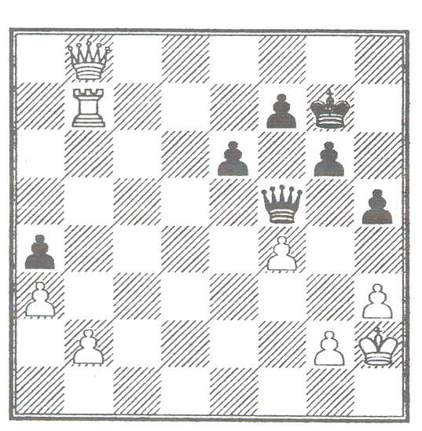
As I set up this position I had the fleeting thought that whoever wrote down the position must have missed a black piece off! But no, black arrived at the board and confirmed that he was a piece down. 3p.m. came and white's sealed move was played on the board.
48. Qe5+ Black immediately wrote 48... Qxe5 on his scoresheet and re-sealed the move in the envelope white arrived over
half an hour later, needing to make 12 moves in 4 minutes and managed to win after using only 30 seconds or so.

Needless to say black's hopes had been seriously built up during the long wait!

2. “I iust don't belieeeeve it!"

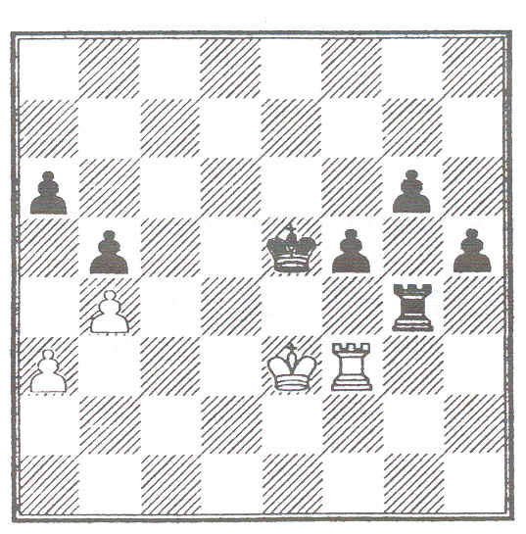
This was the most unbelievable adjournment I had. It was the first one that I handled as a qualified arbiter. (If you remember my last article in AM, the only question that I got completely wrong in the exam was one on adjournments! !)
Anyway
1. The position had been written down from black's point of view on the envelope. (Luckily I had seen the position minutes earlier on the game board)
2. The sealed move was h5?? (Luckily black had written a5 earlier in the game, whilst meaning a4.
3. The white player's scoresheet had moves 32-40 missing.
4. White tried to claim the game based on the 'illegal sealed move'.
5. White then tried to offer his opponent a draw based on the fact that both of them had made mistakes!
6. Black just said...'what ever'.

I suggested that since both players agreed that the position was correct, and that white agreed that black had meant to play h4, that the game continue...
White resigned a few moves later.

3. Some people are iust never happy!

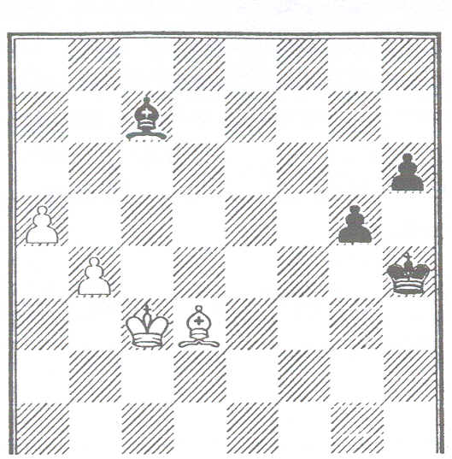
In the position above, when I asked white to seal a move, Black offered a draw. The offer was declined without grace (a mild way of putting it).
On the resumption we got to the following position:

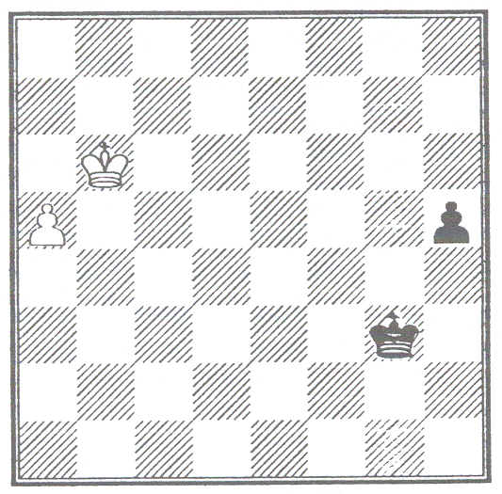
. White, although having 45 minutes on his clock, starting blitzing his pawn; black was caught up in the excitement and did likewise, his clock going throughout the series of moves.
. The inevitable a8=Q, followed by a2 was appearing (the kings had also by now moved so that the black king was covering
hi) as I stepped in to inform the players of the rules about keeping score!
. As black's clock was going I assumed (out loud) that it was his move.
. White threw a fit!
. I stated that without a complete scoresheet it was impossible to prove and that we needed to re-construct the position on another board. White was now foaming at the mouth.
. Black was a true gentleman and slowly started to play through the moves from the adjourned position.
. White wanted to race for a second time and Richard Furness, who had been called in to assist, put him firmly back onto the methodical road!
. When the final position was reached, and notated, white grinning broadly, went back to the board and started his own clock... . Seconds after I returned to the control desk white came over and threw the scoresheets into the results box (draw, of course) and stormed out of the room.

4. Not such a capital idea?
One adjournment envelope had been filled in with a mixture of different notations. Capital and lower case letters were used, as in Forsythe notation, for the pieces but none of them were ringed. The problem was that, at first, it seemed that there was no black king on the board. It turned out that the letter that looked like a capital R for rook was actually a lower case k for king.

SHORTS!
. On opening the envelope for one adjourned game, it was found that both score sheets had the sealed move written on! An open sealed move? No, just a very perceptive opponent'
. On arriving at the board (set up earlier) to open the envelope, I found the two players analysing the position together..
A draw had been agreed during lunch. but nobody had bothered to tell the arbiter!
. Two clock times entered on the same envelope:
Black's clock time: l.
White's clock time: 42.
??
. Another envelope stated that it was the position after Black's 50th move and that Black had sealed and it was Black to move!!??
. Many people could not create a position on paper in that at least one diagram per day was 'upside down'...so I took it upon myself to offer to write down the diagram (usually for Black, if White was sealing). The first player to accept (he had started to write it down from Black's point of view) was extremely amused when I handed him back the envelope and my position was
identical to his !! Oops! It was a very tiring fortnight.

Has anyone got any other amusing adjournments?

BRITISH CHAMPIONSHIP QUALIFYING

Steve Boniface

Once again it appears that the British Championship may be devalued by qualifiers failing to enter by the appropriate date. I understand that several players have not bothered to put in their entry forms which has meant that players who narrowly missed out on qualifying may now not get the chance. Congress Director Neil Graham has sought to address this by the introduction of
the reserve list, an excellent idea which has my full support, and which has resulted in many disappointed players now being pleasantly surprised by a late invitation.

Unfortunately the scheme, while producing a useful back-stop, does not address the two main remaining issues. Firstly, the absent players are in no way inconvenienced by their carelessness. Secondly, players who initially could have taken up the place may now no longer be able to do so because of other commitments. Addressing the first issue should solve the second.

I suggest that any player who does not take up an accepted place without an acceptable reason (illness, for example) should be disbarred from the following year's championship (at least). In addition I would like to see a player who accepts the qualifying place at an event have his prize money withheld until he or she has properly entered for the Championship. This would clearly involve the co-operation of the relevant congresses, but I believe that most would accept the small administrative overhead. Whether the player should complete an entry format the qualifier, to be accompanied by his or her prize cheque made payable to the BCF, or by some other method, would have to be agreed with the event.

This is intended to be a strong incentive not to renege on an agreed action. genuine players need not be disadvantaged. For example, a qualifying player who was unsure of whether he would be able to compete in the Championship could 'pass' his place but book a place at the top of the reserve list, should a slot later become available. The key point is that the player should make a binding decision at the qualifying event, to be enforced by such action as described above.

