ARBITING MATTERS
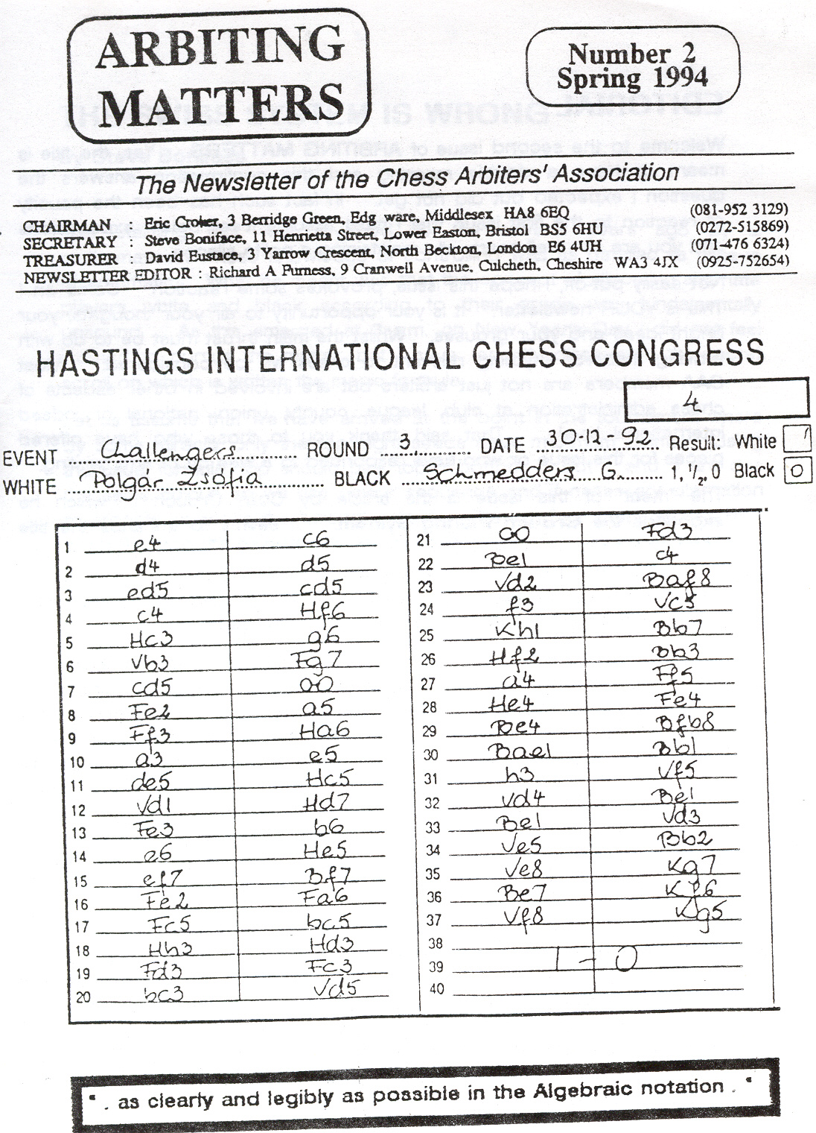

EDITORIAL

Welcome to the second issue of ARBITNG MATTERS. Yes, the title is meant to have a double meaning and this confirmation answers the question I expected but did not get in fact such has been the paucity of reaction to the first issue that I must assume it fell below expectations and you are all - well near1y all - maintaining a polite silence.
Not easily put-off, I hope this issue, provokes some reaction Come on ! This is YOUR newsletter. It is your opportunity to air your thoughts, your bright ideas and your grouses. Whilst the main thrust must be to do with arbiting matters, anything relevant to chess will be considered. Most CM members are not just arbiters but are involved in other aspects of chess administration at club, league, county, union, national or indeed international levels. That said, thank you to those who have offered pieces for this issue or who have responded to a wee bit of arm twisting.

The "meat" of this issue is the article by Colin Crouch in which he expounds the Crouch Pairing System. It seems to enhance the title norm prospects in international events and does this in an objective way, but is it of any benefit in a typical weekend congress? You should consider this as you react An article promised by David Sedgwick, who has used the CPS,. has not arrived in time for this issue.
Going back to the first issue, did you recognise The Three Wise Men on the cover? During the 1992-93 Hastings International Congress a dishevelled old man would frequently drift into the Falaise Hall in the evening and sit some distance from the few games which remained Thinking he was just seeking a quiet and warm haven for a few hours, we let him be. One evening he appeared at the Cinque Ports Hotel as we were having dinner and poked a rolled piece of paper through the trellis which separated the dining area from a passageway. It was a sketch he had made during those hours in the Falaise. From the left, Gerry Walsh, Richard Fumess and John Robinson.

The 1992-93 Hastings Challengers also provides the cover for this issue. All Zsofia's scoresheets were beautifully legible. Not so those of genial Georgian GM Guteld. They were impossible! To think Eddie is Chairman of FIDE's Commission on Chess Art. His movement around the Falaise Hall "Vas always announced by his rustling plastic bag and its contents of "goodies" he was trying to sell to Malcolm Pein. One day during a time Scramble he lost a "won" game. Thereafter, “I unluckiest Russian in England," was his comment each time we met.

THE SWISS SYSTEM IS WRONG
by Steve Boniface

This startling fact was revealed to me several years ago by a mathematician whose knowledge of controlling was as detailed as mine is of arithmetic. What he meant was that the concept of allocating alternate players white and black according to their grade was fundamentally unsound. As this emerged at 3 a.m. on New Years Day ! did not feel
inclined to pursue the matter, but I have recent1y discovered the secret scroll on which is written the magic formula.
Let us assume that we have arrived at the point in the tournament where by some miracle, only the top eight seeds have maximum points. Using the usual formula, top should play top-of-bottom. But 1 and 5 are due the same colour, so we use colour sequence and if necessary alternation to allocate someone the "wrong. colour. The top four seeds all win, so 1 plays 3... and the colours are wrong again!
Now we all know that all the top seeds don't win, but why start with IS system which isn't designed to produce clear pairings? I am waiting for a Statistics of Chaos student to prove that the sprinkling of draws almost exactly balances the "wrongness”, but I will have to be convinced.

Meanwhile my merry (I - RAF) companion produced the following “best bet" theory. Instead of aiming at 1-5, 6-2, 3-7 and 8-4 which doesn't work, we go for 1-5, 6-2. 7-3 and 4-8. This should produce 3-1 and 2-4, leading neatly to 1-2 and a clean finish. Of course draws will spoil this (what about HPBs too? - RAF). but surely no worse than our traditional method (also flawed by HPBs - RAF)? To achieve this. initial colour allocation is different. It's not quite so easy, but if you remember who number 1 SHOULD be playing. it's not so bad. Round 1 - 1 W 2B 3B 4W 5B 6W 7W 8B 9B 1OW 11W etc.

One final point - the adjacent same-colours in the pattern means that in half of cases where a higher seed fails, his replacement is still getting the correct colour.

Well, it's only a theory .. but I intend to give it a go at Exeter this year. If I end up swinging from a lamppost at the corner of the street, you can tell me I was wrong. !

THE CROUCH PAIRING SYSTEM
by Colin Crouch
In this article I provide brief details of the Crouch Pairing System, which I would regard (although maybe t am biased I) as superior to any other pairing system in use. The system can J believe safely be recommended.
for any weekend tournament. provided most of the players are rated, or for any internationally rated toumament. but the very short intervals between rounds at Rapidplays mean that perhaps the system should not be tried out in these tournaments by controllers inexperienced in operating the system.
The two main virtues of the CPS are accuracy and fairness. In a short weekend tournament played under the CPS, it would be quite likely for example that 4.5/5 would secure sole first, and that 415 would secure sole second, and that the two players involved would already have played. There would be a handful of players on 3.5 and a much greater degree of bunching around 50% than in a conventional Swiss system. Stronger players would play each other much earlier and there would be far fewer wasted pairings than under the conventional system. In a longer tournament there would be virtually an all-play-all among the top half dozen players. This would contrast very strongly with the situation at, for example, last year's Lloyds Bank Masters where Jonathan Speelman was leading just before the last round but had not played any of the players half a point behind.

As far as fairness is concerned, any experienced arbiter or congress player win be well aware of the point that the much disliked top-half/bottom-half pairing system is crude and heavily biased against the lower-rated player who is doing well. It quite often happens that to get to 2/2 in a weekend Open, a 21 0 player would have to beat two 1 70 players, while a 1 70 player would have to beat two 21 0 players. This is highly unsatisfactory. Also the yoyo effect is undesirable; typically a player not in immediate contention for a prize might play a string of much weaker opponents until he or she is suddenly in the bottom half of the score group and is then confronted with a string of much higher rated players until a game is lost and the player sinks into a lower group. Most players would prefer to play opponents mainly within about 10-20 8CF points of themselves, rather than jump between rounds from -35 to +35 and back to -35 again.

So what are the basic principles of the CPS? In a conventional Swiss tournament, the players are divided into score groups and pairings are done within these groups. Thus, with top-half-bottom-half pairings a score group may consist of three stronger players (A.B,C) and three lower-rated players (D,E,F). The pairings would be (assuming colours are correct) A-D, E-B and C-F. Not much information is gained from the results of these games. We already knew that A.B and C are stronger than D, E and F, but what we really want to know is who is playing best among A.B and C. These players need to play strong opponents, not lower-rated ones.

In the CPS, pairings are done on an individual basis, not a group basis. Thus at each turn, the highest player (highest score, then highest rating) is given the most appropriate available pairing and the process is repeated. 'n the example above, A-B would be the pairing we most want. It helps sort out the s1ronger players. On the next board. maybe we want a D-C pairing, or maybe C should be downfloated to a high rated player on a lower score. E and F would certainly be downfloated. The final pairings. along with possible results. might be something like :

A 235 | 2. 5/3 | v | B225 | 2.5 | DRAW
C 220 | 2.5 | v | M 225 | 2 | 1 .0
N 210 | 2 | v | D 190 | 2.5 | 1.0
E 185 | 2.5 | v | O 210 | 1.5 | DRAW
P 200 | 2 | v | F 180 | 2.5 | DRAW

For simplicity we ignore the point that under the CPS, A and B would almost certainly already have played! The basic point is that the six co-leaders have been whittled down to one, with all six contenders playing strong opposition. Contrast this with the TH/BH pairing systems where three players get relatively easy rides to the full point, each playing someone 40 grading points lower. I hope this illustration makes my point about the Crouch pairings being both fairer and more efficient.
We now need more detailed rules to put the system into practical operation. We start with the basis rules for use in all rounds after the first.

(1) Sort all pairing cards into score levels and. colour groups.
(2) For each pairing, identify the highest player as yet unpaired. This will be the player in the top score level with the highest rating.
(3) The player's opponent will be the player with the highest rating after all the deductions explained below have been made. Naturally a pairing is discarded if the two players have already met.

ODD-NUMBERED ROUNDS (BCF grades)
Correct colour Wrong colour
Same Score -0 -10
Half point downfloat -10 -20
One point downfloat -20 -30
One and a half points down -30 -40
Two point downfloat -40 -50 etc.

In tournaments using FIDE ratings, multiply the above BCF figures by ten to get a rough equivalent This is more convenient than using the official conversion formula

EVEN-NUMBERED ROUNDS
Correct colour Wrong colour
Same Score -0 -20
Half point downfloat -10 -30
One point downfloat -20 -40
One and a half points down -30 -50
Two point downfloat -40 -60 etc.

Odd and even numbered rounds are treated differently since breaks in colour sequence are far less desirable in even rounds (giving for example a 4-2 colour allocation) than in odd numbered rounds. Where two players are due the same colour, the higher player (i.e. the one for whom the pairing is being sought) has priority to maintain sequence, except when the lower player would then have an extreme colour maldistribution. Thus if the higher player has had WBWB and the lower player has had BWBB, the lower player has white.
Any ties of residual gradings (after subtraction for downfloat and colour) are resolved firstly in favour of the player with the higher score, and secondly in favour of the player due the correct colour. For example if the choice of opponent is between a player on 2 graded 180 and due the correct colour, and a player on 1 graded 200 and due the correct colour, the player on 2 is the chosen opponent

Round 1 pairings need to be handled differently to avoid immediate clashes between top players. The players are divided into three groups.
TOP GROUP - the top n + 3 players, where n is the number of rounds (n + 4 if the tournament has an even number of rounds). These players are paired top-half/bottom-half; thus the top pairings for a five-round tournament would be 1-5, 6-2, 3-7 and 8-4.
BOTTOM GROUP - to avoid mismatches in Round 2, players in the bottom sixth of the tournament should be discouraged from winning, so make a group from the bottom third of the tournament (taking care to ensure that the middle group has an even number of players), and pair them TH/BH. Any Bye goes to the median player in the group.
MIDDLE GROUP - players here should be paired consecutively, thus in a five round event, 10-9, 11-12, 14-13 etc. There is no reason why these players should not play someone close to their own rating.
If any re-pairing needs to be done. pair consecutively, not TH/BH. For tournaments where part-ratings, title norms etc. are a factor, stops may be placed to prevent candidates from meeting unsuitable opponents. Consult either David Sedgwick or myself for further details. The greater accuracy of the CPS in fact means that relatively few corrections in the pairings would be needed to preserve norm chances.

SUMMARY

Strong players will play each other much earlier and more frequently than under conventional systems. Weaker players are unlikely to win a prize without playing strong opposition.
Because of the more testing nature of the CPS, the winning score will be fairly low and there will be an extremely strong tendency for scores to group closely around the 50% mark + 2 in a five-round event or + 3 in a nine-round tournament will generally be a prize-winning score.
While the leading group will tend to be very clearly defined, the sorting of players according to grade will tend to be weak in the +1 to -1, zone.
However within a grading band, sorting will be good, making it likely that there would be sole winners of most grading prizes.
There is no bias against lower-rated players. Any bias will be mildly against higher-rated players and particularly against higher-rated players who are overrated, as they will tend to be upfloated a lot.

THE ARBITER
by Gerry Walsh

I am quite certain that all of you will be able to recite, chapter and verse, 'the five clauses of Section 16 of the Laws of Chess (Editor hastily thumbs through his Laws to see what it is all about - to save you doing the same, it is the one about the duties of the Arbiter), Clearly there is room for a sixth clause in that Article, to be worded as follows,
1 6.8 Resolve all other problems no matter whose fault it is.
Let me share with you a few eventfu1 "additional duties",
A few years ago Radio Sussex decided to cover day one of the Hastings Congress with a live broadcast every hour just after the News. The Tournament Director Con Power decided in his wisdom to delegate this task to yours truly, and so the foyer of the Falaise Hall became the transmission point to inform listeners of such things as how many countries, how many gee-gees, how you become one, the youngest, the oldest, and of course why more men than women sit there for so long without making a move. It was during the broadcast that I had to explain why a chess tournament needed a referee. As I was explaining the duties of the Arbiter, I was interrupted by a player who clearly was oblivious to the microphone being waved around by my interviewer. 'Gerry, there are no toilet rolls in the gents', he blurted out 'And that's just another of the Arbiter's duties' I told my audience.
On another occasion two Grandmasters playing each other in a very strong international tournament decided to liven up the playing room. They took hold of the table at which they were sitting and threw it at the demonstration board. depositing set, board. clock and crockery over the floor. With no obstacle between them it was now much easier to establish physical contact and a real live punch-up got under way. The Swiss audience thought this to be a wonderful way of shattering the tranquillity, but the other players objected to 'the shouts of 'Bravo, bravo', I had to intervene, at which point both players left the room.
Luckily the demo board had remained intact so I was able to reconstruct the game and then went to inform the players that the clock would be restarted in ten minutes, This I dutifully did, and in time both contestants took their seats at the table. I remained in my seat at the, other end of the room. The audience was surely waiting for a bell and the start of round two, The near silence was however shattered by a loud shout of .”Arbiter, arbiter" from one of the two combatants, who asked me on arrival at his side, to offer his opponent a draw as and when he made his next move. I waited and waited until the next move was executed and informed his adversary, “Your, opponent offers you a draw", His reply was not unexpected. "Inform my opponent I will consider the offer", which I did. I hovered around for a while, hoping for an early acceptance, but eventually gave up and returned to my seat Just as I sat down came the caJl, "Arbiter, arbiter. Inform my opponent I accept'
Twenty-three players had completed Round 1 of their Zonal tournament when a majority of 22-1 decided they would much prefer to change to an all-play-aJl event rather than the group system which according to the regulations was the basis for the Round 1 pairings. The Organising Committee debated the issue and refused the request At the appointed time for Round 2. I started the white clocks. Only one player was present in the playing area Some players realised I meant business and arrived at their boards. Those with white made their moves and started their opponent’s clocks. Then the troubles really started, with the more militant ones pressurising those who had started play to withdraw their moves and restart their own clocks.

When this happened I suspended play in order to refer the matter to the then newly elected FIDE President Fridrik Olafsson. It took six hours for the call to be connected and when I asked to speak to Grandmaster Olafsson I was told, "This is the Reykjavik Fire Station. Where is the fire? Fireman Olafsson is not on duty.' Eventually the operator interceded and I was speaking to the President who for a few moments had been trying to calm down a lady whose house was on fire. After lengthy discussions involving many of the players, I was instructed to rearrange the event to an all-play-al1 but with the Round 1 results counting as round 1 of the revised format. I had to carry out a second drawing of lots but with only half the players drawing a number. During this little ceremony a late arrival walked in, thus avoiding the need for a bye.

SEEDED PAIRING RULES - Rule 21

Roger Edwards suggests that the first sentence should have, " after any necessary colour transfers have been made." added at the end. This would clarify the sequence of events in making pairings, but we must still remember the importance of Rule 18. Your observations please!

WHAT HAPPENS TO ALL THE PROFITS?
by Richard Furness
"What happens to all the profits then ?" said the player at a recent congress, with a wink and a knowing look as he passed the organisers' table. This is the reply I wish I had time to give him.
You assume that the congress makes a profit. For your sake I hope it does. Fortunately with prudent planning. most do. If they didn't, they would disappear from the congress calendar and you would have nowhere to play. Just what profit is made when an event finishes in the black'? Far less than you think. It is not simply a case of multiplying the number of players by the entry fee and subtracting the prizes, although this is the mental calculation many players make.

Have you considered the cost of hiring the venue? Although occasionally one is provided free. in most cases it has to be paid for. Typical charges in my area range from about £1 00 for a one-clay Rapidplay to £400 for a weekend congress. LLandudno was f397. Next year it will cost over £800, so we are looking elsewhere.
Have you considered the priming of entry forms (£1 00), the mailing of entry forms - say 500 at 2Cp per time - stamp and envelope (£1 00). bulk mailing to other congresses too distant to visit personally (£20). the hiring of equipment (£25), the purchase of scoresheets. wail charts and pairing cards (£25), the cost of replacing the occasional stolen clock (£25). payment of Game Fee to support the national Federation and ensure that the results are incorporated into the official grading list, without which the congress scene would be chaos (£130). the engraving of trophies (£20) and then there are the Organisers' Expenses! Are. this should be interes1ing, thinks our sharp-eyed inquisitor. So it is !
Have you thought what the organisers do? Consider the Tournament Director. Let us assume a venue has been identified, visited, inspected and approved (3 hours - that's optimistic, but hopefully we have used the venue before and the re-booking is routine, so let's ignore that one.

Updating the entry form, typing out a fair copy for the printer (2 hours). visiting me printer and agreeing terms (1 hour), vetting the proof, making corrections and returning to the printer. later collecting the finished product (2 hours).
Putting address labels, sticking on envelopes, inserting forms, sealing adding stamp and posting (5 hours). Packaging of multiple packs for congresses end taking to post office for weighing (1 hour). Preparing press release for magazine, sponsor and local paper (1 hour).
Receiving entries. Each entry has to be opened, the contents and payment checked, the grade confirmed by reference to the grading list, the grading code established and a pairing card made out Op1imistically all this might take about three minutes per entry. Assume 200 entries (10 hours).

Approximately 20% of entries will be ungraded. These have to be checked against the master list or with other organisers (another 2 hours).
Sorting the cheques, completing paying-in slips and making about five visits to the bank - hopefully this latter can be combined with doing the shopping (nevertheless at least 3 hours).
Preparing the wall charts. 200 entries would be seven sheets (2 hours very optimistic). Making general arrangements about access to venue, refreshments, arbiters. assembling and packing equipment and remembering everything else (1 hour ).
Minimum time spent so far by the Tournament Director = 30 hours.
Setting-up the venue. Take Crewe as an example. Arrive at 3pm.
Four worked non-stop and had the room ready by 5pm. Yes I know you did Rochdale in under an hour DW and PWP. Late entries to be processed, answer queries about grading, accommodation, taxis, train times etc. keeps us busy until the 7pm start.

Play begins - the normal routine of paperwork. pairing cards, wall charts, re-pairing, watching time scrambles, resolving disputes, entering results on cards and charts, doing pairings for next round, tidying-up empty cups, re-setting clocks and boards, having the occasional cup of coffee, but on-the-go until able to leave for home at 11. 46pm. Home at 00.45am.
Saturday - start 0915am - usual routine - leave at 7.15pm. "They also serve who only sit and wait", says a player who passes as I take five minutes for a coffee. Sunday is similar except that after everyone has gone, the hall has to be restored to how we found it Tables, chairs moves carpet vacuumed. condiments returned to 100+ tables, charts taken down, rubbish removed, kitchen area to be cleaned. Reminded of the player who at 4.3Opm had said sympathetically, "Never mind, only two hours to go". Leave for home exhausted at 8.45pm comforted by the knowledge that about three of the 200+ players have thanked us for our efforts. This weekend routine covers four arbiters, one for each section, and excludes all aspects of catering (30 hours x 4 = 120 hours).
During the following days the final scores will need typing out (3 hours), the grading done (computerised, but serf 3 hours), reports prepared and sent to magazines and local press, prizes posted to those who did not stay for the prize-giving (1 hour). The address list will have to be updated with new players being added and details of existing records checked for changes (2 hours), The total so far is 159 hours - and these are only the items I can remember.
So what is the rate for the job? My wife and I pay £10 per hour for our daughter to have cello lessons. I reckon my chess organising expertise is at least equal to the musical-teaching ability of the cello teacher. On that basis the remuneration to the organisers would total almost £1600. Since paying this would entail doubling the entry fee, we had better think again. What if we took the £2.50 per hour my daughter receives for delivering morning papers? On that basis, the organisers' fees for a typical weekend congress would be just under £400

What do the organisers get? Usually absolutely nothing apart from basic expenses. That is petrol at cost Oh, one other thing. At Crewe we did get free cups of tea and coffee. Why do we do it? It helps to be crazy. It also helps to be thick-skinned. I suppose we do it because we enjoy chess and want to bring the delights of the game to as many people as possible.
Enjoy your next congress, but spare a thought for the organisers. We are doing our best!

PAIRING PLAYERS FROM THE SAME CLUB

One of our discretionary rules says that, “In round 1, pairings between relatives, players from the same club. . . are best avoided. The extent to which such pairings are avoided in later rounds is at the discretion of the arbiter.” Our Chairman Eric Croker raises the matter of this discretionary power and has in mind the incident in Round 9 of the Major Open at Plymouth In 1992. Are we in fact storing up trouble by keeping such players apart ? They may then be forced together in a later round with, in some cases (and I can, think or others apart from the one at Plymouth), undesirable consequences

Can we take this as one of the talking Points of this issue? Please send me your views.

