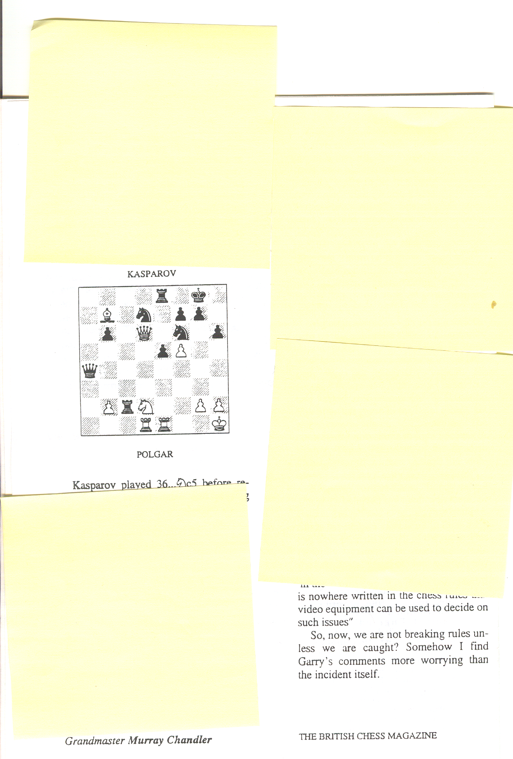
ARBITING MATTERS

Number 3 Summer 1994

The Newsletter of the Chess Arbiters' Association

CHAIRMAN: Eric Croker, 3 Berridge Green, Edg ware, Middlesex HAS 6EQ (081-9523129)
SECRETARY: Steve Boniface, 11 Henrictta Street. Lower Easton, Bristol BS56HU (0272-515869)
TREASURER: David Eustace, 3 Yanow Crescent. North Beckton, London E64UH (071-4766324)
NEWSLETTER EDITOR: Richard A Fumess, 9 CranweU Avenue, Culcheth, Cheshire WA34JX (0925-762654)

EDITORIAL

With this issue you will find notification of, and agenda for, the forthcoming AGM of the Chess Arbiters Association. I hope we will have a good attendance. If you are within travelling distance, do try to go along. Also enclosed is a copy of the Hilton pairings for use at Jamborees (up to three rounds) which have an even number of teams. They have never been officially issued despite being sent to two previous editors of the Year Book
In the first three issues of ARBITING MATTERS the emphasis has been on methods of pairing. This is only one aspect of the work of an Arbiter. It is also the area where there is often time for quiet reflection, a peep at the exact wording of the rules (never be embarrassed at doing that) or a consultation with a colleague. We must not overlook those parts of the job which often require quick and clear decision making. On the one hand are situations where the Arbiter has been present at the board and has seen what has happened. These include the "draw claim' in the Quickplay Finish or Rapidplay. Secondly there are those disputes where the most difficult thing is sorting out the wheat from the chaff when the two players present conflicting accounts and there are no coherent impartial observers. This is where there is no substitute for experience.

In the next issue I would like to redress the balance by dealing with those 'draw claims'. You will all have experience of this. Please send examples as soon as possible. It is important that the necessary information is clearly and concisely set out A diagram of the position would be useful. You do not have to give the arbiter's decision and all examples published will be anonymous unless you state otherwise.
f appeal for contributions to future issues. If I don't receive them, I have to pad out with material of my own and my sense of humour (yes, I do have one) is definitely an acquired taste! Please send me an article for publication. Happy arbiting!

CROUCH PAIRINGS REVISITED by Colin Crouch
In your Editorial, You asked whether the Crouch Pairing System would be of benefit in a typical weekend congress. In fact the system was devised basically with the idea of the weekend Open in mind, although Majors, Minors etc. will provide slightly difficult technical problems.
To answer the question, it is worthwhile to look back at last year's eight round SCCU International and see what happened at the top at various intermediate stages of the tournament There were 41 players, plus a filler, about the same as for a medium sized Open.

After 3 rounds: 3 Koshy (2415), Brady (1679) - Brady had just beaten 2155 and 2260 opponents; 2.5 Summerscale (2355), Stanton (2165), Heasman (2024), Marley (1919).
After 4 rounds: 4 Koshy; 3 Bames (2175), Cooksey (2032), Brady. Already a convincing winner has emerged, Koshy's average opposition being 2324. Koshy beat Summerscale, while the previous joint leader Brady had lost to Barnes. The situation is however still very unstable below first place, with a lot of strong players on 2.5.
After 5 rounds: 4.5 Koshy; 3.5 Murugan (2430), Summerscale, Britton (2305), Hinks-Edwards (2205), Barnes, Marley. Barnes (who drew with Koshy) was the only player on 3/4 to avoid defeat
This is where the typical weekend tournament would come to a close. Only one player has managed to score more than 3.5/5. Anyone who could have reached 4 would have been clear second. Of the players on 3.5, all but Britton and Hinks-Edwards had played at least three of the eight 2200 + players. This would seem to make a very fair weekend prize list. The next couple of rounds help split the players on second place.
After 5 rounds: 5.5 Koshy; 4.5 Murugan, Summerscale, Barnes. Koshy has already played his three main rivals, and Summerscale has played Murugan and Barnes. The all-play-all at the top is nearly complete.
After 7 rounds: 5.5 Koshy; 5.5 Murugan, Summerscale. No players on 5. All three leaders have played each other. After 8 rounds: 7 Koshy; 5.5 Summerscale; S Murugan. Next players are on 5.
The limited experience so far suggests the prize list after 5 rounds will be very accurate, and after 5 will be more accurate than under standard systems. Anyone want to give it a try ?

CROUCH PAIRING SYSTEM
A PRACTICAL TEST by David Sedgwick
The CPS was tested in practice at the 1st Southern Counties International Tournament in August 1993. The event was an eight-round swiss (If a tournament using Crouch Pairings can be so described) designed to give players the opportunity to obtain partial FIDE ratings. 41 players took part, 14 rated and 27 unrated; 10 of the unrated obtained partial ratings. This is a reasonable .strike rate., but not overwhelming. The 1992 Catford masters, a similar event but with conventional pairings, had a field of 14 rated and 26 unrated; 11 obtained partial ratings.

The differences between the CPS and standard methods were much more apparent at the top end of the draw. The three leading players finished at least a point clear of the rest of the field. All three of the possible encounters amongst these players had taken place by round four, much earlier than would have occurred under an orthodox system. Thereafter these players continued to meet opposition which was strong in relation to the average strength of the field. In an IM norm tournament, this would be important in helping to ensure that a player was not deprived of the opportunity of a norm through meeting too weak a field.
The downside of the system also manifested itself. Under standard methods, a strong player having a bad tournament slips down the field and ha a chance to recover against weaker opposition. Under the CPS his existing high rating results in his continuing to get tough pairings. One player suffered from this effect
The players seemed to like Crouch pairings. Of those who responded to a questionnaire, 16 were in favour, 4 against and 6 neutral.
The tournament bulletin contains more details and I would be happy to give a demonstration of how to do Crouch pairings to anyone interested. Overall I consider that the experiment was highly successful. I would welcome further practical tests, particularly in an IM norm tournament
The two relevant addresses for you are :Colin Crouch 98 Elms Road, Harrow Weald, Middlesex, HA3 6BT David Sedgwick 23 Tierney Court, Canning Road, Croydon, CRS 6QA
AREN'T YOU FROM THE SAME CLUB AS ME

by Steve Boniface

One of the vaguest regulations that exists within the Swiss Pairing Rules is that dealing with players from the same family, club or "distant area", This is currently dealt with under the heading "Discretionary Rules"; the wording of the article is very weak. Basically, the Arbiter has the power to avoid pairings between such players, but it is for him (or her - Editor) alone to decide. Why avoid them anyway? There are three main reasons:

1) Players object to travelling many miles to play a clubmate.
2) Players tend to play harder against opponents unknown to them,
3) Players could theoretically manipulate the prize list
Curiously in each example the benefit is to a different group. In the first, the players themselves benefit; in the second, the organisers (less short draws); and lastly, the other players who are NOT involved in the fixture. As this case is potentially more critical, let us deal with it first.
Players A and B are joint leaders on 4/4. They are from the same club and live 50 miles away. They shake hands after six moves and drive home many pounds the richer. More interestingly now, only A has 4 points, a half ahead of B. They agree a draw. Even more interestingly, A wins quickly. This is surprising because B heavily outgrades A. But A cannot now be caught (This would also be the case in the first example if either A or B won - Editor). Of course this is purely hypothetical and such skullduggery could never occur. But should we avoid leading the players into temptation?
It might be possible, provided we do not put too much emphasis on the first two cases. Only towards the end of the tournament is it likely that there are no alternative pairings, By then it is too late. The rules suggest avoiding such a pairing in the first round, but less later. In particular, such a twinning should NEVER be avoided in the penultimate round if such a situation is likely to happen. However it would be equally dangerous to FORCE the players together if this would be unnatural.
Assuming that the event is a seeded Swiss, let us propose a sub-rule that such players should not be paired if this can be achieved by minimum disturbance. Definition of MD is not easy but would rule out, for example, changing a player's colour, or altering a player's opponent's grade by 40 points. If these were the only alternatives. the pairings would have to stand. Switching two opponents only 5 grading points apart is reasonable, but where to draw the line? Discretion again, yes. but if in doubt, DON'T change an otherwise perfectly good draw! The converse would apply in the penultimate round situation mentioned above; if the two players COULD play within the same parameters then let them do so.
Experience tends to influence one's judgement here. In one case I thoughtlessly left one player from the same club on each of the top five boards. The last round was a shambles, the results allegedly being 'constructed' the previous evening. A few years later I heard the same distant rumble and paired them off neatly in the penultimate round. I may have over-reacted in this case, but there was some good fighting chess that day!

Is there anything worse than pairing husband and wife? I say yes husband and ex-wife. On another occasion at the Hanham Congress I was asked by one lady player to re-pair her as she had been drawn against a county colleague. As there was time, I changed this to a player from a club she had only just joined. On the third attempt I gave her a Welshman from a remote village - who just happened to be her junior coach, This left just one opponent with the correct colour, though by now the seedings were looking pretty ragged. Only after the game did she gently explain that the nice man in the beard was her fiancé. Another lesson learned !
I have heard terrible stories of fathers offering physical violence if their offspring were EVER paired together. Oddly in most cases the siblings accept the inevitable when parents seem not to. Thank goodness for EPSCA's wise rule about mums, dads and coaches in the playing arena.

I am quite happy if two players ask NOT to be paired throughout a tournament, even if not from the same area. There may be friendships going back many years, and I agree to this, with the usual proviso. "if possible and within the constraints of the Swiss system', Naturally two players who walk through the door a minute after Round 1 starts must accept the consequences, Towards the end of an event, for those well out of the running. I exercise greeter licence when avoiding same whatever pairings, even extending to breaking the 5ame-score rule. However when running a team tournament one must be very cautious. Certainly, twinning the same clubs representatives DOES limit their team score, but as I occasionally point out, prevents a nil from both I

As a player, I admit to being annoyed if such a pairing happens to me. However as an Arbiter, I realise there are more important factors involved. We are all striving towards perfect pairings (scientific) but must take into account our clients' wishes (psychological). Where the two are in conflict, I say the scientific must prevail and players must not expect never to encounter their clubmates. As far as I know, avoidance is a courtesy extended in no other activities, and its uses must be confined to situations where no other competitors are disadvantaged, either directly or indirectly. Even quantifying a grading difference is dangerous. As always, I say, leave it to the judgement of those in charge - the Arbiters.
Does that bring us back to the existing discretionary rule? (Editor)

FRED BASSET
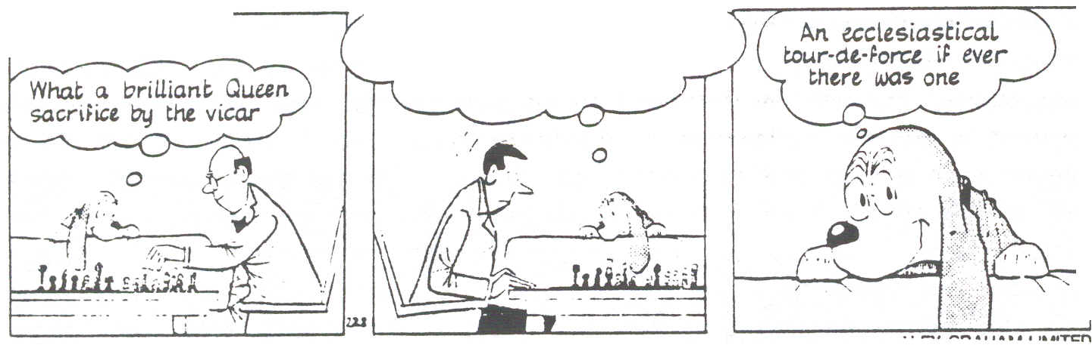
Rendering my man defenceless against a combined onslaught from
both his bishops

Dear Richard
You asked in the last newsletter for comments regarding people from the same club playing each other. In general I am against this happening as players enter congresses to play someone different. Recently Dave Newell took a Junior Squad group to a tournament in Vienna where pairings were done by a computer - need I say more (No Peter. I know your love of computers - Editor). In nine rounds he played 4 of the 7 players he took there, including his son. He was not amused. There must be scope for common sense in this and there are strong arguments for playing clubmates in the next-to-last round if they are otherwise likely to meet in the last round - but even here I have often seen players who hardly knew each other agree a quick draw to share the spoils.

Peter Purland

Dear Richard
I was pleased to receive the new BCF Seeded Swiss Pairing Rules and gratefully acknowledge the work which went into their production. I am however a bit of a heretic when it comes to the seeded Swiss system and I do not think that its merits are so overwhelming that it deserves universal application. I even doubt that it deserves a position of orthodoxy. I note that the Scarborough Congress (under the direction of Gerry Walsh) uses an individual system which appears to be based on a first round in which competitors are paired 1V2, 3v4 etc. followed by (apparently) random Swiss pairings afterwards. This does not always seem to meet with the approval of the strongest players !
I do however agree that Congresses should on their entry forms give guidance as to the pairing methods to be used, but I have rarely if ever seen this done. Why is this? I suspect that in many cases congress organisers do not formulate a policy on this and leave it to individual tournament arbiters to run the tournaments according to their own judgment I feel that competitors deserve better treatment than this and it may well be that pressure for improved standards may emanate from the players themselves, some of whom are becoming more knowledgeable about the intricacies of the pairing systems.
In my view there is no doubt that the Seeded System is elitist, and mitigates against the players in the bottom half of the tournament, especially those in the third quartile. Its purpose seems only to guarantee the strongest players a reasonably easy ride in the early rounds while avoiding the extremes of grading differences in a pairing. In congresses which employ this system and where we have a standard Open, U150, U120 etc. there is absolutely nothing in it for the player of grade 170-185 except the possibility of a grading prize and the occasional good scalp. My own performance in the recent Washington Congress bears this out. I scored 2.5/5 (+130,+183,=209,-211,-187). My own grade is 174. I finished in the middle, but few, if any of those who finished higher will have played such strong opposition.

If we want to introduce fairness into the system, we have to enshrine one principle in a tablet of stone - . A competitor's pairing shall not be directly influenced by his or her own grade. The acceptance of this principle means that immediately all competitors start the tournament as equals.
My central principle of pairing would be (after score group and colours) the equalisation of average strength of opposition met in the tournament. This method requires a running average of the opponents' gradings to be kept for each player. From here I can see two ways of proceeding :
a) In each round after the first, within each score group, the White-seeker who has so far played the strongest opposition is paired against the Black-seeker who has so far played the weakest opposition, and so on until the White-seeker who has played the weakest opposition is paired against the Black-seeker who has played the strongest opposition. The first round could be drawn at random or some kind of banding arrangement could prevent pairings which are too uncompetitive. Over five rounds, this should tend to equalise the opposition played within a score group.
b) A hybrid method, which might provide more direct results is (from Round 2 onwards) to pair (within a score group) the Black seeker who has so far met the strongest opposition against the White seeker who actually has the lowest grade, and so on.
In both a) and b), the downfloater can be the player who has the median average opponents' grade, who has not already floated and who is in the required colour-seeking group.
I have never actually employed either of these systems, but if fairness is the goal, they appear to me to have more merit than the seeded system, a random system or horrible accelerated methods.
Referring to other articles in the magazine, I have always had doubts about the need to keep apart players from the same club. It seems to pander to unreasonable demands on the part of competitors - they should be prepared to play anyone in the tournament As a player I have never been troubled by this. I think that pairings between members of the same family is a different and special case, and that these should be avoided unless the basic principles of score group and colour demand them.
John Turnock
EDITOR'S COMMENTS Gerry Walsh tells me he uses random pairings in the Scarborough Open. If it is Suba v Howell in Round 1, then that is random! Most Arbiters are aware of the drawbacks of seeded Swiss pairings, but they do enable pairings to be seen to be done impartially. Of John's two suggestions, method a), (pairing the White-seeker who has had the strongest opposition against the Black-seeker who has had the weakest opposition) does not rectify the imbalance, since the player who has had the weakest opposition may be high graded. Method b) has merit, and is one I have dabbled with from time to time. The most recent occasion was in April this year when I was Arbiter at the Civil Service Individual Championship. This event had 18 finalists, but a grading spread from 197 to 74. The tournament thus encompassed players who at a typical weekend congress would have been divided between the Open, Major, Minor and Novice sections.
Round 1 was top half v bottom half. In Rounds 2 and 3 I paired (on each score level) the player with the highest average opposition against the lowest graded player who sought the opposite colour. I then took the player with the lowest average opposition and paired him with the highest rated remaining player seeking the opposite colour, and so on. In a small tournament only a few pairings can be done in this way on each score level. I call it "topping and tailing" and it does deal with the most extreme cases. After three rounds no player had received opponents who were collectively markedly stronger or weaker than anyone else on that score level. For rounds 4 and 5 I used normal seeded pairings. By then the score groups were so small I had little flexibility anyway.
I cannot dispute the logic of John's statement that all competitors should start a tournament as equals. How do we achieve this?

PERFECT PAIRINGS

In those occasional idle moments at a tournament, usually one where there is only one round per day and an eight-hour playing session, one's mind can wander. It can dream up ideal pairings such as Morecambe v Wise, Little v Large. You get the idea. The first amusing pairing I can recall was about twenty years ago at a county match between Greater Manchester and Warwickshire. The two captains stood side-by-side and each read out his player on each board. So we had "B Sharp" plays "A Flatley",
I had been planning a little light relief on these lines for this issue when I heard that Peter Morrish had beaten me to it by a letter to the "Addicts Comer" in CHESS Monthly. After perusing the Cadogan Grading list he had come up with the following pairings:. Cable-Carr. Daly-Duzen, Enoch-Powell, Flower-Power, Gilbert-Sullivan, Ginger-Catt, Gladstone-BSaggs, Glass-House and Guy-Fawkes.

I recently came across a game by the delightfully named Russian player Leonid Slutzky and then remembered a young Cheshire player called Thomas Mudd. So we have Slutzky-Mudd.
I now offer you a little pairing exercise in the same style. The twelve White-seekers are :- Crouch. Hebden, Parker. Flear, Rich, Little, Gibbons, Short, Stone, Hardy, House and Rogers. They are to be paired against these twelve Black-seekers :- Nelson. Lamb, Cummings, Down, Moore. Mason, Bridge, Stamp, Knott, Carr, Mann, Martin.

I invite you to send me your Perfect Pairings. A selection will be published in a future issue of ARBITING MATTERS.

THE RATING OF FIDE TOURNAMENTS

by George Smith
When I first took over the job of BCF International Rating Officer about ten years ago the task was a leisurely one with few queries and 130 names on the English part of the list. At the latest count there were 409 names on the list with 65 having been added in the last year. Not many you may say compared with the 10,000 or so who appear in the BCF Cadogan National Grading List but there is a growing interest amongst good club strength players particularly amongst juniors in seeking to join the chess-playing elite on the International Rating List

Not surprisingly I receive a number of enquiries from arbiters and controllers on the organisation of a rating tournament. For the benefit of others who have not yet been involved in this explosion I have set out a number of points that need to be taken into account in order to get a tournament, league or team event FIDE-rated.
1 Firstly the event must be registered with FIDE. In order to be accepted for rating the following must apply: - a) Rate of play: This must not exceed 23 moves per hour at any stage of the game; b) A rate of play of 40 moves in two hours followed by all moves in one hour is acceptable, but only one such result is acceptable in a title application; c) In events with Quickplay finishes (i) at least four hours total time must be allowed for the game with not less than one hour to the first time control with a rate of play no faster than 23 moves per hour (or pro-rata). After the first time control all remaining moves must be completed in not less than one hour. Thus 20 moves per hour and then all moves in the remaining hour is allowed, but 24 moves in one hour or 30 moves in 75 minutes and all remaining moves in one hour is not allowed; (ii) for games lasting seven hours minimum, provided the speed of play does not exceed 46 moves in two hours at any stage, a final time control of at least 30 minutes is acceptable; (iii) one hour chess and Rapidplay chess (all moves in 15 to 60 minutes) are only rated for the Rapidplay list; (iv) All moves played in two hours is acceptable for the normal rating list
(d) Games played with electronic clocks (these are digital timers which, amongst other things, can be used for a traditional start of the game In one or two periods to make a certain number of moves. After the last time control the player gets extra time for every next move). One hour minimum per player may be rated wherever players have an additional ten seconds (minimum) for every move after the time control.
2 Not more than two rounds per day may be played.
3 Unplayed games, byes, etc., and those played against a computer are ignored.
4 In an all-play-all event one third of the players must be already rated end if there are less than ten players, a minimum of four rated players must participate. All players are rated in this type of event, unrated players being accorded a rating based on their performance in the event provided the first rating of a player worrks out at 2005 or more.
5 In a Swiss tournament only games against rated players are counted. For unrated players results are only counted against rated players and a minimum of four rated opponents must be met for the results to count

The FIDE Administration of the rating system is financed by affiliated chess Federations and the registered rated events. For a Swiss tournament the FIDE charge is about £50, whilst the cost of administration of the rating list by FIDE and all their other activities is retrieved by the BCF from event organisers by a charge of £3 per rating for a player in the event The FIDE rating list is published twice a year on January 1st and July 1st with a close down date for receipt of results one month ear1ier. To get onto the list an unrated player must have a minimum of 9 rated games. Results can be pooled over events completed within a two-year period.
The minimum rating for publication is 2005 (equivalent to 175 BCF). Players dropping below this level are de-listed and must start building up a rating again. Once a rating is achieved and provided it does not fall below 2005 it remains valid, but players not having any rated games for three years are removed to an Inactive list.
As to the rating system itself, this is Elo-based, a system invented by Dr Arpad Elo, which relies on statistical probability of results between players of different ratings. The difference between the average rating of opponents and the player's rate is calculated, and by reference to a conversion table of differences in rating, a percentage scoring probability is extracted. Applying this percentage to the number of games played gives a rated player his expected score in the event. This is compared with his actual score against rated opponents and the basis of the rating increases or decreases for the event calculated. Before finalising the change of rating for the event the increase or decrease is multiplied by a development factor that varies according to the rating of the player. This is known as the "K" factor and is 10 for a player who has achieved a rating of 2400 whether or not he has subsequently dipped below that. The "K" factor is 15 once a player has completed 30 games for rating, and is 25 for players newly entering the rating list Special rules are used when an unrated player competes in an all-play-all tournament or in a Scheveningen team event based on the calculation of the unrated player's performance.
One special problem has come to attention since the rating list has been extended down to 2005 though it was always present before but rarely had an impact The Elo system would work quite well if games were rated chronologically one game at a time. This is not a practicality even with current state of the art computers so average rating of opponents in an event is used to rate the whole tournament. In this way it is possible for a player to lose rating points by beating a player much lower than himself. This is shown to arise when the difference in rating is about 350 points. FIDE has ruled that where such a difference arises, for rating calculations the difference in rating is taken to be exactly 350 points. A similar problem arises In BCF grading that is met by the 40-point rule.
There are a number of other special rules that are applied for instance when a player achieves a first rating in a published list before an event in which he is competing is rated. In such cases the newly rated player assumes that he is rated for that event for his own results but his opponent still treats him as an unrated player. The Hastings Challengers is the prime example of this as it commences on 29th December for which ratings published on 1st July always apply except for those newly appearing on the 1st January list
FIDE rating is straightforward but there are a number of pitfalls for the unwary. I hope to provide a note on FIDE titles and events at a future date.

SWISS RULES. O.K.
by Stewart Reuben
I looked at Steve Boniface's heading. THE SWISS SYSTEM IS WRONG bated breath. Could he really have cracked it '? Disappointingly, he was only referring to a defect in the Seeded Swiss Rules. Who believes in them anyway? Moreover, Tony Miles had made the same point to me many years ago and fallen into the same trap of generalising from the particular.
Consider eight players ranked 1-8 The pairings are either 1-5, 6-2, 3-7, 8-4, or 5-1 etc. Assume all the games go with grading. Then the next round pairings will have to be 4-1, 2-3. Clearly it would have been better to have made the pairings 1-5, 6-2, 7-3 and 4-8. Then the next round would be 3-1, 2-4. The same applies to ten players, assuming the median is downfloated. But, when you move to twelve players, the normal system produces the best pairings of 4-1, 2-5, 6-3 in the second round. The same is also true of fourteen players. I wonder if Steve discovered this at Exeter.
Thus if the number of competitors is 8 x n or 8 x n + 2 then the pairings should reverse every four. If the number is 4 x n or 4 x n + 2, then the pairings should be standard Seeded Swiss. I can just imagine Richard's reaction if I were to suggest this seriously. Anyway, I seldom have the luxury of knowing the number of contestants in a Swiss until well after the start of the first round (nor did David and I when Pakistani entries for "The British" kept materialising on Eastbourne Pier as happened in 1990 . Editor).

There are far more serious matters. More than half the Swisses in the world are played with an odd number of rounds. This is less true in Britain because of our penchant for six-round Rapidplays. Assuming White scores 57% in Open events, his expected score in 9 rounds is 4.67 to Black's 4.43, 50.8% But there is a double whammy. It you have White in Round 1 you are more likely to have White in the last game and we all know it is an advantage to finish well in a Swiss. An even number of rounds must be fairer.
A more serious defect of the Seeded Swiss is that it perpetually disadvantages players at the top of the second half. Consider a 64-player tournament and compare the opponents of players 31 and 33 assuming all games go with the seeding. 31 and 33 are chosen because they will have had the same colours. After four rounds they will both have scored 2/4. 31 will have met 63, 15, 47 and 19. 33 has met 1,49, 17 and 45. The sum of the former is 144 and of the latter 132. 31 has met easier opposition. Again there is a double whammy. People who start well in tournaments tend to continue to have good results. This is particularly pernicious for players of static playing strength. In the British Championship it is possible to suffer from this effect for several years. The effect is even more marked if the two players draw all their games.
Although supposedly the guru (Hindu spiritual teacher, head of a religious sect, influential teacher, revered mentor - Editor's Oxford Dictionary) of Seeded Swisses in this country, I only learnt of this defect relatively recently. This is because I have mainly used Accelerated Pairings and varied the cut from one event to another. The repeating effect is then eradicated.
Almog Burstein of Israel (whom some of you have met) advocates pairing by Sum of Opponent Score after three rounds. e.g. eight players are placed in order of SOS. Then 1-8, 2-7, 3-6 4-5. Where players have the same sum, the original grade is used for the ordering. The objective is to balance out strengths of opponents and the system is to be used in the next Olympiads. Almog says that for 80 players the system takes about twenty minutes longer by hand than normal pairings. The same effect could be achieved with Sum of Opponent Grades. Like the Crouch System, this suffers from the defect of relying extremely heavily on accurate grades.

There were 600 players at Oviedo and several of my fellow English players (all professional) thought it inappropriate that I should be paired with Richard Britton in Round 2. Personally I thought the organisers had more than enough to think about. If you don't like keeping friends apart artificially. then don't do so. If you very much like to avoid such pairings, then give them the same colour in Round 1 (* see below). Some controllers at Opens for which I have been responsible, like to keep juniors apart. This has led to adults asking me whether they can win the junior prize because they are playing in a junior event
* EDITOR - I frequently use this ploy, most recently at the Morecambe British Championship Qualifier. Top seeds were Arkell, Lund, David Knox, Vic Knox and Tebb. Knox, Knox and Tebb were all graded 206. Alphabetically David and Vic would have been numbers 3 and 4. With just 41 players and 6 rounds, they would surely have met. By making Tebb 4 and V Knox 5, although often on adjacent boards, they were kept apart naturally. I know it could have backfired, but it didn't.

TWO Ks TOO BIG FOR THEIR BOOTS?

In both the Kasparov and Karpov incidents the warning for Arbiters is clear, so if either of the two big K& enter your next weekend congress you would be well advised to arrange to have their games recorded on video. Additionally don't allow Kasparov to get away with entering a section lower than the Open. He may say he is unrated and hope you have not heard of him. He is after all a founder member of the PrimaDonna Chess Anarchists (PCA).
There was another "incident" at Linares 1994 and this involved both the Ks. Anatoly (white) was getting carved up by Big Gary and was desperately Short (sorry about that) of time. Gary played 24 … cxd1 =Q+.
"The arbiter had thoughtfully provided Kasparov with a WHITE queen to replace the newly crowned BLACK pawn. In the absence of a Black queen to hand, Kasparov left the pawn on the board. With only a minute left Karpov complained and was (rather extraordinarily) awarded two extra minutes. This only gave him more time to contemplate his destruction” . BCM

By Malcolm Pein
ANATOLY Karpov. the FIDE world champion, trails Boris Gelfand of Belarus by half a point after five rounds of the Dos Hermanas tournament in Spain.
Karpov has been embroiled in controversy for the second successive tournament by again refusing to accept the decision of the arbiter and turning a defeat into a draw.
Karpov appealed against the loss on lime awarded against him during his game against England's .John Nunn at the 3rd Amber tournament earlier this month and after a terrible fuss the arbiter relented.
In the first round in Seville Karpov faced Manual Rivas of Spain. Both players were in serious time trouble and Karpov, who stood better was trying to avoid a series of checks from his opponent’s queen.

Inexplicably the arbiter was not noting the actual moves played as prescribed in the regulations but rather just ticking the move numbers on a blank scoresheet. When Karpov's clock flag fell indicating his time had run out, the arbiler announced he had only made 39 moves of the required 40 and had thus lost on time. Karpov refused to accept the decision and claimed in the flurry of moves Rivas had made two extra checks with his queen.
According to Gelfand, Rivas eventually offered a draw which Karpov accepted despite his advantage on the board.

Gelfand was so concerned about Karpov’s antics that he asked for the second round game against Karpov to be recorded on video. The game ended in a draw.
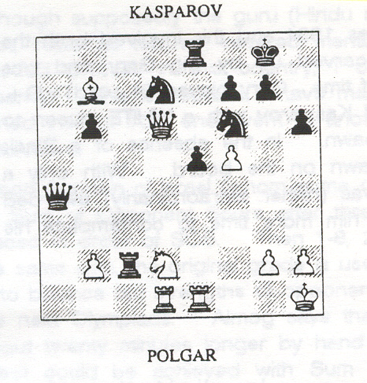
PCA World Champion Garry Kasparov did not have a happy time in Linares, being accused of taking a move back in his game with 17-year-old Judith Polgar.
Initially he denied the illegality, but later a slow motion Spanish television video of the game appeared to confirm his fingers left the piece for a brief moment.
Here was the position reached after 35 moves with both players in time trouble:

Kasparov played 36... Nc5 before retracting the knight move and playing 36...Nf8.

In Monaco. shortly after Linares, I asked Judith why she had not protested at the time. "I guess the truth is that I just respected Kasparov too much. I knew his hand had left the piece, and looked up at Falcon (the chief arbiter) who was watching, but he said nothing. Also I had just a few minutes left and was afraid of getting a time penalty,"
Given that a time deduction (of five minutes) would have meant a loss on time Polgar's fears were understandable, but was she really liable to a penalty under FIDE (World Chess Federation) rules? International Arbiter Bob Wade believes that the standard time penalty applies in the case an incorrect claim of a draw by three-fold repetition. It should not, in Wade's interpretation, be applied in the case of a touch-move protest.
Although opinions vary on the seriousness of this particular case - a momentary loss of contact with the piece in time trouble - Kasparov's reaction to the incident was not especially logical. He accused Polgar of “outrageous" behaviour and "cheap self-promotion" in accosting him after the game in the hotel lobby, yet rather contradicts himself by saying "The controversy only came to light because Sr Roman Toran, President of the Spanish Chess Federation, paid to have the videotape played back very slowly to him."
Kasparov further stated "In any case, I sincerely believed my hand was there. Sr Falcon has normal eyes and saw nothing. Since the umpire's decision is final there can have been no breach of the rules. This certainly cannot be compared with the Maradona "Hand of God" controversy in the World Cup. It is much less clear. It is nowhere written in the chess rules that video equipment can be used to decide on such issues"
So, now, we are not breaking rules unless we are caught? Somehow I find Garry's comments more worrying than the incident itself.

Grandmaster Murray Chandler

TIiE BRITISH CHESS MAGAZINE

