ARBITING MATTERS
Number 4
Autumn 1994

The Newsletter of the Chess Arbiters' Association

EDITORIAL

This, probably the first bit you read, is generally the last page I write. By then I know what the issue contains. Although it will be into November before you read this, today is a beautiful October day. I am wondering why I am sitting typing when I could easily be walking along some spectacular Lakeland ridge. Perhaps that is for tomorrow!
Thanks to all who in response to my request in ARBITNG MATTERS have submitted positions for the "draw claim" in the Quickplay Finish or [Rapidplay game. Or to put it another way, "Thank you Stewart,. since you, were the only one. Thank you to those who have contributed to this issue in other ways, notably Eric Croker, David Welch, John Dunleavy and John Robinson, and to Roger Edwards for doing the photocopying for me.
I have again had to inflict quite a chunk of my own upon you in this issue. In early September I wrote to one of our members inviting him to write a short piece on a topic which I thought him eminently qualified to cover. I gave a copy deadline about a month later. Unfortunately nothing has come. Exactly the same happened a year ago when I had written to another of our members. I can understand not everyone has the time or inclination to make a contribution, but couldn't they have dropped me a line or given me a ring. At least I would then have known where I stood.
I am still hoping that if you find any snippets of information in chess magazines which are of relevance to arbiters, you will send me details for possible publication. Generally I only see BCM and CHESS. I am willing to continue producing this newsletter so long as members - that means YOU - make contributions. I have only two short articles in stock. The next issue is due to be typed in early February. What about it?

WHERE DO WE GO FROM HERE?
by Eric Croker
Chairman of the Chess Arbiters Association

Those of you who were able to attend the Annual General Meeting of the CAA at Norwich would probably agree that after a fairly quiet period the CAA is showing signs of becoming a very useful organisation. During the last year we have taken over the training of would-be arbiters and made recommendations, where appropriate, to the Chief Arbiter and the BCF for their formal appointment as BCF Arbiters. We have started a newsletter, of which this is the fourth issue, and in the process dealt with a number of matters of interest to arbiters in general as well as others with sufficient interest to become associate members of the CAA. In the process of course we have spent some of the money obtained by subscriptions; until at AGM nobody had paid anything beyond his or her initial subscription. We have also taken up the cudgels, or shown that we are prepared to do so, on behalf of members as individuals. All this has meant a good deal of work for our Secretary, Stave Boniface, for our Treasurer, David Eustace, for our Editor, Richard Furness, and for a number of other active members. Our thanks are due to all of them.
Now we have to consider our programme for the coming year and our longer-term policy. The financial question is clear enough, and the AGM agreed that we should - at last, you might well say - ask everyone who joined us before the 1993 AGM to pay a further subscription of £5, and hopefully you will all pay promptly and with good grace!
BCF Seeded Swiss Pairing Rules have been the subject of much debate wherever arbiters meet, as well as in the pages of ARBITING MATTERS. Even so, the present rules, introduced in 1993 for an experimental year, have on the whole been thought reasonable even if we have our doubts about, say, floating up and down from the median of the group. So the recommendation of the AGM was that the BCF should leave things unchanged - though possibly with some words of explanation which might appear in the Year Book or these pages - so that we have time to give the rules a thorough test and make a proper informed judgment on any changes which might be needed at the end of the three years.

Next we have to consider recruitment of members. We are trying to get into membership every BCF Arbiter, and of course we should like to attract as Associate Members all those who have ambitions to become properly qualified or who are simply interested in arbiting activities. Perhaps that might include some chess players who merely want to ensure that we don't get up to what they would regard as mischief. How do we get in touch with such people? Obviously we can put notices in BCF publications, but the best method is undoubtedly by word of mouth. So if you know someone who might be interested, please let us know, or better still persuade him or her - why aren't there more women arbiters? - to write to us and we'll take it from there.

A job which has taken up time since the AGM has been the revision of the published advice on how to become a BCF Arbiter. We hope the revised version will appear in the 1995 BCF Year Book. The major change will make it clear that passing a test on the rules is not all that is required; candidates also have to show their ability to do the job. This work has also reminded us that at present the Laws of Chess and BCF Rules, e.g. on swiss pairings, appear together only in the 1994 Year Book, which is not the handiest of documents to carry around, so we are considering producing an arbiters' handbook which will include all these things and some others of general value to arbiters. We need a volunteer to do this job. Little or no drafting is required because most of the documents will be in print, but somebody has to find a printer to produce a suitable pocket-sized booklet at a reasonable price. A volunteer to the Secretary please.
Finally there is the problem of communication. We have our AGM at the BCF Congress because that is the place where we find the largest number of arbiters already on the spot, but we can never achieve the really large attendance we should like. When, as at Dundee in 1993, we meet at a point which is geographically off-centre then inevitably not many people turn up simply to attend our meeting. We tried to remedy this last year by holding a supplementary meeting in London, but only half a dozen people attended that. If you have any bright ideas on how we get round this problem we should be delighted to know. But it goes further than the AGM. We need to reflect the ideas of our members in general, but if you don't tell us what you think we can't read your minds. Of course you probably hate writing letters as much as I do, but if an issue bothers you please let any member of the committee know, by whatever means you prefer, so that your views can be passed on. The names, addresses and telephone numbers of CAA officers can be found on the front page.

ODDS AND ENDS

Quote from the INTEL SPEED event in New York :
“Adams was one of ten players who qualified for six vacant places.
It must have been mighty crowded I

WORKING METHODS

by Stewart Reuben
Senior Arbiter & BCF Director of Congress Chess

Many of you will know I have a number of views on how things should be done with which you may not always agree. The Intel Speed Chess Grand Prix involved two of these where, being paid, I had to put aside preferences.
I strongly believe the spectators come to see the players, not the Arbiter. Several events, particularly in Northern England, reserve the stage for the arbiters (Editor is holding his tongue). I agree this has the benefit of allowing them an over-view of what is going on, but seldom see the arbiters using this, especially as the clock faces are not usually visible. The stage should be for the players or demo boards. Even in weekend tournaments these add a tone to the event which will cause players to return.
At the Intel event I was set on the stage beside the players, perched on a stool from which there was a real danger of my falling if I nodded off. Yes, I had an uninterrupted view of the play but could not see the clock face. This was only visible to me on a screen in the opposite direction. Moreover, it was required the Arbiter call the flag-fall (BCF Rapidplay Rules stipulate that the player is in charge of his own clock). The situation was thus nonsensical.
In addition, Bob Wade and I arrived at the rehearsal on the assumption we would alternate being in charge. No, he was Assistant Arbiter and, much to his dismay, never had anything to do (Could have doped your drink so you fell off the stool). I was expected to remain alert for eight rapidplay games and several play-offs each day. It is an only too familiar scenario. Arbiters are treated badly. Millions are spent on the Chess Olympiads but the arbiters are very poorly rewarded - if at all.
I believe there should always be an Appeals Committee. This gives excellent protection to the Arbiter. On occasions I have made bad decisions but the players have been sheltered from my errors by the Appeals Committee. Originally there was to have been an Appeals Committee at the lntel event, but it was made extremely clear that the event had to proceed to a completely tight schedule. An Appeals Committee would have required three of the players to be on hand at all times in addition to the two in play. I saw no alternative to the principle that the Arbiter's decision would be final. I managed to gain the concession that I would be allowed to consult Bob Wade if necessary.

Of course there were no arbitng decisions made. Nobody claimed a draw on the 'can't win by normal means' rule. I stepped in only once, to reassure Korchnoi that his opponent's clock was running properly. Also Ivanchuk went to make his move, then thought more about it and left his hand hovering over the piece. I remonstrated with him. He didn't argue and the game was quickly restarted. After the game I asked his opponent Anand whether I was correct. He said technically yes, but Ivanchuk hadn't annoyed him as he had plenty of time left in a late endgame.
I wonder whether I was the only person to be aware of a possible dispute which has overtones in relationship to the Polgar-Kasparov incident

Korchnoi went to play Rc7 to f7 but fumbled the piece and let go of it on its way!. He quickly resumed the sequence. I think the piece never stopped moving but, at the time, knew there was no way I was 100% sure. Had his opponent complained, I would have allowed Korchnoi to make the intended move. You will remember the Arbiter in Linares came in for some stick for probably failing to notice that Kasparov's hand quit the knight. Well, there you are. An example where the Arbiter saw exactly what happened and yet it was still too quick to be absolutely sure what occurred.

A LITTLE LIGHT RELIEF

Yes it is what CHESS MONTHLY describes as those POTTY PAIRINGS. Positively for the last time I promise you. John Robinson presented me with a long list when he arrived at Norwich. Here are a few of his white-seekers :- Raynor, Holland. Stenhouse, Down, Boyd, Rumsey, Brown, Curry, Toll. Chaplin. White, Mills, Dickie, King. Baker, Boswell, Sage, Vann, Spencer, Pink
They are to be paired with the following black-seekers :- Rice, Boone, Snow, Cobb, Church. Boston, McDonald, Johnson, George, Onions, Carpenter, Floyd, Bridges, Windsor. Driver, Muir, Wong. Tracey, Bird, Dilley.
One of the above pairings did happen at Norwich; White-Wong
In the recent Monarch Assurance Open in the Isle of Man I had Leslie Stuart, Stuart Conquest and Ken Norman. I did not manage the Stuart-Conquest pairing, but round 8 did see Norman-Conquest The players confirmed to me that it has happened on at least three occasions.

CHESS MONTHLY offerings include Stephenson-Rockett (John Turnock the arbiter), Wood-Carver, Chambers-Potts and Fry-Bacon (Steve Boniface), Wade-Anker. Arnold-Palmer, Fox-Hunt, Bailey-Bridge. Thanks to John Dunleavy for sending me details! of these. Just room for some of mine Alms-Legge, Wiley-Persson, Farmer-Giles, Silver-Birch and Barley-Waters.
“ARBITER! I CLAIM A DRAW”

A player, just inside his last two minutes, makes this statement What is your decision? Please take these seriously. You are the man on the spot and have to decide. Make a note of your decisions. ARBITNG MATTERS 5 will return to these positions and will include the comments of a panel of CAA members.

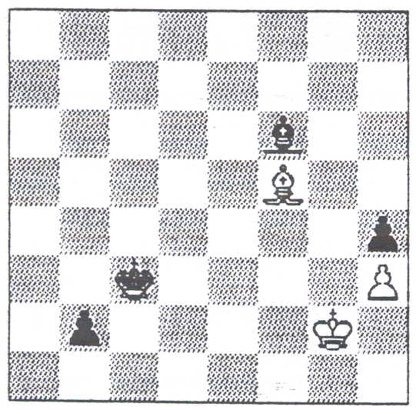  1 White claims a draw stating he intends to sacrifice his Bishop for the Black 'b' pawn and then keep his King in the h1 corner | 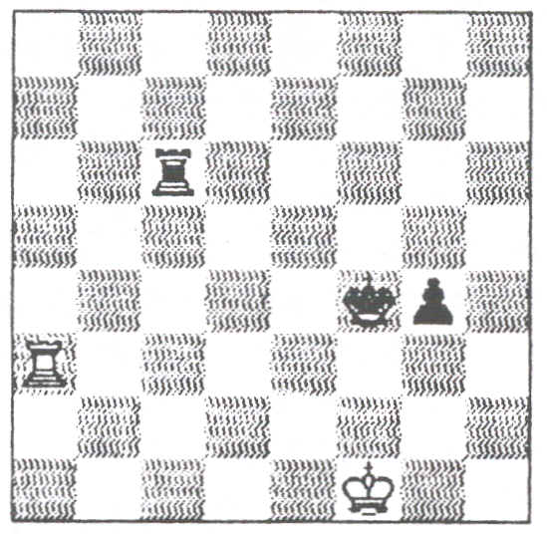  2 White claims a draw. | 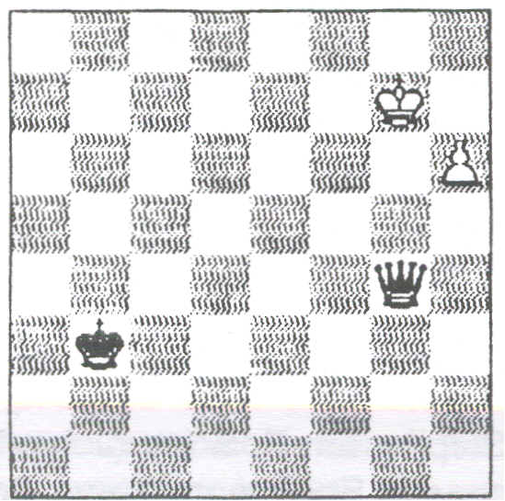  3 White claims a draw.
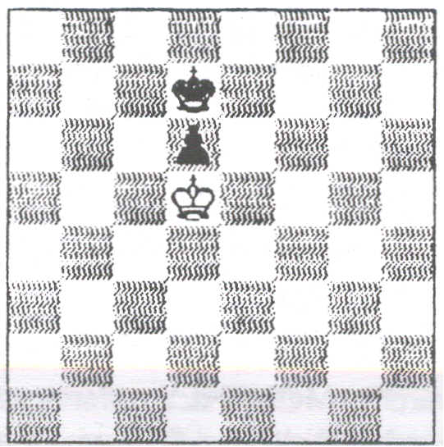  4 White claims a draw. | _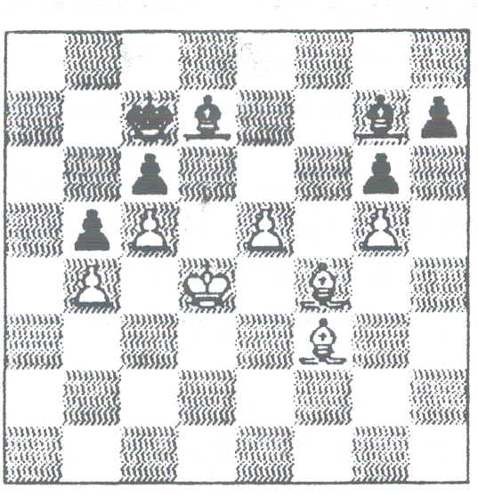  5 White claims a draw. The arbiter instructs the players to continue and observes the moves 50 Be4 Kd8; 51 Bf3 Ke7; 52 Bg2 Be8; 53 Bf3 Kd7; 54 B94+ Ke7; 55 Bf3 Bd7; 56 Bg2 Kd8; 57 Bf3 Kc7; 58 Be4 Be6; 59 Bf3 Kd7: 60 Be4 Bf5; 61 Bf3 Bh3; 62 Be4 Bf1 and White's flag falls. | 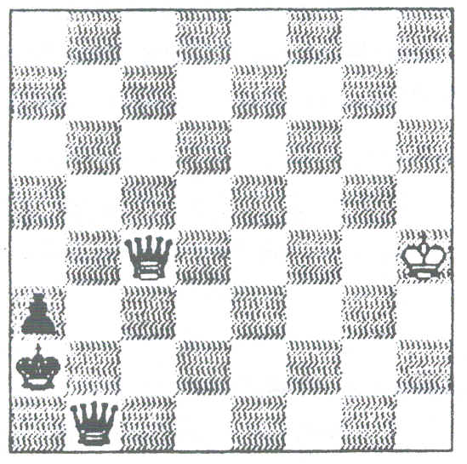  6 Since White claimed a draw with two minutes left, Black has captured White's pawn on a4 and advanced his own pawn from a5.
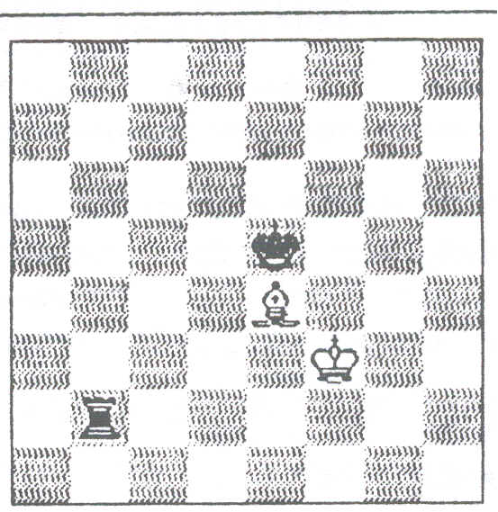  7 White claims a draw. | """""\,_)m_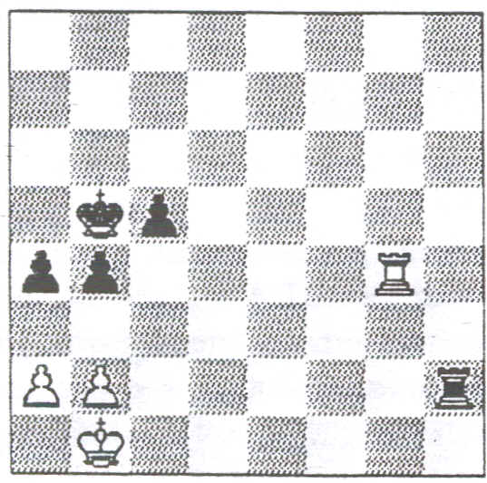  8 Intel Grand Prix 6-5 minute play-off. Black needs a draw to qualify. He is very short of time and claims a draw. | 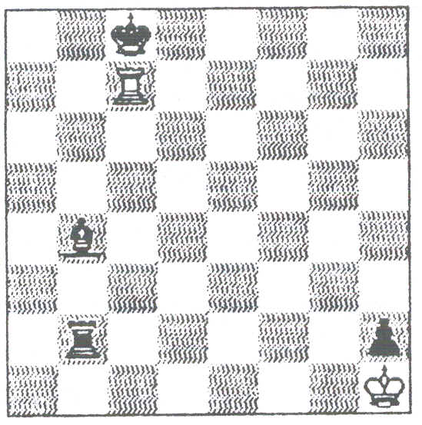  9 White claims a draw.

AMENDMENTS TO RULES FOR QUICKPLAY FINISHES AND RAPIDPLAY GAMES
by David Welch, BCF Chief Arbiter

These rules have been in use for a few years now and no serious flaws have been found. There are however three areas where clarification is needed and the appropriate amendments - as detailed below - should come into effect from 27th December 1994 (There is sense to this date – think!)
Firstly, FIDE has dropped the 75-move rule.
AMENDMENT 1 (QPF rule 18) delete 50/75 move rule and replace with 5O-move rule.

Secondly, our rules use the words "cannot possibly checkmate" and "does not have mating material" almost indiscriminately. The amendments below avoid this anomaly, and accept the FIDE version of "mating material".
AMENDMENT 2a (QPF rules 12 &. 13, RPG rule 14) delete cannot possibly checkmate", Replace with does not have mating material..
AMENDMENT 2b (QPF rule 12, RPG rule 14) ADD ”Mating material is sufficient material to allow a position to be reached in which the opponent, having the move, is unable to prevent mate next move."

AMENDMENT 2c (Guidance for Arbiters (QPF & RPG) Replace the first paragraph with, “Two Knights and King versus lone King is not mating material because the defending King cannot be forced to move to the corner of the board so that the mate may be delivered..
Finally we are attempting to minimise the difference between the rules for different styles of chess. In the Rapidplay Rules, illegal moves will no longer lose, but we have taken account of the fact that arbiters are not normaly involved during the final time scramble. . .
AMENDMENT 3 replace RPG rules 11 and 12 with
11 An illegal move will be treated under the normal Laws of Chess. There is no automatic loss, but the Arbiter may decide to give the opponent extra time.
12 An illegal move is not completed until the player has stopped his clock. An illegal move retracted prior to that suffers only the normal penalties of the “touch and move" rule. If a player completes an illegal move when his opponent has less than five minutes remaining, the opponent may automatically claim an extra two minutes.

HERE AND THERE DURING 1994 by Richard Furness

My year began at Hastings where with first David Welch, and then Gerry Walsh and Julie Leonard, I was responsible for the Challengers Tournament. With well over a hundred players from a variety of countries, the possibility of problems was very high. There was only one. The fun began the following weekend when, after the supposed stresses and strains of a big international open, I sought refuge in controlling the Weekend Minor.
In round 1 seven players did not show up. I prepared to do re-pairings. It was difficult locating all the players, but four were matched and began play with a suitably shortened session so they would finish at about the same time as everyone else. Of the others, who would receive the Bye? One player looked at his watch and said he was not starting a game now. He was promptly re-paired and told that as one of the highest-rated players in the event, he was not going to be given a Bye. He played. Two days later he was the event winner.

Perhaps the oldest competitor was a delightful 82-year-old gentleman. He was brought each morning by his wife and collected at the end of the day. He alternately lost his gloves, scarf etc. During one round he shuffled up to the control table, apologised for being a nuisance and said that he had moved away from his board and now couldn't find it. Would I take him back to his game.
In passing one game late in a session, I noticed that White (20 minutes left and in a probably losing ending) was about five moves behind on his scoresheet. Black (about five minutes left) was up-to-date. I asked White
to bring his scoresheet up to date. He said angrily that he would do so after he had made his move. Since he was well behind in recording and his opponent had much less time, I said he must do it before he made his move. He tumed on me and said why did I have to interrupt him when he was thinking. I told him why and he grabbed his opponent's scoresheet and brought his own up to date. I thanked him and moved away. Soon afterwards he lost. The next day he came to apologise for his behaviour.

A surprising number of players thought they had the right to decide on which side of the board the clock should be. "Black can choose", I was regularly told. I have only come across this at Hastings.
The Minor (Under 130) had a few unrated players estimated as in the 110-120 range. After the problem caused by an unrated player the previous year, I decided to put them to an early test because if any of the unrateds had started well, there would have been discontent amongst the rateds. In round 1 I paired them all as though they were the top of the bottom half. In this way they met strong opponents. As things worked out, this discontent did not happen. The only player without a BCF grade ,to do well was a German having a conversion of 115. There were a few mutterings about him but when he lost in round 6 they ceased.
Lara Ogunshola was doing badly in the Minor, so asked if she could transfer to the Major (Under 160) where she felt she would do better ! I told her such a move would probably result in both sections having an odd number of players, so she agreed to stay put. One round later, having lost again, she withdrew and I wrote this on her pairing card. HaIf-an-hour later she was back - having been persuaded by her friends to continue. Could she be reinstated? I offered her her pairing card and a bottle of Typex. She smiled and "duly obliged.
An elderly man (playing White) was playing a young keen newcomer. King and five pawns each. Black came and asked when he could claim a draw since (he said) the position was a "book" draw. I showed him the Quickplay Finish Rules and he realised that with 40 minutes still on his clock he had a long time to wait before any such claim could be considered. He took the rules back to his board. I was surprised when I saw the position since I thought he had winning chances, but he failed to advance his King to gain the opposition and instead retreated. He showed obvious signs of dissatisfaction with his opponent. A good while later it was the opponent (white) who presented the result slip - a win for White. He asked what his opponent had been speaking to me about. As I was telling him, the opponent came up and before long the two were having a rare old argument Black's main grievance was that White should not have played on in a "book" drawn position. I pointed out that White had won and told them to go away and have their argument elsewhere.
Stick to the Challengers Richard !
At the Crewe Congress I had to deal with an awkward "draw claim" during the Quickplay Finish with the claimant into his last two minutes. I eventually .ruled against him when his flag fell. I explained that it was a marginal decision and I could understand another arbiter ruling differently. He was clearly displeased. The next day the same player made another claim. As before I required them to play on whilst I observed. A (the claimant) had just under two minutes, his opponent (B) had about five minutes. B played quickly, but A only slowly. He (A) meticulously kept his scoresheet up to date so made only about three moves before his flag fell, Again I ruled against him. My reasoning was that by making no attempt to avoid losing on time, he had denied his opponent the opportunity to make progress. When 1 tried to explain to A why I had ruled against him, he got up, folded his scoresheet and said he didn't want to know. I am told that since then he has spent a great deal of time telling everyone what he thought about the decision. What a pity he hadn't been prepared to hear why he had lost These were the only two incidents during the whole weekend.
During the 1993-94 season my friend (i.e. player A) has begun to play in his local league. I am told there have been more disputes than in any season in living memory, most involving his club.
A pleasant but very tiring three hours was spent at a primary school in Winsford, one of Cheshire's traditional salt industry towns. It was a treat seeing chess played purely for fun.

Many events later I was at Norwich for the British Championship Congress. It had been decided to use the Digital Game Timers in "The British., but as it had not been announced in the entry form I did not feel in a position to enforce their use. How many of the 52 players would object? Not many ! Just one the first day, three the next and it eventually settled down to six. Being new to the arbiters too, we decided to use them simply in a digital countdown mode.
Later at the Monarch Assurance Open John Nunn gave me his opinions based upon their use at the Lloyds Bank Masters. You may have seen John's comments in the October BCM. We plan to use them at the Owans Corning International at Wrexham. with a 30-second add-on after each move. Until arbiters are confident in their use, there will always be fear that the clock has not been set properly. With the conventional clock you can see the setting, but surely we must move forward !

An amusing incident happened during the last round at the Monarch Assurance Open. Normally on a Sunday the room we were using was a bustling carvery with up to 150 diners. Some frequent visitors were clearly unaware of the chess tournament. Being the last round we had started early. At about midday a well-dressed lady and gentleman entered the room and walked its full length, apparently oblivious to about a hundred chessplayers hunched over their boards. Reaching the far end they held a whispered, but rather audible conversation. I hurried in their direction. Upon seeing my badge the lady clearly thought I was the Head Waiter. "We have booked a table for lunch", she said. I tried to explain that the Carvery was in a different room that day, but the lady continued to look around for a vacant table. "But we have booked., she continued.

MEMBERSHIP lIST

Our current membership Iist is as follows. It is printed here so members will be better able to spot omissions and know who to approach with a view to our membership becoming more comprehensive.
FULL MEMBERS JA Alderton, Salford; R Beville, London SW, 5; PR Bielby, Sunderland; S Boniface, Bristol; D Brown, Orpington; R Brown, London E,O; R Burgess, Leeds; AC Corfe, Potters Bar; I Cowen, Boston; L Coyle, Uverpool; E Croker, Edgware; P Dansey, St NeoUi; D Eustace, London E6; AJ Edwards, Stoke-on-Trent; RA Fumess, Culcheth; PC Gibbs, Hinckley; N Graham, Kirby-in-Ashfield; F Hatto, Uanelli; JG Jones, Hitchin; GM Jones, Leigh; H Lamb, Bolton; P Lamford, London N'6; Mrs _ Leonard, Gloucester; - J Man/ey. Alnwick; A McFarlane, Renfrew; D McGregor. Scarborough; R Middleton, Bolton; R Milner, Leek; PE Morrish, Edgware; RW O'Brien, Brighton; Mrs J Parker. Lynton; RO Powis, Stroud; P Purtand. Uverpool; S Reuben, Twickenham; P! ,Richmond. Nottingham; J Robinson, Kettering; DR Sedgwick. Croydon; RI iSinelair, Leatherhead; JT Swain, Nottingham; DR Thomas, Birmingham: K Thurlow, Sutton; T Thurston, Hitchin; JR Tonkin, Manchester; J Turnock,' [Newcastle-upon-Tyne; JD WaUace. St Andrews; GF Walsh, Middlesbrough; lA Webster, Sutton; D Welch, Uverpool; M Wills, Ilford; AJ Whiteley, 'London WD Woodruff, Bristol.
ASSOCIATE MEMBERS (with apologies to anyone who was recently been "elevated) N Belinfante, Yeovil; EIS Biddiok (Bristol; C Blaekwell, Staines; F Bowers, Spalding; VJ Dunteavy, Kingsbridge; J McAllister, London NW9; R McShane, London W9; A Mushens, Cartenden; PJ Patienoe. Southampton; S Phillips. Pommouth; A Raoof. Hendon; GMA Smith. Benfteet;

THE LAST WORD
This goes to Associate Member John Dunleavy for increasing the level of intelligence from the 'Potty Pairings' standard. He offers the following latecomers to the 'Toumament Director's Ball'. Please welcome Mr & Mrs Float and their Cockney son Da(h)n; from Iran, Imam Diester-Benz and his wife Min; from France Mme Rincard and her father-in-law Pere; Mr & Mrs Gress and their daughter Con; from Denmark. Mr & Mrs Bomberger and their little boy Sonny. Finally Mr & Mrs Bray-Hick and their son Algy. 'Smart Giant Tribe" is an anagram of ARBITING MATTERS.

