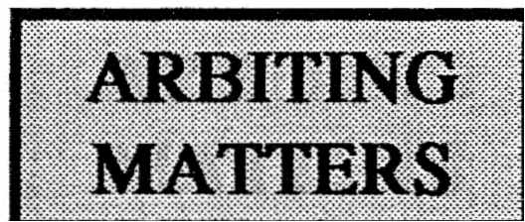
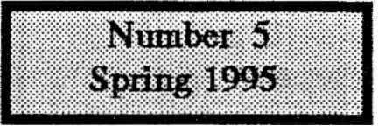
The Newsletter of the Chess Arbiters' Association
CHAIRMAN : Eric Croker, 3 Beaidge Green, Edgware, Middlesex, HAS 6EQ SECRETARY: Steve Bcniface, 11 Heruietta Street, Lower Eastm, Bristol, BS5 6HU TRFASURER : David ElEtace, 3 Yarrow Crescent, North Becktm, Londm, E6 4UH NEWSLETTER: Richard FUIIless, 9 Cranwell Avenue, Culcheth, O1eshire, WA3 4JX 0181-952 3129 01272·515869 0171476 6324 01925·762654
At the 1994 Annual General Meeting it was agreed that Full and Associate members who joined the CAA prior to August 1993 should now be required to renew their subscriptions but that members joining since then would have a further year of membership on their original subscription. Accordingly our Treasurer sent out renewal requests. I am pleased to report that the vast majority have renewed their membership. Being in a generous mood, I am sending this issue also to those whose membership was still awaited (at 20th February 1995), together with a last reminder.
Those whose membership is up to date will find enclosed with this issue a booklet detailing exactly how the BCF Rules for Seeded Swiss Pairings were interpreted during the last six rounds of the British Championship at Norwich. I hope this is of especial interest to those Arbiters who would like (a) the opportunity to prove they are as competent as, or better· than, those arbiters who were at Norwich, or (b) further ammunition to prove that seeded pairings are not the best thing since sliced bread (Incidentally what was the best thing fefore sliced bread? Suggestions please)
The Amendments to Rules for Quickplay Finishes and Rapidplay Games which were detailed in AM4 provoked a few violent reactions. Whilst individual events are of course free to use them - and some have - their official introduction will be delayed until after the next AGM. Why not let me have your views for and against in time for AM6. If you are unlikely to be at the next AGM (Swansea ?) do take this opportunity to have your say.
One of the tactical tricks which chess learners (that's all of us) hear about is the overloaded piece; the one vainly trying to guard a key piece or pawn and also defend against a checkmate threat. Our Secretary Steve Boniface is overloaded. As well as doing the purely secretarial tasks, he spends a great deal of his time in spreading the word and training new arbiters. In order that he can do more of this specialised work, Steve and the other members of the CAA Committee ask for a volunteer to take on the role of Secretary from the next AGM in August. Further details can be found on page 8.

THE PUBLIC IMAGE

by Steve Boniface
Secretary of the Chess Arbiters' Association

It was seriously suggested at a CAA meeting a few years ago that controllers of events should dress in suits and ties to set a smart example to the players. A quick glance at the sartorial level of most events demonstrates that in general, clothing does not figure high on the list of player priorities. This is why the chess tie lies unwanted at the back of most bookstalls. Tie-breaking interests the competitor far more.
Naturally there are exceptions; David Norwood in the upper reaches and. Martin Page at the club-player level have impressed me with their style. I suppose Joan Parker who passed on some of her good habits, is a shining example of immaculate dress sense for arbiters. But your average tournament participant, be he or she player or controller, tends to be the epitome of casual indifference to how they appear to the public. Indeed, an infrequent visitor to congresses once remarked how dull were the pullovers sported by competitors. How many shades of grey were there? Only a few were enlivened by the occasional chess motif.

Of course we have no control over how our charges dress during events. Rarely has comment been made to me objecting to offensive or "distracting or worrying" clothing, or lack of it. Thank goodness we do not normally attract the previously not uncommon "medallion man" with golden sovereigns dangling over the pawns, while the back row is obscured by excessive pectoral hair, real or otherwise.
The arbiter should take advantage of this lack of distinction to stand out in the caissic crowd. This is a big advantage for players, who claim that they can never find a controller when they need one. The BCF badge is not much help, being small and fairly dull. Nevertheless, it is a symbol of power which should be displayed proudly when wishing to silence an objection to a given ruling. In general, I would recommend bright clothing, stuff you would never dream of wearing at a normal social gathering. Aunt Ethel's ghastly last Christmas present jumper is ideal. It will clash with nobody else's, and. you sure will be visible. Where you have one or more assistants, some form of colour co-ordination might be fun, though exactly matching garb (except possibly humorous sweatshirts) might be seen as naff or worse.

My own preference is for bright yellow or red collared shirts, occasionally offset by a hideous clashing tie. If you are lucky enough not to possess one of these, they are easily obtainable for a few pence at your local charity shop. And should you find a player dressed in similar style, watch out . . . it might be another arbiter on holiday stealing your good ideas.

(For the 1990 Oakham Young Masters I obtained four vivid red Oakham School sweatshirts and the two arbiters (Gerry Walsh and David Eustice), myself (Tournament Director) and Mike O’Hara wore these at the start of each day’s play and again around the time controls. Whether naff or not, they were appreciated by the players and the school sponsors. It was very helpfulto be able to see exactly where we all were during the time scrambles.

At the British Championships I think we would look more of a team if some form of “uniform” was worn. Perhaps when – if we ever get a sponsor, we might be trotting off to M & S for red sports shirts – Editor)

CONGRATULATIONS and WELCOME
The following list shows those trainee arbiters who have passed the Arbiter Exam during the last few years. No doubt I will be told of any errors or omissions.

PRE -1993 lan Campbell John McCormick Martin Cooksey

1993 John Richards (Bristol) Tyson Mordue (Bristol) Gerry Jepps (Shepton Mallet)
John Dunleavy (Kingsbridge) Sean Pope (Exeter).
PREPARED BY STEVE BONIFACE
Julie Leonard (Gloucester) PREPARED BY GERRY WALSH

1994 Mark Sanderson (Sale) Julian Clissold (Bolton) PREPARED BY HARRY LAMB
Rod McShane (London) Neville Belinfante (Yeovil) PREPARED BY STEVE BONIFACE
Jack Davies Gareth Ellis (Huyton) Colin Hailstone (Hull) Francis Bowers (Spalding)
Phil Meade
PREPARED BY PETER PURLAND

1995
Nigel Dennis
Roger Sharman Roy Heppinstall
PREPARED BY PETER PURLAND

Cyril Johnson (Syston) David Carrott (Hinckley)Alan Jex (Leicester)
PREPARED BY STEVE BONIFACE

Practical experience also has to be gained. Of the above, the following have so far met the rquirements at the sharp end and are now BCF ARBITERS :
Julie Leonard Rod McShane Mark Sanderson
Julian Clissold Phil Meade Colin Hailstone

"ARBITER! I CLAIM A DRAW"

My thanks to The Brave Nine who accepted the challenge and agreed to make decisions on the nine positions given in AM4. Encouragingly there was a very high degree of agreement, indeed in only one case was opinion divided. The Brave Nine were a mixture of BCF Arbiters and Senior Arbiters. I accept that in a number of cases it would have been helpful to have had a little more information and a clear statement as to who was to move. My panel was able to work this out.

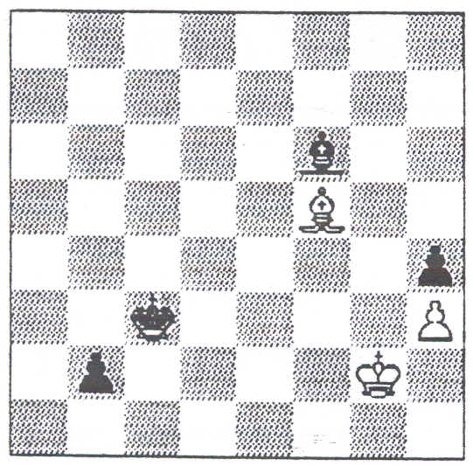  1All were agreed that this was a DRAW, but five of the panel would have required play to continue for a few moves to establish that White was carrying out his stated drawing plan. | 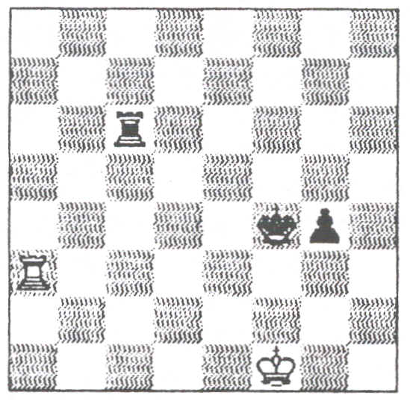  2All members of the panel said play should continue. Although a theoretical draw, Black is entitled to have the opportunity to exploit any weakness in the White defensive play. The likelihood is that the Arbiter would eventually declare a DRAW provided White defended sensibly and made a reasonably number of moves. | 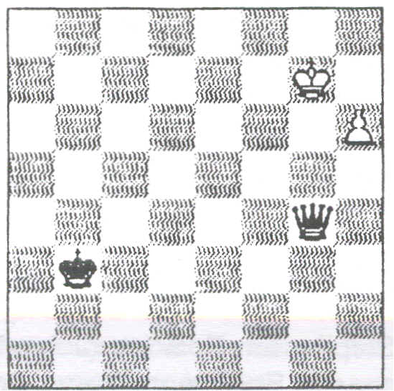  3Eight of the panel would turn down this claim as it should not take Black many moves to prove his win. In this position White would be expected to move briskly.
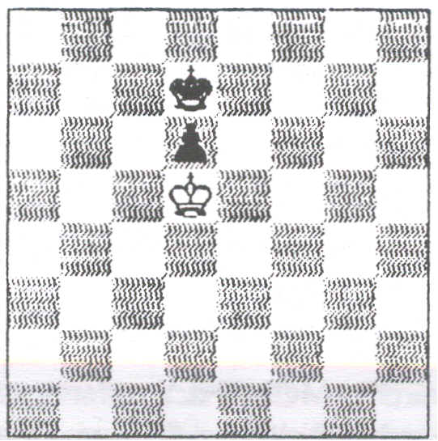  4Play on. Unless this was a game between novices, it should take only a few moves to establish that White knows what to do and the DRAW would then be declared. | _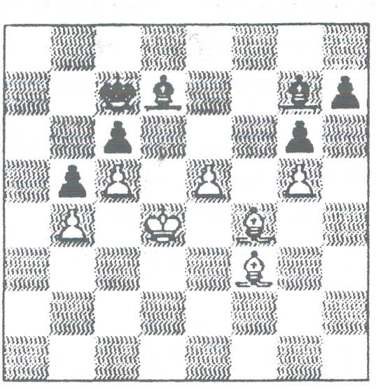  5Universal agreement that Black has made no progress and that a DRA W should be awarded. White has made thirteen moves in just under two minutes - about ten seconds per move. This was thought to be an acceptable tempo. | 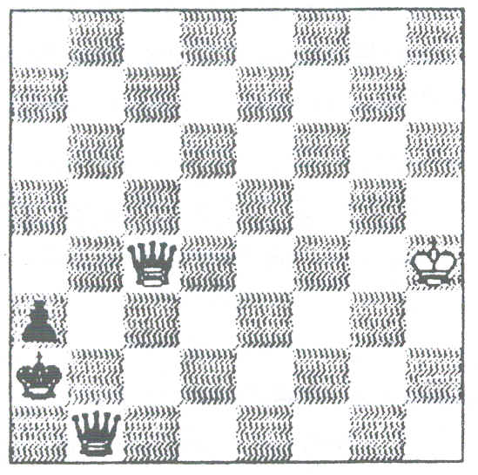  6This was the position where opinion was almost equally divided. Four of the panel gave White (yes it was a White Queen on c4) the draw whilst five would not have over-ruled the clock and would have given Black the win. Since the claim was made, Black has made progress but it seems White can, by repeated checks, halt further progress and get the draw. In the game Black had not yet tried moving out of the corner and seeking a way to block a check with his Queen and in turn give check.
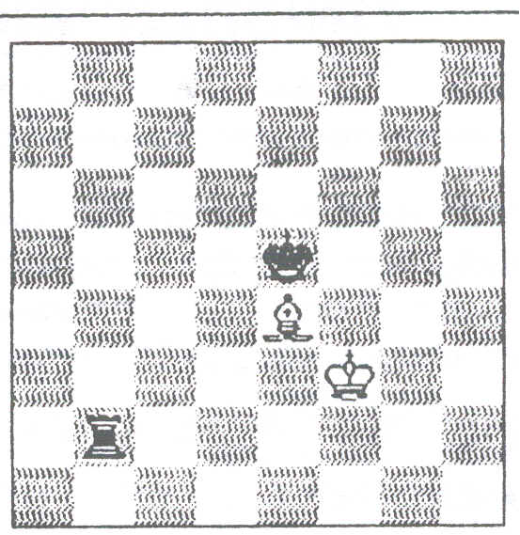  7Although a theoretical draw, the defence is not easy, so Black must be given every opportunity to try for the win. Reuben Pine states that, "In the general case this is a draw. It can be won by force only if the defending King is in the wrong corner or in the center with his opponent having the opposition." The wrong corner is the one of the same colour as the Bishop. All the panel expected to be awarding the DRAW eventually. | """""\,_)m_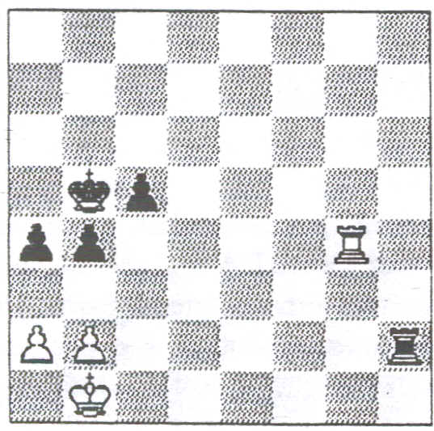  8We would need to be familiar with the Intel Grand Prix rules for this one. Since including this position I have been told these required the Arbiter to award the draw immediately or not at all. Being a 6 minutes v 5 minutes play-off, to qualify White had to win, Black had to draw. Two of the panel said play on a bit, but given the additional information above all the panel would have awarded the DRAW. | 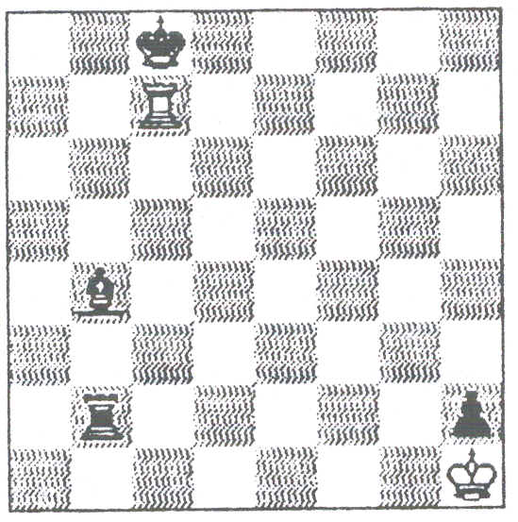  9All the panel expected to award a DRAW before very long, but would first allow play to continue to establish that White intended to continue checking on the seventh rank and not on the eighth.

I feel that the benefit of any doubt should be in favour of the player having more time. The claimant must have a very good case before the loss on time is over-ruled. Some players still maintain that there should be no exclusions. Overstep at your peril !

HERE AND THERE

NICE ONE DAVID

Playing white, Norwood managed to stand worse after only five moves as his young, opponent took over the centre and Norwood's pieces were misplaced.

Vescovi, confused by the unorthodox position, missed his chance and Norwood Itook over with some fine play. Vescovi fell into deep time trouble, until on move 39 his clock (digital? - Editor) showed he had just one second left to make his final move.The youngster had his hand poised over the board, ready to respond the instant Norwood moved. Norwood, relishing his opponent's discomfiture, pondered his move for six minutes, before flashing out a rook retreat - a move that threatened nothing at all.
The tactic worked to perfection. Vescovi was momentarily confused, the hand quivered and he lost on time as he attempted to play the move he had intended against the move he had expected from Norwood.
Malcolm Pein in the Daily Telegraph

CHESS ARGUMENT LED TO SHOOTING

A chess player who tried to shoot his opponent because he was such a bad loser was jailed for 10 years at the Old Bailey yesterday.
Robert Bryan, 55, of Star Road, Fulham West London, admitted trying to murder Matthew Hay, 22, who lived with him.
“I dreaded playing chess with him always had to lose," he told police.

CONFUSING

A report on a PCA event stated, “The games were played in rapid chess mode where each player had just 30 minutes on the clock to make all his moves. Each player took white and then black in a best-of-two-games final." (Wasn’t it confusing jn game one when both Players had the white pieces in game two when both had black? And who had first move? – Editor. Yes I know what they meant, but they didn’t say it.)

I LIKE IT

According to the 1994-1995 Year Book of the Welsh Chess Union, at a 1994 meeting of their Management Board the following resolution was passed :
It is suggested that all events try to follow the guidelines given below:
If an event takes place on one day only, the recommended minimum payment to the Control Team should be 50p per entrant.
If an event takes place over more than one day, then the recommended minimum payment to the Control Team should be £1 per entrant
Additional expenses such as travelling, meals and accomodation (sic) should also be paid. It is hoped that as many events as possible will follow these guidelines.

A vacany has arisen for the post of
SECRETARY OF THE CHESS ARBITERS ASSOCIATION

Duties include dealing with general correspondence and matters to do with the Annual General Meeting.Contact the Chairman or Secretary for details of salary, bonuses, company car, pension plan, private medical insurance and share options. Or possibly you can work all these out for yourself.

HEALTH MATTERS

by Stewart Reuben
Senior Arbiter & BCFDirector of Congress Chess

Chess is unusual relative to most other sports in that it is often possible to cope with the ill-health of a contestant. After all, it is only a game. One wouldn't want to make a decision which caused a player to become seriously ill.
Dr Hennigan advised me at the 1981 British Championships that Peter Wells, then 16, shouldn't continue playing against Jon Speelman. The game was stopped after the next move was played, sealed move prepared and the game adjourned until later that day on the understanding that, if Peter was still too ill, he would lose by default.
In 1982 a player was suffering badly from asthma in the first three rounds of the British Championship. He was
allowed to play in a separate room so as not to disturb the other contestants. This was not entirely satisfactory. His opponents were almost certainly put off and the conditions were probably worse for them than if they had still played in the hall. Social pressure would also have made it extremely difficult for them to complain.

This year (1994) in the Lloyds Bank Masters a player had severe breathing problems. This was audible in the hall but I wasn't able to trace the source until a complaint was made. The opponent was then allowed to play on a separate board with the clock remaining in its original place. We were careful to ensure in later rounds that the player with serious health problems played where he would cause minimum disturbance.
In another Lloyds Bank Masters a player had to leave the board because of breathing difficulties. The game was temporarily stopped. Fortunately there was a doctor present who diagnosed an anxiety attack. Oddly, his opponent commented he didn't intend to resign his inferior position just because his opponent was poorly. I reassured him that this wouldn't have occurred to anybody. He then offered a draw which was accepted. Thus no decision was required of the Arbiter.
Once at Tilburg Tony Miles had back trouble and played his games lying face down on a hospital bed. One player complained but I believe it was turned down.

