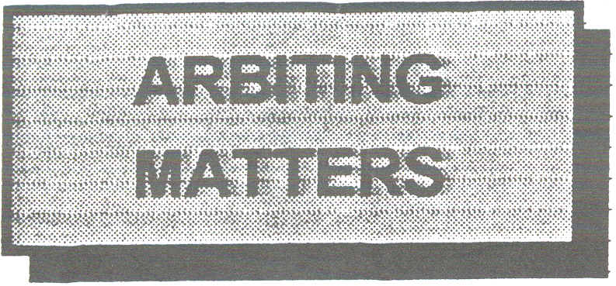
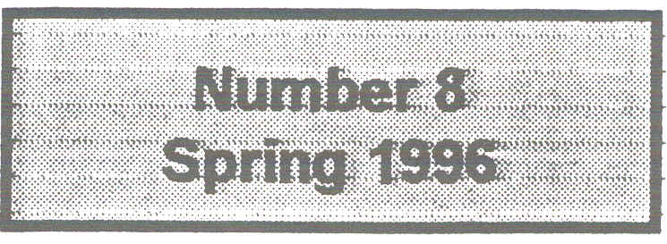
The Newsletter of the Chess Arbiters' Association

EDITORIAL
With 16 pages I must class this issue as a bumper number, so thanks to those who have contributed. especially John Robinson and David Sedgwick, and also those who have written to me. Yes, we even have two pages of letters. That serves me right for suggesting something controversial!
Most of you will be aware 1996 is the year far FIDE to rewrite the Laws. At the Paris Congress (November 1995), the BCF’s offering (the laws rewritten by David Welch) was accepted as the version FIDE would work from. Already in the draft most of you will have received there are amendments and additions to David's version. We are not necessarily happy with the changes.
If you have thoughts on the Laws, act now. Submissions have to be received by FIDE before the end of April. Most of us have never before had the opportunity to make an input to the Laws of Chess. "Speak now or forever hold your peace ".

I had hoped for comments from more of you with regard to that half-promotion referred to in the last issue - the one in the Intel Qualifier at Hastings last August.
There is a distinction between an illegal move. which generally leaves a genuine position on the board (perhaps a check to move out of); and an incomplete promotion which leaves a pawn on the eighth rank, clearly a non-chess position (even more nonchess if someone promotes to a King as in Dave Vigus' suggestion).
With the pawn left on the eighth surely the arbiter must intervene (if he sees it or has his attention drawn to it), stop the clocks and have it rectified. In the absence of any evidence to the contrary what about a Queen being the piece to promote to by default.
A time allowance to the opponent see John Turnock's letter - what do you think? Come on, lets grasp this nettle and have some suggestions. "It could be you" who has to face this at a top Rapidplay. Let's sort it out now.

EGG ON FACES UNLESS ARBITERS ACCEPT CHIPS by Richard Furness

Blackpool 1988 was my first year as an Arbiter at The British. In those days I actually had spare time in the evenings and on the first Monday I joined the assernbled throng to listen to Malcohn Pein explain the wonders of ChessBase. I wanted it !
Unfortunately my faithful BBC B computer was unsuitable and it was a further five years before I was able to acquire a second-hand PC.
During the intervening years chessplayers had also been offered Fritz, NICBase, Chess Assistant and a variety of other software packages with strange sounding names, but there had been next to nothing for the Arbiter - at least not in Britain.
In the early 1980s Clifford Hilton made great strides with a program for the BBC B which we found invaluable during the Benedictine Internationals in Manchester. It did rating and title norm calculations and as soon as the event was over we were able to issue players with full tournament tables containing rating changes.
Another of his programs displayed the current pairings and allowed us to input results as they came in and scroll with an up-to-the-minute leader board. I used this at the Oakham Young Masters tournaments in 1990 and 1992. Players and spectators found it very helpful. 13-year-old Peter Swidler playing in his first international event usually managed to anticipate the results and beat the players to the control table so he could enter the details himself. He nearly achieved an IM norm as well !

Clifford's tournament rating program was the prototype of the one George Smith the BCF International Rating Officer has developed. When Clifford died suddenly in January 1988, meaningful development of software for chess administration seemed to come to a halt in England..
I know that Harry Lamb developed a program for doing Swiss pairings on his Spectrum (I think) during the 19805, and no doubt unknown to me there were other attempts to bring the power of the silicon chip to the aid of Tournament Directors and Arbiters.
The rest of Europe. seems to have left us. behind and there are now a number of software packages available which will do Swiss pairings according to the FIDE seeded pairing rules. This is the problem. FIDE pairing rules. We - in England that is - cling to the belief that our pairing system is better. The large European Opens use computers as does the Olympiad
New in Chess (1995/7) carried a telling article by Anatoly Vaisser on the InteI Grand Prix Qualifier at Hastings last August. He said, "The organisation was not bad, except for two details: long archaic manual pairings and electronic clocks " For events such as the British Championship, Hastings Challengers, Isle of Man Monarch Assurance, Intel Qualifiers etc. we must see how computers can help. Two articles in this issue bring you up-to-date. Read on.

PROTOS and SWISS CHESS reviewed by John Robinson

Swiss Chess
Copyright 1989 - 1995 by Dipl.-Ing.
Franz-Josef Weber

A program for Chess Tournaments: Swiss System - Round Robin, Individuals and Teams.
Suitable for IBM Compatible PC's with
MS-DOS or WINDOWS.
A few months ago Stewart Reuben sent me details of a Swiss Pairing program, . PROTOS, which he had obtained from FIDE. Was I interested? In spite of a gut feeling that if the program were any good, it would spoil the fun of solving a tricky draw, and if is wasn't, there might be no point. I was certainly curious and set about loading the disk. I decided to see how the program would have reacted to the situation at each of the eleven rounds of the 1994 British Championships at Norwich, a tournament where the pairings had been closely examined in our editor's excellent pamphlet. which has become for me an essential reference source whenever any difficulties of interpretation of the BCF Pairing Rules is needed.
I soon discovered that PROTOS offers a choice of two methods of performing the draw, one based on a system devised by Dr. Um Kok Ann, the other, written after the revision of the FIDE pairing rules in Manilla1992, by Guert Gijssen, and referred to as the Dutch System. In either system. the FIDE rule for choice of floaters will select a "bottom to top" pairing rather than the "median to median" choice which has been preferred by the BCF Rules since the Lone Leader rule was dropped a few years ago. Because of this no PROTOS draw ever faithfully reproduced the actual draw, but there was some confirmation that the Gijssen pairings when no floats were involved were very similar to a BCF rules draw;
PROTOS was moderately user friendly, but I found that any mistake in entering a result was difficult (impossible) to correct once the program had been advanced to the next round so that frequent backing up appeared to be essential. By the time Stewart left for the FIDE meeting in Paris I was
able to report that if required, I would be happy to use it in a real tournament.
In Paris, Stewart learned that PRO
TOS was now virtually released from copyright, and members will be aware that I am able to send them an up-to-date copy, which they may use (although oddly not pass on to a third party!). However he also discovered that a program with rather more scope, SWISS CHESS was now available,
which, to cut a long story short; the BCF decided to purchase. The pairing system used is based on Gijssen's original work and as far as I can establish gives identical pairings to PROTOS.
SWISS CHESS is considerably more user-friendly than the version of PROTOS I had seen, and also offers
many post-tournament facilities. PROTOS appears to have been extensively restructured in the 1996 version which I am allowed to pass on. I have not investigated the implications. of these improvements, but since the cores of PROTOS and SWISS CHESS are probably the same, many of my comments on SWISS CHESS will apply to PROTOS users also Copyright rules forbid me to pass on copies at SWISS CHESS, my disk being the property of the BCF
To run a tournament using SWISS CHESS it is first necessary to give it an identity, select the type of tournament, (Swiss, Team or All play all), nominate the number of rounds, and to set various tournament parameters. All tournament parameters have default settings which in most cases will be the commonsense choice, but it is possible for example to save memory space by capping the maximum number of players, more interestingly to select Sum of Progressive scores to establish ranking order, and more usefully to prevent clashes between members of the same club. In a six round tournament, this protection may not be extended to the fifth or sixth round, but there is no reason why you might not cheat by nominating a longer tournament than that you intend to run.
The contestant list may be built at leisure as entries come in. SWISS CHESS comes complete with a current FIDE rating list (but the January 1st ratings were not received until early in February), so that a fragment of a rated contestant's name is all that is needed to transfer full details - even date of birth - to the list. There is no reason why the BCF master list cannot be incorporated into this scheme, and if it were, any tournament could be up and running in a very short time. SWISS CHESS works only on the ELO system, but it can distinguish between rated and unrated players, allowing the post tournament calculations to take into account games against rated players only if necessary.
For a domestic tournament where rating performance is irrelevant, it may be convenient to enter the rating as a pseudo Elo figure based on BCF grade +1000 rather than the conversion from BCF so that any figures appearing on tables produced by the program will be that much less mysterious to English players.
Shortly before the first round draw, the contestant list should be sorted, normally into rating order. If it is decided to use the FIDE pairing rules in toto, all that is then needed is to scan the contestant list for first round half-point byes, and mark the contestants accordingly. The draw takes only a few seconds and may be printed for publication. There is a provision for the additional pairing of late entries.
In the event of an odd number of players, it is quite simple to award the bye to a player more appropriate than the weakest of the field. An extra player "nogame", (who would have been automatically activated into the contestant list if the automatic draw had been made) is added to the contestant list and the selected bye paired against "him" manually before allowing the computer to complete the draw.
The program constructs a complete set of Swiss pairing cards, (which it updates round by round and which may be printed at any time during the tournament). Once the first round pairings are finalised, the players to be given a half point bye may be re-activated and the "no colour" result edited on to the internal Swiss card. Some care is needed in this area. If there have been latecomers, they should be awarded their correct seeded position in the contestant list by re-sorting it. As a result it will be necessary to re-enter the actual first round pairings manually, using revised PIN numbers. Any players not present for Round 1 who are de activated for this exercise, lose their edited entry on the internal Swiss card which must then be re-inserted.
The result of any game is entered as 1-0, ½-½ . or 0-1 with a single keystroke There is little point in entering them piecemeal,. since the cursor automatically shifts down to the next pairing as a result goes in which makes the full batch of results very simple to put in in a single operation. However, once the results are complete, it is a mistake to assume that use of the program has eliminated the possibility of an error, and it is still very much worth while to check the print out of the completed round against the hand completed daysheet and to check the total number of points against the expected total.
The program can provide a "ranking order" table, so that if six players (say) have a common score of 2½ , they are listed consecutively, and the six names can conveniently be compared with the Swiss cards showing that total.
Once the round is complete. the draw for the following round may be made, but it must be preceded by a thorough update of any withdrawals, returns or half point byes. Any draw may be wholly automatic, wholly manual or anything in between; for example, the BCF method of selecting the player who has ideally not floated down for two rounds and is amongst the majority colour seeking group and is at or closest below the median of the group as a whole, to float down etc. could be imposed by manual pairing with the remainder of the draw being completed automatically.
SWISS CHESS was used at the recent Hastings Congress for the Challengers Tournament, where the use of accelerated pairings in the first few rounds made the choice of manual pairings at that stage mandatory. In the succeeding rounds, computer parings were distorted by the false "upfloats" which are the characteristic of accelerated pairing system. The damage was repaired at this stage by removing selected pairings as necessary, then using the "manual entry" facility for repairings of the players involved.
A similar practice was used when small alterations of the draw could be seen as an opportunity for title norms or ratings to be kept alive for individual players. In addition there was a handful of cases where the computer pairings seemed at variance with FIDE pairing rules - one "fault" which occurred several times concerned floats in consecutive rounds. These cases have been reported to the programmer, who has intimated that they will be examined so that such "faults" can be eliminated in the future.
Somewhat to our surprise, use of SWISS CHESS at Hastings was overall a success. There were pitfalls which it is unlikely any amount of homework beforehand would have revealed. At the end, we felt that we knew enough of its workings to justify using it at such an important event. Some combination of the virtues of TOURNAMENT MANAGER. With its ability to calculate actual rather than "Inofficial" data on FIDE rating performances, and its inbuilt relationship with the BCF Grading system, and SWISS CHESS would be a real winner and it is perhaps not too much to hope that the BCF can cooperate with Weber to achieve this.
The current BCF pairing rules may not be perfect, and if performed manually are inevitably subject to human error, but I remain slightly sceptical that a blanket acceptance of the FIDE pairing rules is necessarily acceptable. The BCF rules cover many carefully considered features, which it would be a shame to discard in the interests of progress. Consider the following extract from a tournament I controlled this year which demonstrates the finer points of the BCF system, in particular Rule 18. Details of the players concerned are given below. It is suggested that the reader performs this draw before continuing. The players are numbered in grading order.

W seeking B seeking
2 points 2
------------------------------------------------
1½ points 1
3
--- - - - -------
4

Player 2 had a default win in Round 1 and had W in Round 2
Player 1 drew with black v 3 in Round 1 and had W in Round 2
Player 3 upfloated as Black in Round 2
Player 4 drew with Black in Round 1 and won with W in Round 2
See page 16 for the BCF Seeded Pairing solution to these two pairings.

An anecdote from Alan Phillips
Noticing two players diligently continuing a game with only a King each, he advised them the game was a draw. "Go away. Leave us to play our game in peace", was their indignant reply. Meeting one of the players the next day he enquired as to the result. "Oh I lost as usual", said the player sadly.

Probably not original, indeed I think I have heard it before - possibly from Alan last year.

IN A HURRY
At the Swansea Championships I covered one memorable time scramble. Remember the time controls were 40 in 2 hours, 60 in 3.
With both players down to two minutes and about to stop keeping score, I began recording at move 29. With a few brief pauses they rushed through to move 45 then looked at each other and then at me. When I did not react they started again, then paused, looked at each other and continued once more. Eventually they stopped and watched a flag fall.
"Have we made the time control... one of them asked. Which one", I replied, then told them they had made about 67 moves and were well beyond the second control having made 76 moves between them in four minutes !.

LETTERS

Is it a Draw?
In view of the age and inexperience of the players and the fact that the position is drawn unless one player makes an outright blunder, the arbiter was correct in asking the players to play on and subsequently awarding a draw. I do not understand the suggestion by some spectators that White's failure to play Nxd4 proved that he was playing for a win when he had already claimed a draw !
Promotion
Here the arbiter is put in an impossible position by the tournament rule that an illegal moVe played and replied to must stand. It is clearly ridiculous for a game to continue with an unpromoted pawn on the 8th rank or with one of the kings in check.. 1 00 not know what 1 would have done in the heat of the moment, but on reflection this seems to be a case in which rigid interpretation of the rules should give way to common sense and the arbiter would be justified in intervening to avoid a farcical situation arising. Appropriate action would depend on whether or not the arbiter is able to intervene before the illegal move is replied to.
I'm Afraid You Have The Bye
I support John Turnock's suggestion that players who are given enforced byes in Swiss tournaments should receive a refund of the appropriate fraction of their entry fee. I have frequently thought of doing this but have never actually got round to doing it. Rounding down to the lower 50p (rather than £1) might be sufficient simplification of payment
Ron Powis, Stroud

Accelerated Pairings
Your accelerated rules are rather long. Why not, "For the rounds where acceleration is used players in the top half have a notional score (NS) one point greater than their actual score. The players in the bottom half have a notional score equal to their actual score.
Notional scores are marked in green at a convenient place on the pairing card.
Accelerated pairings are then done according to BCF Seeded Pairing Rules, but using notional scores.
Acceleration ceases when all bottom half players have dropped one point and must never be used in the last two rounds of an event."

I think the system is flawed. Try doing the Round 2 pairings for the 16-player tournament below.
Round 1
1v5 draw 6v2 draw
3v7 draw 8v4 draw
9v13 1-0 14v10 0-1
11v15 1-0 16v12 0-1

Is it a Draw?
White could have thought: N worth 3 points, P worth 1 point. Capturing allows Black to gain material so the arbiter will give Black the win because he has made progress.
David Welch, Liverpool
(David's point on APs is well made but I doubt if he or I would be using accelerated pairings in a 16-player event. For a larger one to have such freak results would be highly improbable-RAF)

The Hastings Intel non-promotion
Dave Vigus had it wrong regarding the promotion incident in Hastings. I am surprised you didn't correct it as you were part of the Appeal Committee.
Accelerated Pairings
Your suggestion does seem to me to be a viable alternative, whether better of worse I don't know. Personally I wouldn't find it simpler to put notional points on a Swiss Pairing card which had to be ignored later in the tournament, but that is just a matter of administration. I devised the system after playing in a tournament in Atlantic City.
Acceleration was concluded incorrectly after Round 2, with the effect that players with 2/2 met weaker opposition than players on 1½/2. In 1967 I introduced the current system at Islington, believing it to be the standard method. Ontl on meeting Phil Haley (the Canadian inventor) in 1993 did I find out his method was more like that proposed by you. In London we have even divided the groups into tenths, when the notional concept would not work (I think).
Thus the BCF AP System was an accident that hasn't been questioned for 19 years. Of course, the Crouch System is just APs writ large for every round.
Is it a Draw?
The player with the knight never captured the pawn. Perhaps he didn't do so because he would then be ceding his material advantage and thus be more likely to lose in his opinion? Personally I would have given the draw before the flag fell and gone on to more important matters.

Stewart Reuben, Twickenham

The Pawn Promotion
On the question of the pawn promotion is there not here a difference between an illegality and a manifest absurdity ? A pawn left on the eighth rank and a promoted king do not exist in the real world of chess - they have as much right to be on the board as an edgehopper or a square root of 50 leaper.
I have two answers - one theoretical and one practical.
My theoretical answer is that (following the above) the piece has no reasonable role on the board and should be removed. My practical answer (based on natural justice) is that Black should have his queen and White should have an extra minute.
Is it A Draw?
At flag-fall I would award the draw. Black has made no progress and White has played a reasonable number of moves. His failure to play Nxd4 is curious but I don't think he should lose because of it.
In most Rule 16 situations the Arbiter will ask the players to continue, but here I would have been very tempted to award the draw immediately. The players are strongish juniors about the standard of the average club player and the draw is absolutely clear. The level of play necessary to lose this position is of the same order as in the case of K+R v K+R.

Awarding the draw immediately in very clear situations would cut out all the doubts about whether the claimant has later decided to play for a win.

John Turnock, Newcastle-Upon-Tyne

THREE QUICKPLAY FINISHES by David Sedgwick
I often think that games which end in situations requiring difficult decisions to be reached under the quickplay finish rules occur less frequently than one might intuitively expect. This tournament (SCCU 3rd International, August 1995 - the article is taken, with the permission of its writer, from the Tournament Bulletin), however, was an exception, with three. interesting examples. In each case I do not have a record of the exact point at which the defending player claimed the draw, but it was early in the sequence of moves given.
The first two positions both occurred on the Wednesday morning in games adjourned from Monday and Tuesday. In Lund-Whiteley the concluding moves from the diagram were :
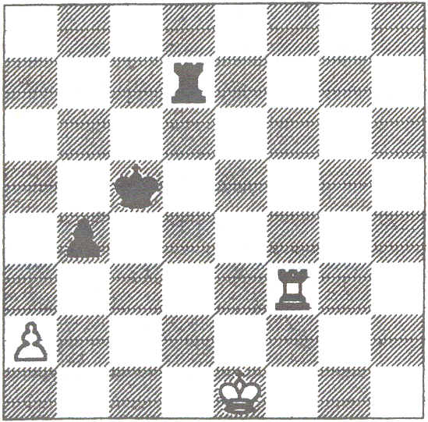
6O.Rf2 Kc4 61.Rc2+ Kb5 62.Rd2 Rh7 63.Rc2 Ka4 64.Kd2 Ka3 65.Kd3 Rd7+ 66.Ke2 Rd8 67.Rc4 Rb8 68.Rc2 Rd8 69.Rc4 Rh8 7O.Kd1 Rh2 71.Kc1 Rh1+ 72.Kc2 Ra1 73.Rh4 Rf1 14.Rg4 Rf2+ 75.Kb1 Rf1+ 76.Kc2 Rf2+ 77.Kb1 Rb2+ 78.Ka1 Rxa2+ 79.Kb1 Rb2+ 8O.Ka1 Rb3 81.Rg2Rf3 82.Rg1 Rh3 83. Kb1 b3 84. Rf1 Rh2 and White's flag fell (metaphorically speaking, as Digital Game Timers were being used).
I was the Arbiter at the board. Rather than make a decision against which an appeal would undoubtedly have been made, I decided, with the agreement of Lund and Whiteley, to proceed straight to an Appeal Committee comprising two players and myself. I was joined by Ben Martin and Matthew Turner.
I felt that Whiteley had made some progress and voted to award him the win. The two players both felt that the "progress" had only been to a totally drawn position with no realistic. winning chances, and accordingly the majority decision was a draw. Matthew seemed a little unhappy about not agreeing with me, but I told him that he was there to reach his own conclusion.

A few minutes later another game finished. In view of the strange double blunder, I shall spare the blushes of the players by not naming them.

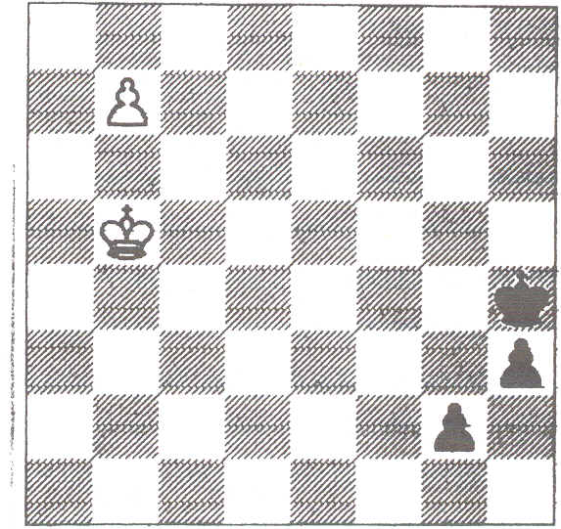
67.b8=Q g1=Q 68.Qh8+ Kg3 69.Qe5+ Kf3 70. Qf5+ Kg3 71. Qe5+ Kg2
72.Qe4+ Kh2 73.Qe2+ Qg2 74.Qe5+ Qg3 75.Qe2+ Kg1 76.Qd1+ Kf2 77.Qd4+ Kf3 78.Qd5+ Kg4 79.Qg8+ Kf577 80.Qf7+?? Kg4 81.Qc4+ Kf3 82.Qd3+ Kg4 83.Qg6+ Kf4 84.Qd6+ Kf3 85. Qd3+ Kg2 86. Qe2+ Qf2 and White's flag fell.
The Arbiter at the game awarded the draw. Ben Martin again joined me on the Appeal Committee and on this occasion the third member was David Wood. Ben and I quickly decided this was a clear-cut draw and David agreed after some hesitation. Looking at the final position again I am not so sure.
After the obvious 87.Qg4+ Kh2 White has no more checks and there are several plausible ways for White to blunder. e.g. 87.Qe4+Kg1 88.Qg6+ Qg2 89.Qb1+ Qf1+.
The final example occurred in the last round game Tumer-Richardson.

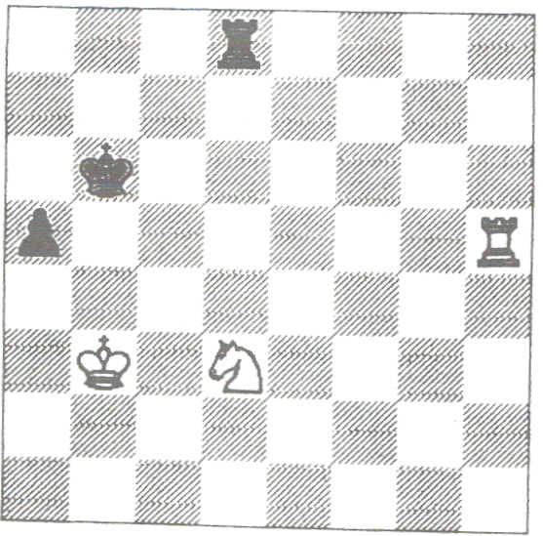
71.Nb2 Rg8 72.Nc4+ Kc7 73.Rxa5 Rg3+ 74.Kb4 Rg4 75.Rh5 Kd7 76.Kc5 Rg1 77.Rh6 Rd1 78.Ne3 Rd2 79.Nf5 Rd1 80.Nd4 Ke7 81.Kd5 Kf7 82. Rh4 Kf6 83. Kd6 Kg5 84. Re4 Kf6 85.Rg4 Rd2 86.Rf4+ Kg5 87.Ke5Ra2 88.Ne6+ Kg6 89.Rf6+ Kh5 90. Rf4 Ra5+ 91.Kf6 Ra6 92.Rb4 RcS 93.Kf5 Rc1 94.Rg4 Ra1 95.Rb4 Ra5+ and Black's flag fell before he could stop his clock.
Again the initial verdict was a draw. As I was preoccupied with preparing the prizes and other administrative duties, I asked Les Blackstock to chair the Appeal Committee. He was joined by Daire McMahon and Jonathan Witson. The players disagreed and Les had to decide. He backed the original decision and upheld the draw.
I imagine that Matthew Tumer considers himself a little unlucky. On the basis of my verdict in the LundWhiteley game, he may well be thinking that, if only I had been chairing the Turner-Richardson Appeal Committee rather than Les Blackstock, the win would have been awarded. However these examples have led me to wonder whether I am in general too reluctant to grant draw claims. What do readers think? I would welcome comment both from Arbiters and from players.

Cartoon by MATT
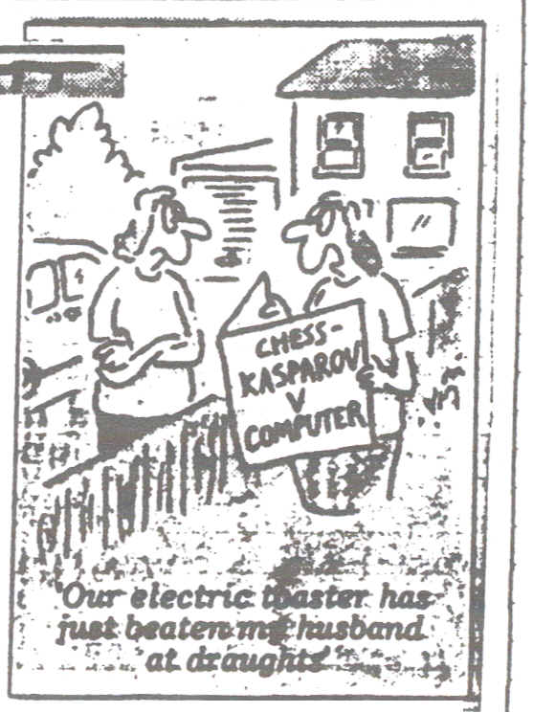

TOURNAMENT DIRECTOR reviewed by Richard Furness
This long-awaited program written by Marc Shaw is now available from Tony Corfe at TCS. Members connected with junior events or who have attended recent British Championships will be familiar with the output from TOURNAMENT DIRECTOR. It has been used to produce printouts showing full tournament details including all results, with players listed in finishing order and showing everyone's grading performance. But this is jumping to the end. As Julie Andrews suggested, "let's start at the very beginning."
The opening screen gives us five choices:
CREATE
SELECT
OPTIONS
MASTER
QUIT

On selecting CREATE, we are invited to enter details (Congress title, name of section, date, type of event, number of rounds etc.) of a new tournament This then becomes the Current or Active tournament.
SELECT enables the user to activate whichever of the tournaments he has created he wishes to work on.

OPTIONS allows various parameters to be set These include the method of output (printer or text file), type of printer, content of headers and footers and the ability to edit various reports and certificates.
MASTER takes us into the main data base which the user will gradually build up with the details of his regular customers. New players are added here. The example below shows the variety of fields in each record.

Master 24/02/96

Tournament Director Version 1.0

Title CREWE ROLLS-ROYCE CONGRESS
Event OPEN
Date 09/02/95 to 11/02/96
Surname ALMS Record = 256 of 455
First Name E Noel

Address Grove House Club WHITLEY
Whitley School
Warrington DOB / / Age
County CHESHIRE

Post Code WA4 4EW BCF A 117 Code 105673G
Telephone 01925-730333 Rapid A 90 Code 105673G Fide Code
Performance 93 (Last 3 Events)
BCF 0 (Last 6 Months) Union N Title Nation !NO
Rapid 0 (Last 6 Months) BCF Est 0 FIDE Est
CAA [ ] Personal [Y] User Defined [ ] User Defined [ ]

Registered To Richard Furness
Add Select Edit Tourney Current Find Next preY Print History Join
Increment Update

Move to Next Name

You will soon appreciate that If you run a series of events during the year there will be no need to painstakingly check grade and grading code every time an entry is received. Once entered, the
data is there. I understand it will be possible to update the grades from disk when a new grading list is issued. When the data entry is complete, you are invited to enter the player in the currently active tournament. All relevant data is then transferred into the tournament file.
You will see from the first example that there are many further choices from this screen. EDIT gives eight choices as to which fields require editing, which saves going through the lot. With a little experience the user soon discovers which group of fields become active with each choice. If subsequently a detail is corrected e.g. the spelling of a name - it is important to 5elect CURRENT to transfer the .changes to the event The data already in the tournament file will be amended. The player will not be entered as an additional player. If when entering a new player (ADD) the program recognises a similarity with a name already on the master data base, it displays the existing name and offers the choice of moving to that record or of continuing with the new entry. Despite this, duplicate records do occur. Not to worry! Marc has thought of this. We select JOIN and proceed from there.
HISTORY allows us to see the player's recent record. That is, in the events on the system. This is superimposed on the screen as in the example below.

Master: History

24/02/96

Tournament Director Version 1.0

Ti tle |  | CREWE ROLLS-ROYCE CONGRESS
Event |  | OPEN
Date |  | 09/02/95 to 11/02/96
Surname |  | ALMS |  |  |  |  | Record = 256 of 455
First Name |  | E Noel
Address | CREWE ROLLS-ROYCE CONGRESS. |  |  |  | INTERMEDIATE (Under 130)
 | 09/02/95 |  | BCF standard
 | BCF | 3 pts. Performance = 105 |  |  |  | ( | 523/ 5)
County |  | ----------------------------------------
Post Co | CHESTER KING'S RAPIDPLAY. MINOR |  |  |  |  |  |  | 73G
Telepho | 16/07/95 |  | Rapidplay |  |  |  |  | 73G
Perform | BCF | J pts. |  | Performance = | 84 | ( | 501/ 6)
 |  | ---------------------------------------- |  |  |  |  |  | ENG
R
 |  |  |  |  |  |  |  | lned [ | ]

Registered To Richard Furness

When all new players have been added to the master data base and also added to their appropriate tournament section, you will be ready to start your event by choosing SELECT from the opening screern. Choose theevent you wish to work on and move to SETUP, then PIN.
are given a choice of having PINs allocated automatically (by grade or alphabetically), manually (i.e. D.I.Y.) or of having existing pins cleared. With manual allocation you will be prompted if anyone is missed, perhaps someone you inadvertently put into the wrong section.
A few presses on the ESCape key will allow you to select RUN, then ROUND. Enter "1" and you are invited to enter the first board number - very useful for lower sections beginning at, say, board 41 or 61 or whatever. Next the number of boards. Remember each Half-Point Bye will require a board. Again don't worry if you get it wrong. An on-screen Help tells you how to add another board or delete a surplus one.
A blank day sheet is offered and you simply enter the PINs, with "0" as the PIN to be paired with any byes (full or HPB). You will not be permitted to enter the same number twice, nor will you be allowed to overlook anyone. This can be printed for display.
Later, from this same screen, Results can be entered using keys W, E and R. Oddly you press the left key _ for a win by the player on the right (Black) and the right key (R) for a win by the player on the left (White). Swapping the functions of the W and R keys seems more logical. As with everything (I think), incorrect results can be amended. Entry of pairings and results can be done very rapidly.
At any point players can be listed in PIN, alphabetic, grade or score order: The latter is very useful for checking score groups against pairing cards.

The moment your event is over and the last result is entered you have the final bonus, sufficient on its own to justify the existence of TOURNAMENT DIRECTOR. Your grading is as good as done!
Instead of RUN, select FINAL. You can have that impressive final results table I mentioned at the outset. You can have a grading printout and, so long as you remember to change the output method to FILE, you can have the grading data exported to a floppy disk to despatch to St Leonards the next day.
This account does not claim to cover all the features of this piece of software, but sufficient I hope to give you a good idea as to its usefulness. You will have gathered that unlike SWISS CHESS it does not do pairings. It does do most of the rest and takes a great deal of the "hack" work away from the Congress Secretary.
There- are a few things I have- not yet mastered. Which brings me to my one grouse. To date three months after purchasing, and despite a few reminders, I have still not received the instruction manual despite it being available in early December. I know someone who got one then! It says a lot for the user friendliness of the- package- that I have got so much out of it without the manual.

The following page shows the pairing printouts (day sheets) produced by TOURNAMENT DIRECTOR and SWISS CHESS. The latter does not have the facility for a variable starting board number. This can be overcome, but takes a few precious minutes.

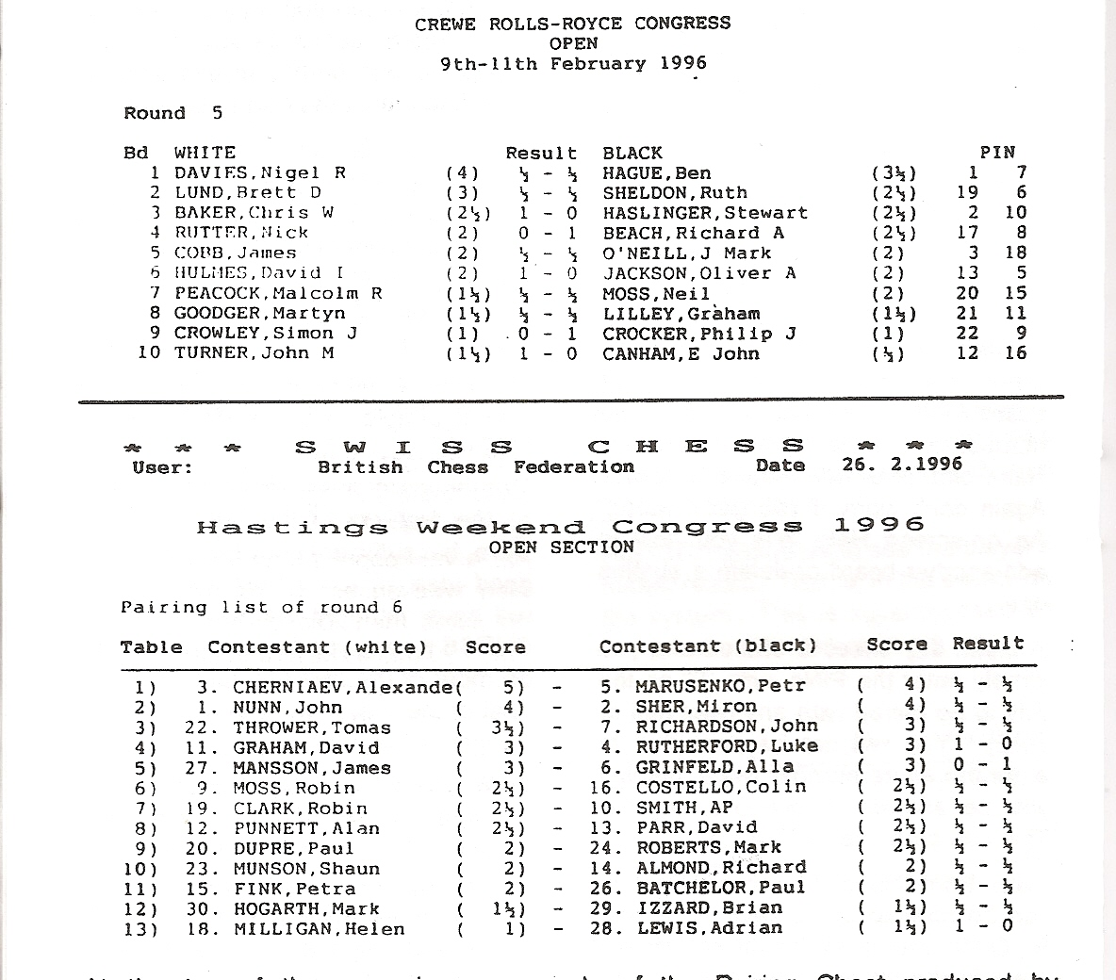
At the top of the page is an example of the Pairing Sheet produced by TOURNAMENT DIRECTOR, whilst below it is the equivalent offering from SWISS CHESS. I have a strong preference for the former, but then that is the one I am used to. It is useful to arbiters and recorders to have PINs shown, but as these are of little relevance to the players, I like them to be well away from the names (as in TD). At Hastings we often found players, used to seeing a pairing board rather than a printout, mistaking their PIN immediately before their name, for their board number. Believe me it happened very often - especially in the lower sections - and eventually we resorted to the thick felt pen reminder in red, which was a pity. I also prefer the results down the middle, so on TOURNAMENT DIRECTOR's is more in tune with what our players are accustomed to seeing.
The two programs complement each other with only a small area of overlap,

NEW IN CHESS (1995/7)

Extracts from a letter written by Roland Brockman of Victoria. Australia
I write with great concern about the recent practice in official FIDE tournaments of using the guillotine finish.
... The problems arise from the fact that it is impossible to come up with an objective definition of a drawn game.
A good example is the game Gluzman-Speck, Adelaide 1993. The following position arose:

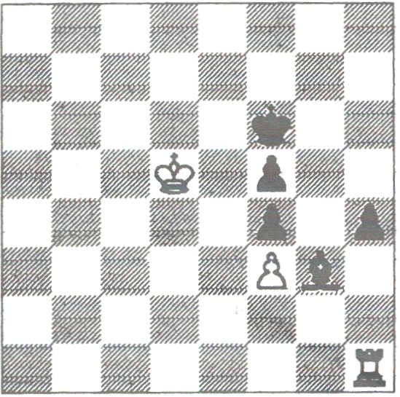
Speck, down to his last few seconds, claimed a draw under the "not trying to win by normal means" rule and this was upheld. After an appeal a disputes committee was convened but they upheld the original decision. Guzman I gather was furious.
What can one make of this incident? Well, first of all it should be made clear that an analysis of the above position to determine whether or not there really is a win for White would completely miss the point. The point is that it is not immediately clear and therefore must come down to the opinion of a third party and this strikes at the integrity of the game itself.
... Let me emphasise that I am not criticising either player, nor the disputes committee. I simply do not think there is a correct decision in this case.
What I am criticising is the guillotine time control that forced the game to an adjudication.
... The remedy for these problems is quite simple and has been used in many Australian tournaments for years. The idea is to increase the speed of play as the game progresses.
... A very popular time limit in Australian weekenders is 40 moves in 90 minutes, then 20 moves in 20 minutes, then 20 moves in 10 minutes repeating until the game is complete. The continual winding back of the clock is not a nuisance to the arbiters since only a few games ever reach the 20/10 repeating. Those that do however have a fair result.
Had Gluzman and Speck been playing under these rules then Speck would have had some time to keep moving and to simply count out the 50 move rule. On the other hand Gluzman would not have been denied the chance to try for a win. ...
When it is dear that no progress is being made in the position the players will virtually always agree a draw long before the 50 moves is reached. With a guillotine finish it is quite another matter, you can play on to "Win" on time. ...

Australian weekenders that use the 20/10 repeating type of time control, comfortably manage three games in a day.

AN EPIDEMIC?
Judging by the list of Arbiters in the BCF’s Yearbook for 1996 there has been an epidemic of new FIDE Arbiters during 1995. The 1995 Yearbook listed 19 FIDE Arbiters. The current book gives the asterisk to about twice that number. Someone has succumbed to asteriskitis.

We do of course have one genuine new International Arbiter, namely John Robinson from Northamptonshire. Well done John!
Congratulations are extended to Roy Heppinstall (Essex), Chris Howell (Crawley) and John Richards (Bristol) who have all had their BCF Arbiter title confirmed by the Federation's Management Board following recommendation by the Chief Arbiter.
Three CAA members, namely Gerry Walsh, Stewart Reuben and Richard Furness - together with Con Power (Director of the Hastings Congress) are amongst the first to be awarded FIDE's newest title, that of International Chess Organiser.
Since ARBlTING MATTERS 7 was issued the BCF International Director has resigned. CAA Secretary David Sedgwick bravely stepped into the breach as acting International Director and his appointment was confirmed at a meeting of the Management Board early in 1996. Good luck David!
It follows from this that David will be unable to continue as CAA Secretary after our next AGM. There will be a vacancy. How about you, yes YOU.

THOSE PAIRINGS
(from page 6)
Player 2’s opponent must be a white seeker, but there is a surplus of black seekers in the group. 1 and 4 have identical colour records, and since Rule 18 states specifically that no colour transfer should be made which will cause that player to be floated unless such a move is required to produce a top half upfloater ,the
upfloater clearly must be player 3. Had player 4 had even a slightly stronger claim for black than player 1, Rule 18 would not have applied, player 1 would have been transferred - and upfloated, since player 3 had an upfloat in round 2. Thus: 3 v 2 and 4 v 1.
The draw was unpopular with the players, since 2 and 3 were members of the same club and 4 had hoped for an easier opponent, but it has received support from authorities of the system within the CAA - and at least player 1 didn't object!
SWISS CHESS produced 1v2 and 3 v4, whether or not the rule on players from the same club was invoked or not. Maybe you didn't agree with my manual draw. The whole point of Swiss pairing rules is that there is consistency. and at least the computer ensures this. Or has that other invaluable feature, fairness been sacrificed?

