. '

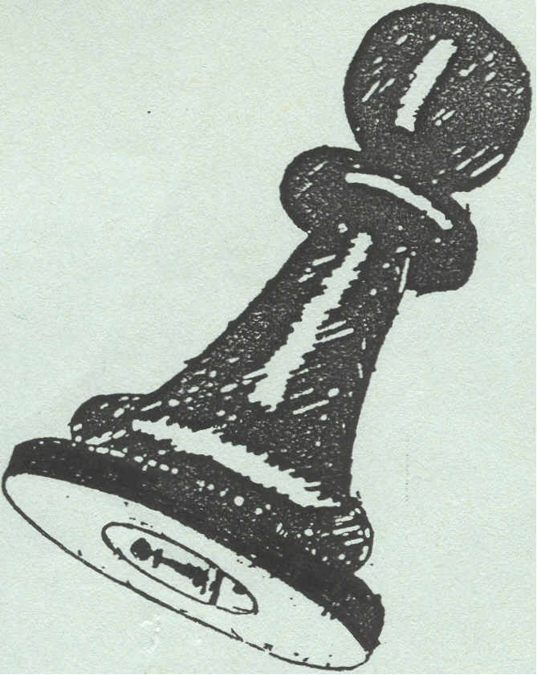
CHESS ARBITERS'
ASSOCIATION

agm notice & bulletin

,..,

Dear Colleague,

Notice is given that the Annual General Meeting of the Chess Arbiters' Association will take place on :

SATURDAY 8th AUGUST 1992 at 2,30pm
at the Plymouth Pavilions, Plymouth (actual room of meeting to be announced at the venue). Any member unable to attend who wishes an item or items to be included on the agenda should contact me at the address below or after Saturday 1st August at the Congress Office,
Plymouth.

Changing the venue:
In the last issue I asked for comments on Plymouth as the venue for this years AGM. The majority view was in favour but many of those who so commented were going to be at Plymouth anyway. Here are a few of the views expressed ...............
“ I am happy with Plymouth...however I do see the logic of using Bristol, London or Birmingham as more easily accessible places” Steve Boniface
“There is no satisfactory answer with an Association having such a small membership and so widely spread across the country. To get as many members as possible to the AGM it would seem that it must be held at the Championships.” Paul Bielby
“The only sensible alternative which I can suggest is to hold it in London during the Lloyds Bank Masters” David Sedgwick
“Perhaps we could establish a London Birmingham pattern, with occasional excursions to, say, Bristol, Newcastle or Manchester.” Eric Croker

FIDE Rules Commission
The F.I.D.E. Rules Commission met at the FIDE Congress. The main alteration was the reintroduction of the 50 move draw rule It will still be possible for Individual events to stipulate specific exceptions in advance of their own event. The overwhelming view of the leading players is that they prefer the rules without exception.
A new Dutch variation of the Swiss system was approved alongside the existing FIDE Swiss system.
New five minute chess rules were also approved. A new text of the Laws of Chess was approved.

Editor's Comment :- Anyone interested in the Dutch system is welcome to receive a copy & I will prepare these on receipt of a large s.a.e. Their definitions are more like a sociology manual. So what is a “heterogenous score bracket” or a “homogenous group”?

The five minute chess rules are of more potential interest and I propose to reproduce them verbatim with the next issue of this bulletin.
Neil Graham, 52,Skegby Road, Annesley Woodhouse, Kirkby-in-Ashfield, Nottingham NG17 9JH Tel 0623-756228

Dick Boxall (1928-1992)
Gerry Walsh writes :
The chess world was sad to learn of the death of Dick Boxall in Basingstoke District
Hospital earlier this year.
Dick was born in South London; unlike most young players today he did not learn to play chess at school but at the age of twelve from his father in an air raid shelter during the early years of the war.
He joined Streatham & Brixton Chess Club in 1950 and was Club Secretary until he moved to Basingstoke. a move which was necessary for Dick to continue his career with the Automobile Association. Dick had tried to work in his father's stockbroking firm ,and then for an insurance company before a job in the administration section of the.AA.where he continued until taking early retirement in 1991.
He controlled his first tournament at Twickenhamin the early 1950s and was also one of
the Controllers at the successful Bognor Regis tournaments run by Norman Fishlock-Lomax
in the 1950s and 1960s.
Oxford 1967 was Dick's first British Championship and up to the 1987 Championship at Swansea there were only a few occasions when he was not part of the Arbiters' team. The British Chess Federation awarded him the title of Senior Arbiter in 1982.
In 1990 & 91 he officiated at the Hastings Weekend Congress in place of his great friend the late Harry Baines who had died in 1989. .
Dick was always linked with chess activity in Basingstoke and he will be particularly remembered as the founder of the one day events in the town.
In 1989 Richard Edward Boxall received the B.C.F. President's Award for Services to Chess.

CONTROLLER'S CASEBOOK

Details of Numbers 1 & 2 will be included in the next bulletin as well as a special British Championship Controllers Casebook. If you have any interesting cases for discussion please let me have them as soon as possible.
ARBITERS’ COURSES These will commence in the Autumn under the jurisdiction of Peter PURLAND - prospective dates and venues will be discussed at the Annual General Meeting next month.

MEMBERSHIP
Reproduced below is the subscribing membership of the C.A.A. Do you know anyone who isn't a member who would like to join?

Julian ALDERTON
Steve BONIFACE
Robert BURGESS
Lee COYIE
*David EUSTACE
*Neil GRAHAM
Paul LAMFORD
Roderick MIDDLETON
W Ritson MORRY
Ron POWIS
P Allan RICHMOND
Mike SINCLAIR
Trevor THURSTAN
David WALLACE
*David WELCH
David WOODRUFF
Richard BEVILLE
David BROWN
Tony CORFE
*Eric CROKER
*Richard FURNESS
Frank HATTO
Stuart MANLEY
Robert MILNER
Richard O'BRIEN
Peter PURLAND
John ROBINSON
John SWAIN
John TONKIN
*Gerry WALSH
Mike WILLS
Paul BIELBY
Roy BROWN
Ian COWAN
Paul DANSEY
Peter GIBBS
Glynne JONES
Duncan McGREGOR
Peter MORRISH
Joan PARKER
Stewart REUBEN
David SEDGWICK
David THOMAS
John TURNOCK
Alec WEBSTER
Andrew WHITELEY

* Current Committee members

