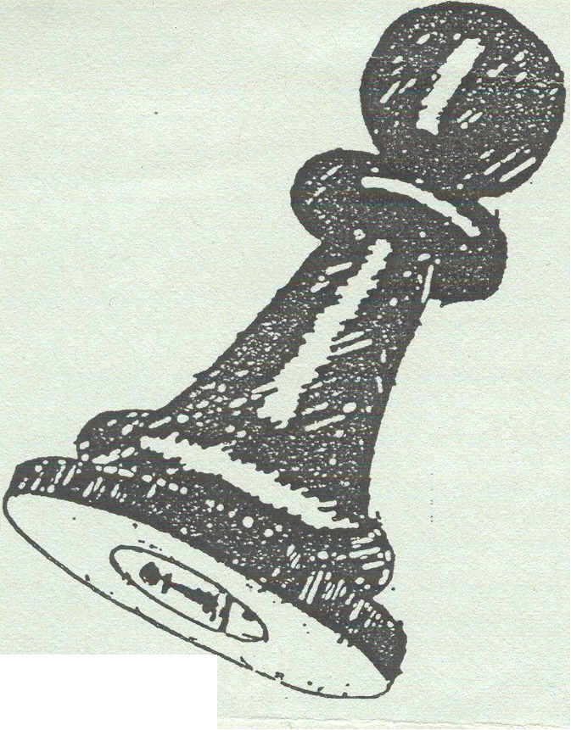
CHESS ARBITERS'
ASSOCIATION

_

Preliminary bulletin

Editorial :

This is the first of a quarterly bulletin from the Chess Arbiters Association.
The first "full" newssheet will be issued with the invitations to the Annual General Meeting. Obviously we are on the lookout for budding writers to contribute articles and also examples for discussion in our "Controller's Casebook". The Annual General Meeting must be held by the end of August. I have heard from several sources that the British Championship venue at Plymouth might be OK for those arbiters already there but is both inaccessible and expensive for those who aren't. What do you think? Please fill in the tear-off slip at the bottom of the bulletin and return to me forthwith. A decision will then be taken as to the venue of the AGM.

controllers' casebook

No. One

At a Rapidplay event White (with less than 2 minutes on his clock) asks an arbiter to come to his game as he thinks his opponent (12 mins) is making no progress towards winning. They have equal pawns largely blocking each other, one bishop each (same colour) with kings behind their pawns.
The arbiter requests them to play on while he observes. Black tries to get his king round the back of White's pawns, but realises he can only do so by allowing White a winning passed pawn. Black brings his king back and tries moves with his bishop but is getting nowhere. Arbiter is on the point of declaring the game a draw (sound defence by White, no progress by Black) when Black blunders away his bishop.

It is now a won position for White, but he has very little time left; probably not enough to create a passed pawn, promote & deliver made. It is Black's turn to move. What
should the arbiter do?
(a) Assume White still wishes a draw & declare the game drawn. Despite the acute time shortage White might object, thinking he can win.
(b) Assume White might now be playing for a win and do nothing. If White's flag falls
and the game is declared a draw, White is having two bites of the cherry.
(c) Stop the clocks and ask White whether he is claiming a draw
(d) Wait till it is White's move, stop the clocks and then ask him

No. Two

At a Rapidplay Black (hardly any time left) asks an arbiter to come to his game claiming his opponent (several minutes) is making no attempt to win.
The arbiter requests them to play on while he observes. White makes one unambitious move and then Black's flag falls. White admits that over the last few moves he had not been trying to win. '

---------------------------------------------------------.

Return to Neil Graham, 52, Skegby Road, Annesley Woodhouse, Kirkby-in-Ashfield, Nottm NG17 9JH
I am satisfied/not satisfied* with Plymouth as the CAA AGM Venue Signed _ /

"* delete as appropriate.

Say Aaaaaaaaaaaaaaghh

When was the last time you saw the Congress doctor? Players at the British may occasionally have seen this worthy but on the weekend circuit he is conspicuous by his absence. Those of you familiar with Kazic's "Chess Competitor's Handbook" will immediately refer to Page 120 where the doctor's role is discussed .......... “he is usually a chess fan and is well acquainted with the psychology of the players
he decides when a game can be postponed due to illness "
I can't recall seeing the congress doctor recently (you need more exercise walk twice round the playing hall) but perhaps the regular diseases/illnesses etc detailed below don't require such advanced diagnosis.
1) First Round Bowel disease - clearly affects many players early on the opening Friday evening. Is marked by competitors complaining after ½ hour's play that the gents have run out of toilet rolls.
2) Blue Spotitis :- this mostly affects the chest area and is caused by buying inferior ballpoint pens from the bookstall. Permanent scarring is usually avoided although dry cleaning bills normally exceed any prize money.
3. Swiss pairing syndrome - this affects high graded players particularly those with FIDE ratings. Frequently occurs after the posting of the draw with more violent attacks towards the end of tournaments. Telltale signs include shouting, tearing of score sheets etc. Arbiters are particularly at risk from unprovoked attacks by syndrome sufferers.
4. Fifth Round Withdrawal Virus - this illness is undetectable in early rounds at weekend events. However on Sunday mornings this mystery disease has a way of striking many competitors without warning. However after years of research it has been discovered that the virus is only active amongst those players with a score of 50% or less.
5. Controllers' Palsy - affects arbiters only and can be recognised by sore fingers and involuntary movements caused by turning chess clocks back by 15 minutes. Black, red and blue spots around the hands indicates an associated condition felttip fibrisitus commonly caused by excessive chart marking.
6. BatsfordPergamonania – usually abbreviated to BPM. This chronic complaint compels chessplayers to hang around bookstalls for interminable periods. In its advanced state the player believes he can actually find a variation that isn't in a chess opening book. This delusion can extend to the playing hall.
Fortunately not contagious.

I would be pleased to hear from any arbiter who may have witnessed these or any other common chess allergies.
Next issue the Doctor discusses "How to avoid the BYE”.............

----------------------------------------------------------------------------------------------

If you a not satisfied - please suggest an alternative venue .................................

